Before “A Will Windward”:
The Poetry of Mary Tookey
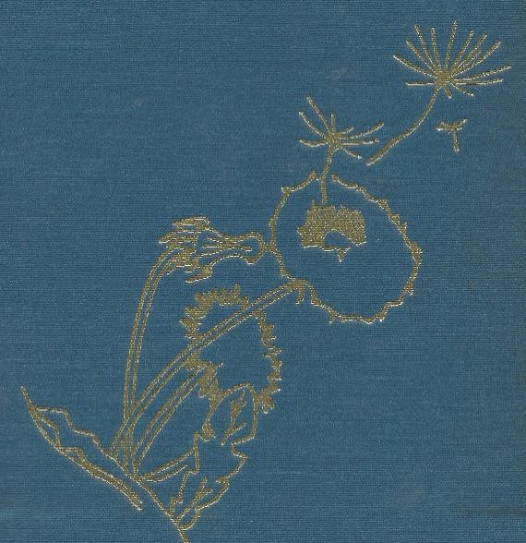
K.R. Tookey, editor

Before “A Will Windward”:

The Poetry of Mary Tookey

K.R. Tookey, editor

Thanks to Wally Armstrong, Eureka College Class of 1982, for the tribute he sent, unsolicited, to the family upon Mary Tookey’s passing; and also, for the original illustrations used with “A Will Windward”.

Mary Tookey, born Mary Webber, has loved poetry and writing from an early age. In order to preserve her contributions, the editor has searched through her papers, and compiled every known poem that she has written. This collection, together with “A Will Windward”, contains all of her known poems. Poems that were never published, or published elsewhere, were included, even if they were later included in “A Will Windward”. Poems that were only published in “A Will Windward” are not included here. To give the reader a feel for the process of digging through old papers looking for poetry, original source material was often scanned.
The editor hopes to next compile her prose works, and ultimately to produce an appreciation of her life. In the meantime, it is hoped that this collection will inspire family members, friends, and former students.
As an introduction, this compilation begins with a tribute from a former student. It ends with her obituary. If you are only interested in the compilation of her poetry that she published, “A Will Windward” is what you are looking for.
Material not previously copyright is copyright 2023 on behalf of her heirs.

K.R. Tookey, editor
Keith.tookey@gmail.com

Contents
Major Sections:
A tribute from a former student.
Middle School
High School
Published High School
More from Mary Webber
Early Married Years
Early Years at Eureka
Later Years at Eureka
About “A Will Windward”
Mary Tookey Obituary

Detailed Table of Contents
The Poetry of Mary Tookey
Contents
A tribute from a former student.
The Poetry
Middle School
Star
The Skylark
A Lark
High School
Prophecy of a Cloud
Autumn Night
A Spruce Before Dawn
Coming of the Night
Flowers of Spring
In Memory of a Baby
Night
War Clouds
Where?
Lady in the Clouds
A Rose
Sing
Sunset Clouds are Flowers
Make Believe Land
To A Sunset
The Christmas Baby
Farewell to Earth
Starlight
The Christmas Story
Published High School
Your Choice?
Spokesman
A Poet’s Prayer
To Mother Eve
More from Mary Webber
Directions for House Building
Teacup
Water Whimsies
Spring Fever
Sonnet to Someone Young
Look Well at this Fair Hostess, Friends
Early Married Years
Early Thirties
Sympathy
Woven
Interlude
Entire
The Sun Shines
Rapprochement
Unwelcome Autumn
Oriental Deaths
In Perfect Sunshine
Individuality
The Ultimate Fear
Who Are We?
Huge Night
October
Doubtlessly
If
Wiser
Pleasant Weather
On Immortality
Timorous
Sacrament of Love
Fleeing Creature
Brightening
Musing
Scientific View
The Turns of Time
The Doubting Sheep
Obit for a Dead Tom
Semicircle
Avid Socialites
Clock Watching
Early Years at Eureka
Offspring
Sloven Song
Spinster
Restraint
Unaltered Love
Restraint
Apology
Minor Monarch
Mental Architecture
Later Years at Eureka
To a Newborn Child
May Love
Infusion
Frame
Carrot-Weed
To Our Daughter at Commencement
Ice Flow
Friend of the Deceased
Interim Protest
June Beetles
Brightening
City Shine
Insult and Revenge
About “A Will Windward”
Mary Tookey Obituary

An Ebook copy of “A Will Windward” is also available.

A tribute from a former student.

Dear Tookey family:
I wanted to express my condolences for the recent passing of your father and mother. My parents, who also live in Washington, saw your mother’s obituary in the Peoria Journal Star. They called me that day, remembering that Mary had been my teacher at Eureka College from 1978 – 1982 and a friend ever since. I looked forward to receiving her Christmas cards each year and enjoyed reading the news about her family, of whom she was very proud.
Mary was easily one of the finest teachers I ever had — very supportive and also willing to be gently critical when necessary. In addition to being her student, I worked as her student assistant at Eureka for three years and provided several drawings for A Will Windward. She wrote letters of recommendation for me when I applied to grad schools and agreed to be a reference on my resume. She was directly responsible for so many good things that have happened in my life, and I am forever grateful for her wisdom, kindness and generosity.
I'd like to share a memory of your mother that I hold most dear. In1985, after I had completed my masters in English and begun PhD work at the University of Illinois, Eureka College offered me an opportunity to join its English faculty for one year while another professor took a sabbatical. That year marked a turning point in that I gradually realized teaching was not a good career choice for me. By the end of the final term I considered myself a failure. I felt very humbled and uncertain about what to do next.

A few weeks after the school year ended I received a letter from your mother. She enclosed an essay written by a student name Jill … — Jill had been in Mary's advanced composition class, and was also in several courses I taught earlier in the year.
Mary had assigned her students to write a "mock" letter to the college about any issue of significance to them. Jill chose to write them to hire me permanently for the English faculty. She referred to discussions in my classes which I had no idea made any impact at all. The letter was only pretend, of course, but its content -- the note your mother included, congratulating me for my work — was exactly what I needed to hear at the time. I don’t know how she knew, but she did. Almost thirty years later, I still have and still cherish that letter.
Although I can no longer say "thank you" to Mary personally for the enormous positive impact she had on my life, I would like to share my appreciation and admiration with you. I cannot begin to imagine what you’ve been through in the past few months. For whatever comfort it brings, know that your mother’s influence on her students, their colleagues and families will remain as strong as ever, and this world is a far better place for it.

Sincerely,
Wally Armstrong
Eureka College Class of 1982

Contents
The Poetry

Poems from

Middle School

Star
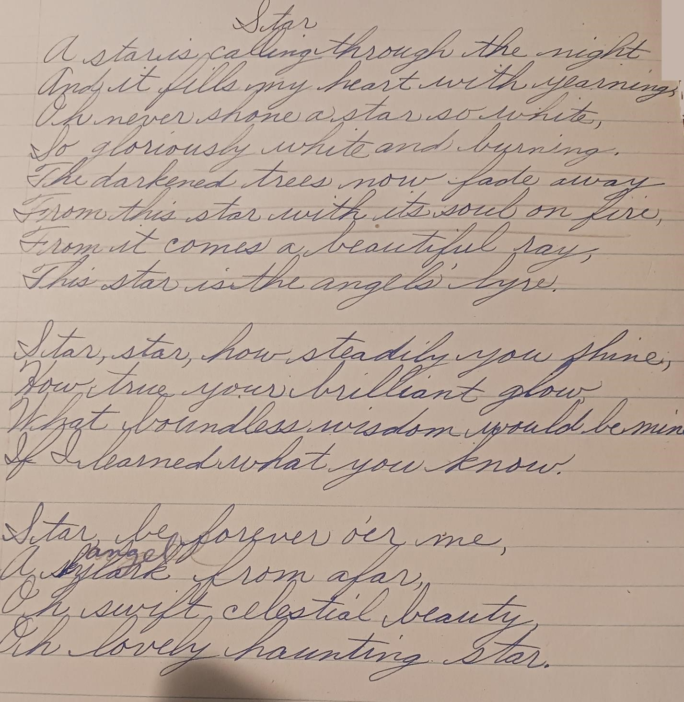
Contents

The Skylark
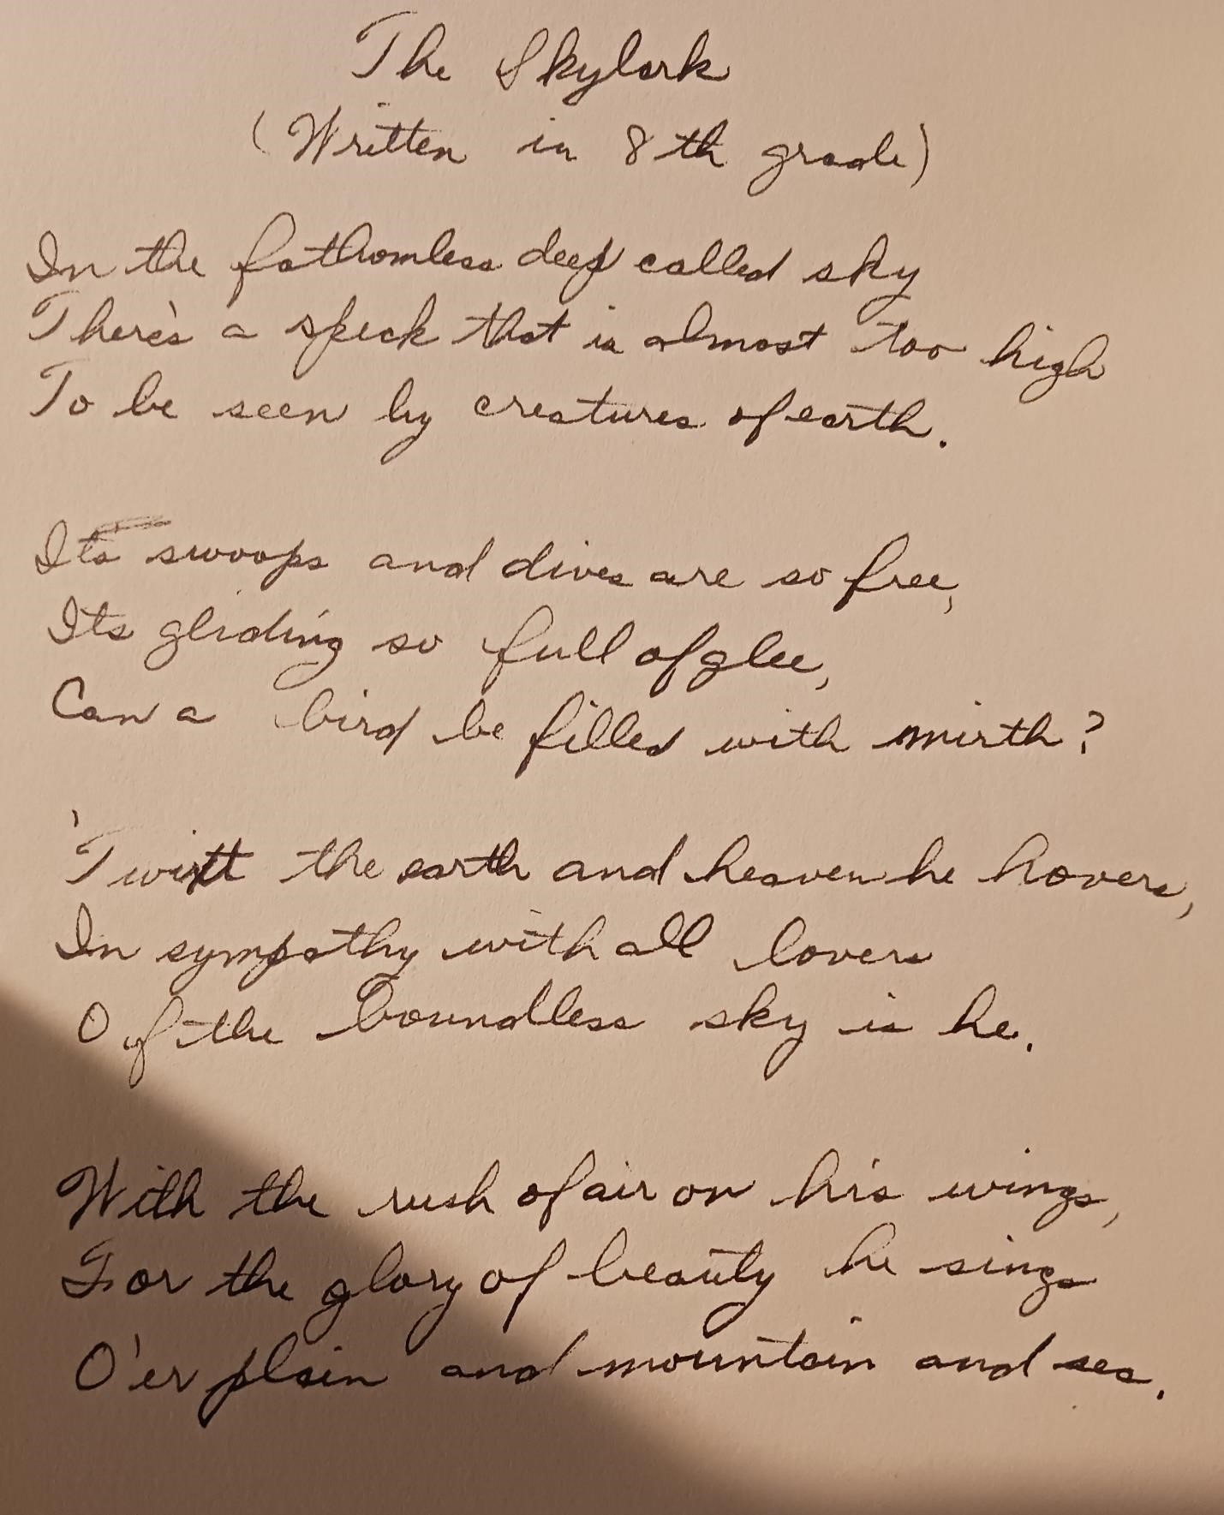
Contents

A Lark
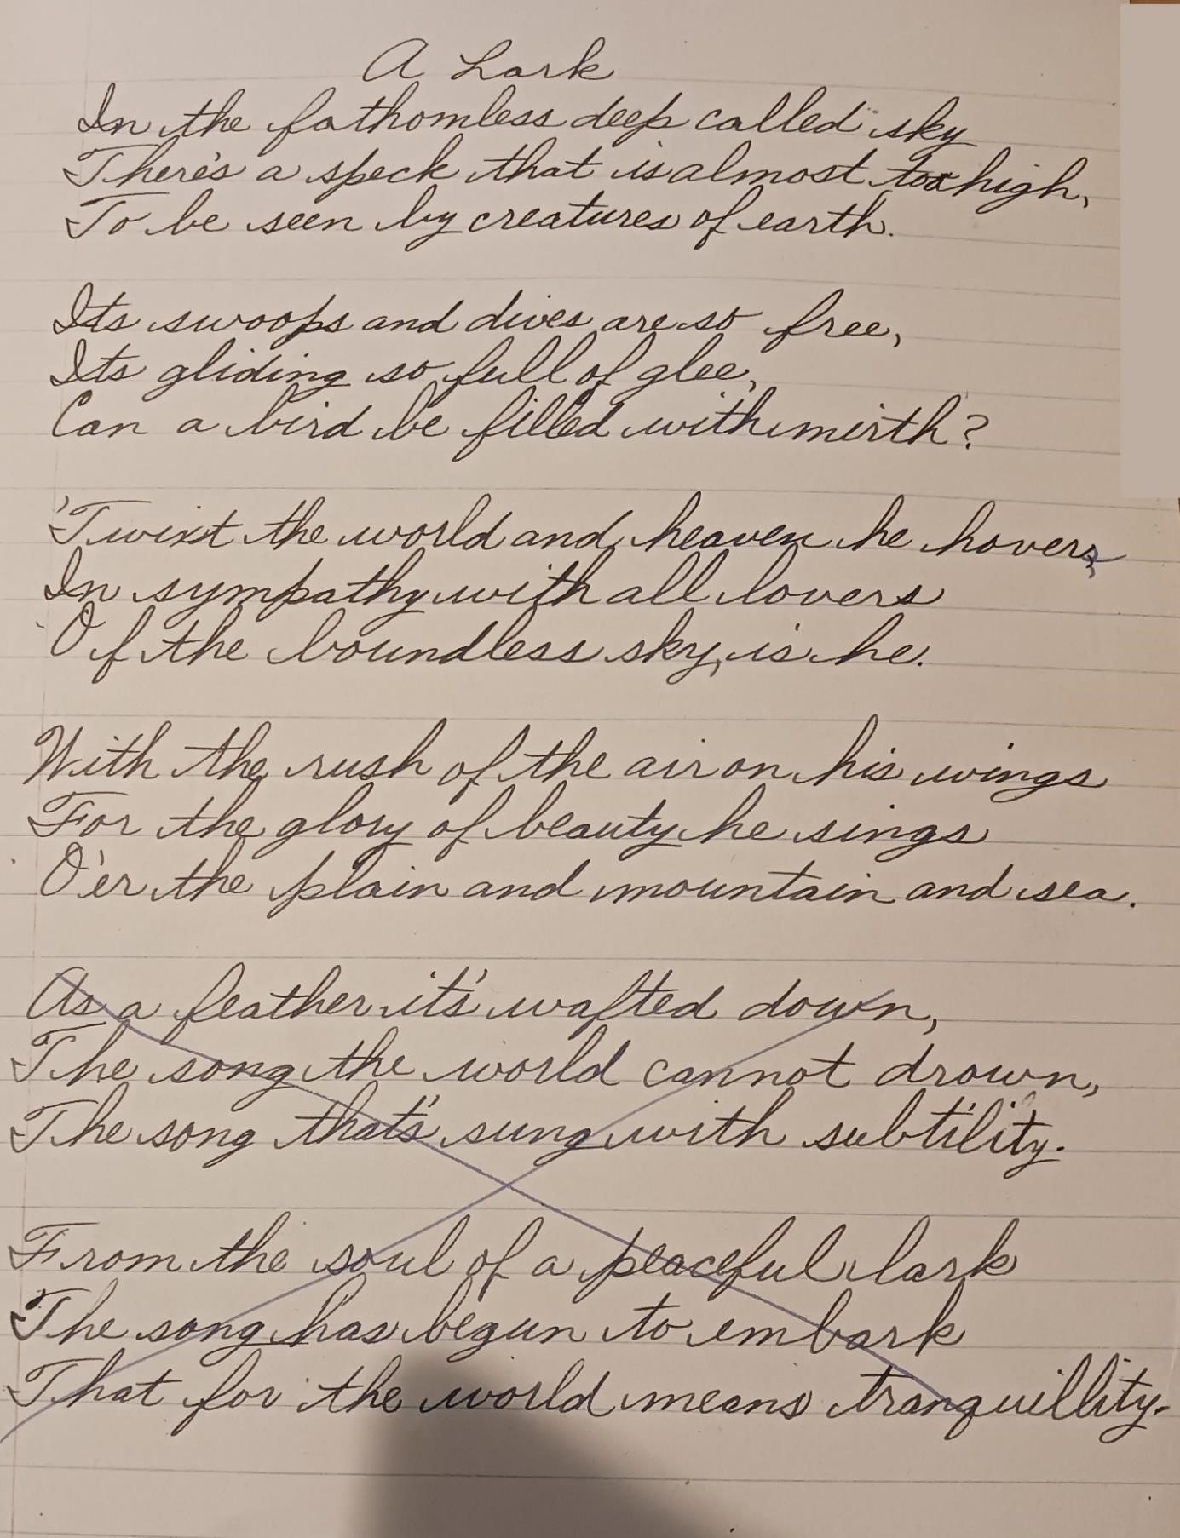
Contents

Poems from

High School
(“In Rhyme”)
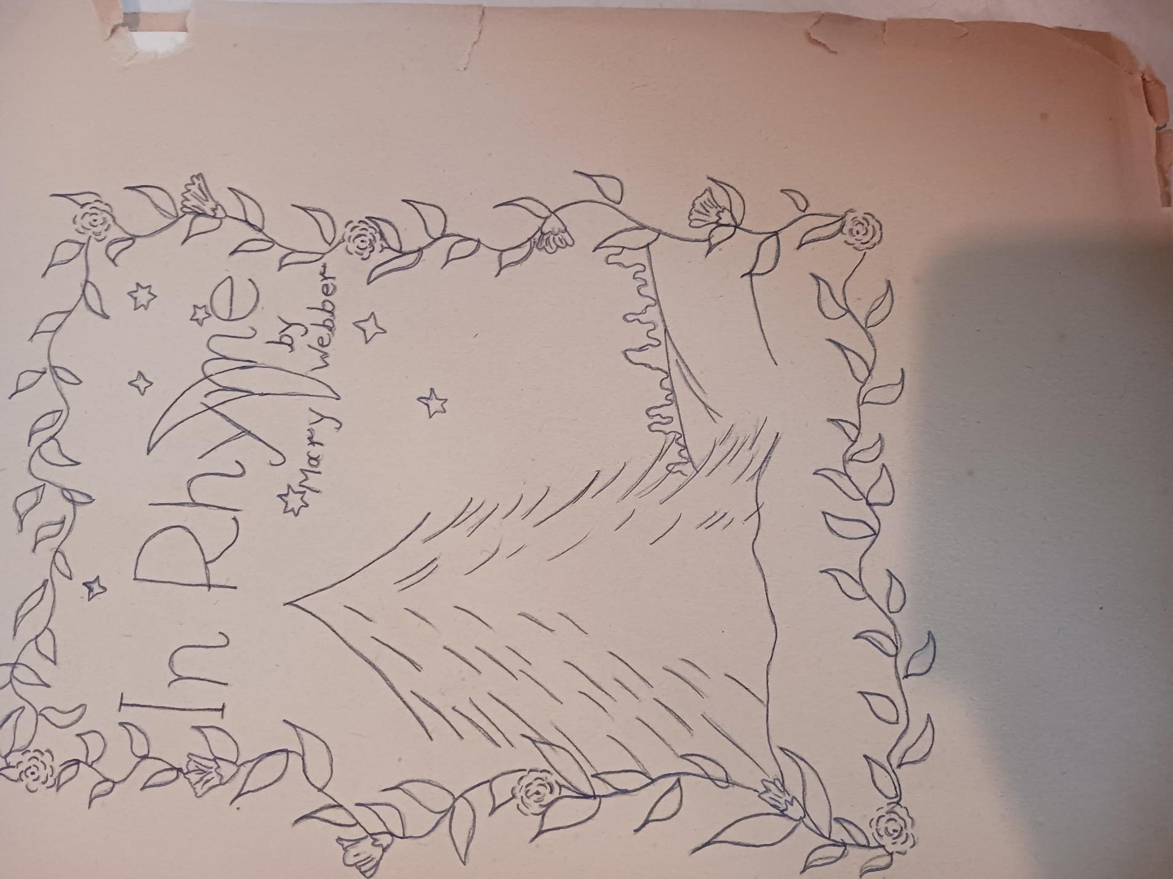

Prophecy of a Cloud
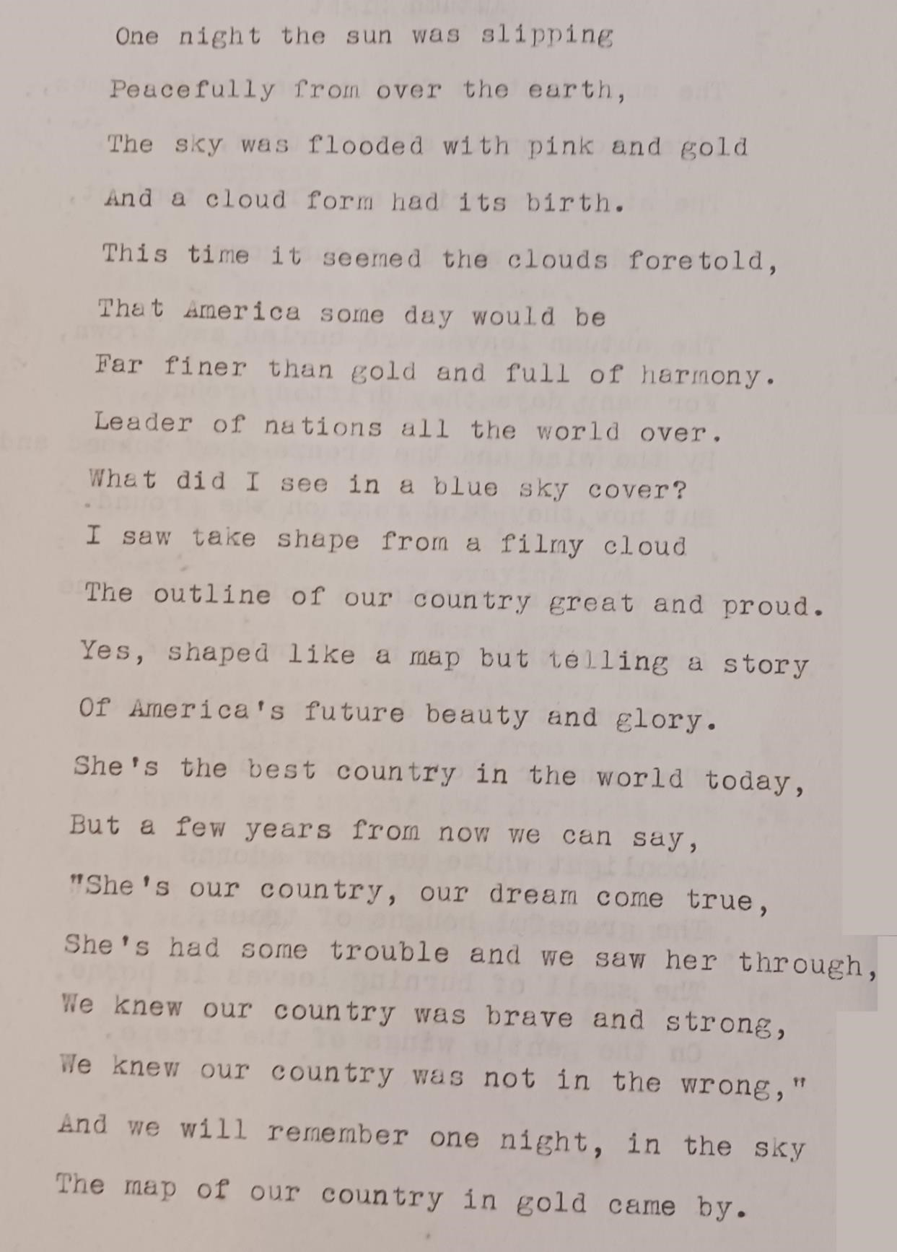
Contents

Autumn Night
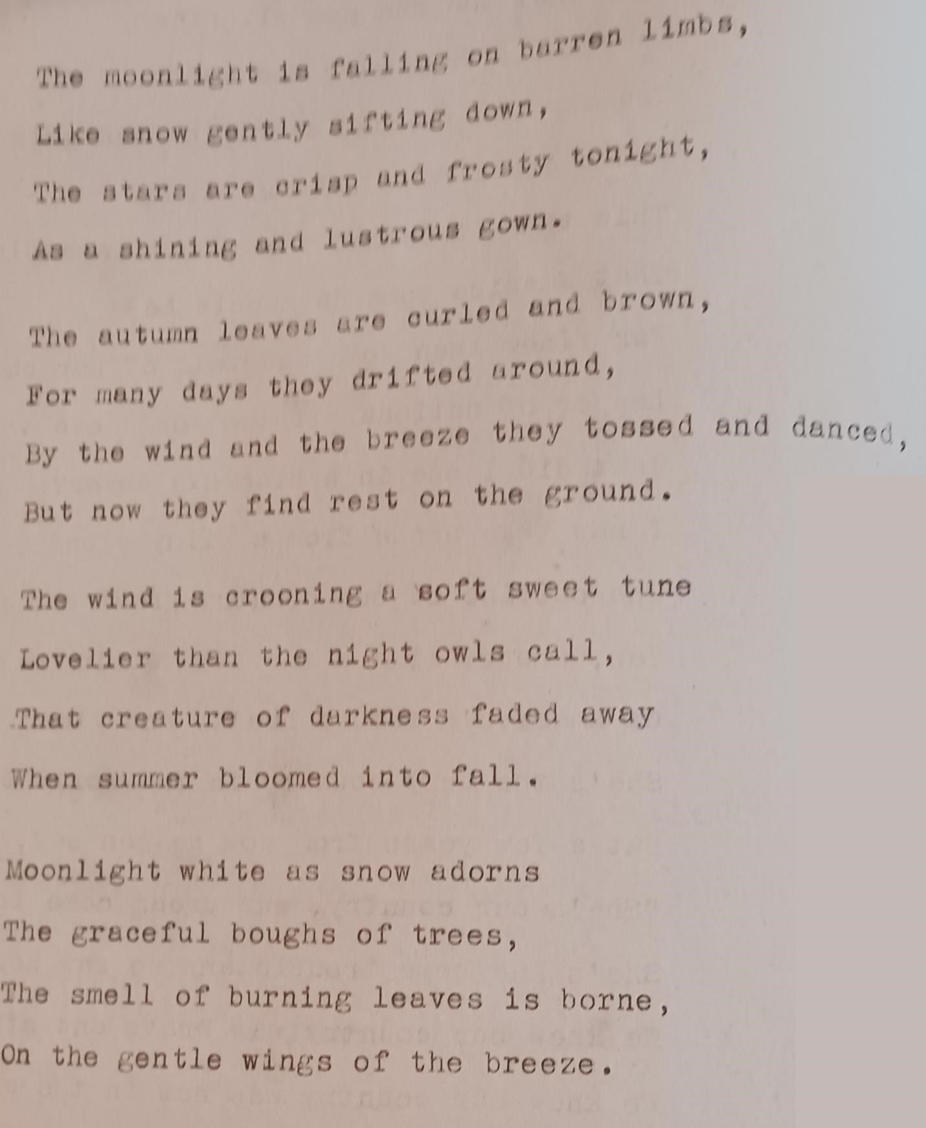
Contents

A Spruce Before Dawn
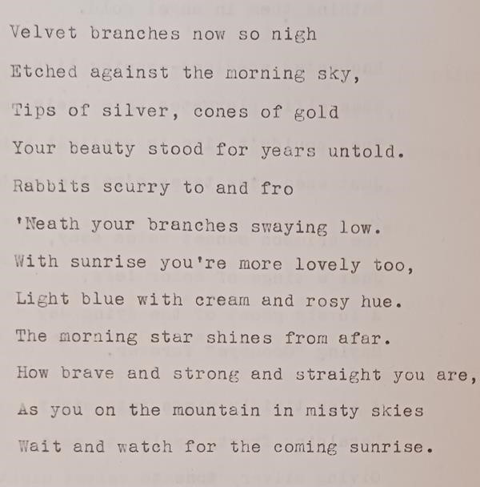
Contents

Coming of the Night
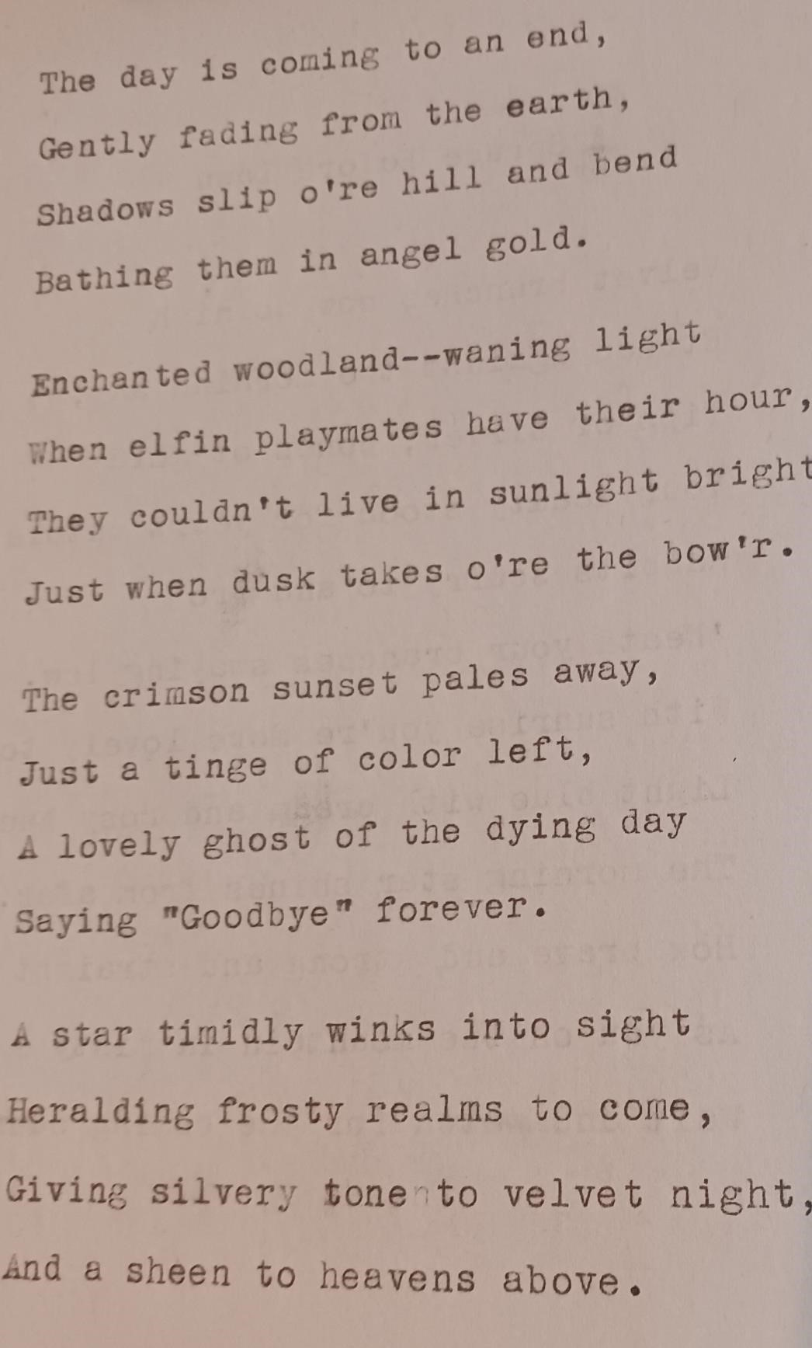
Contents

Flowers of Spring
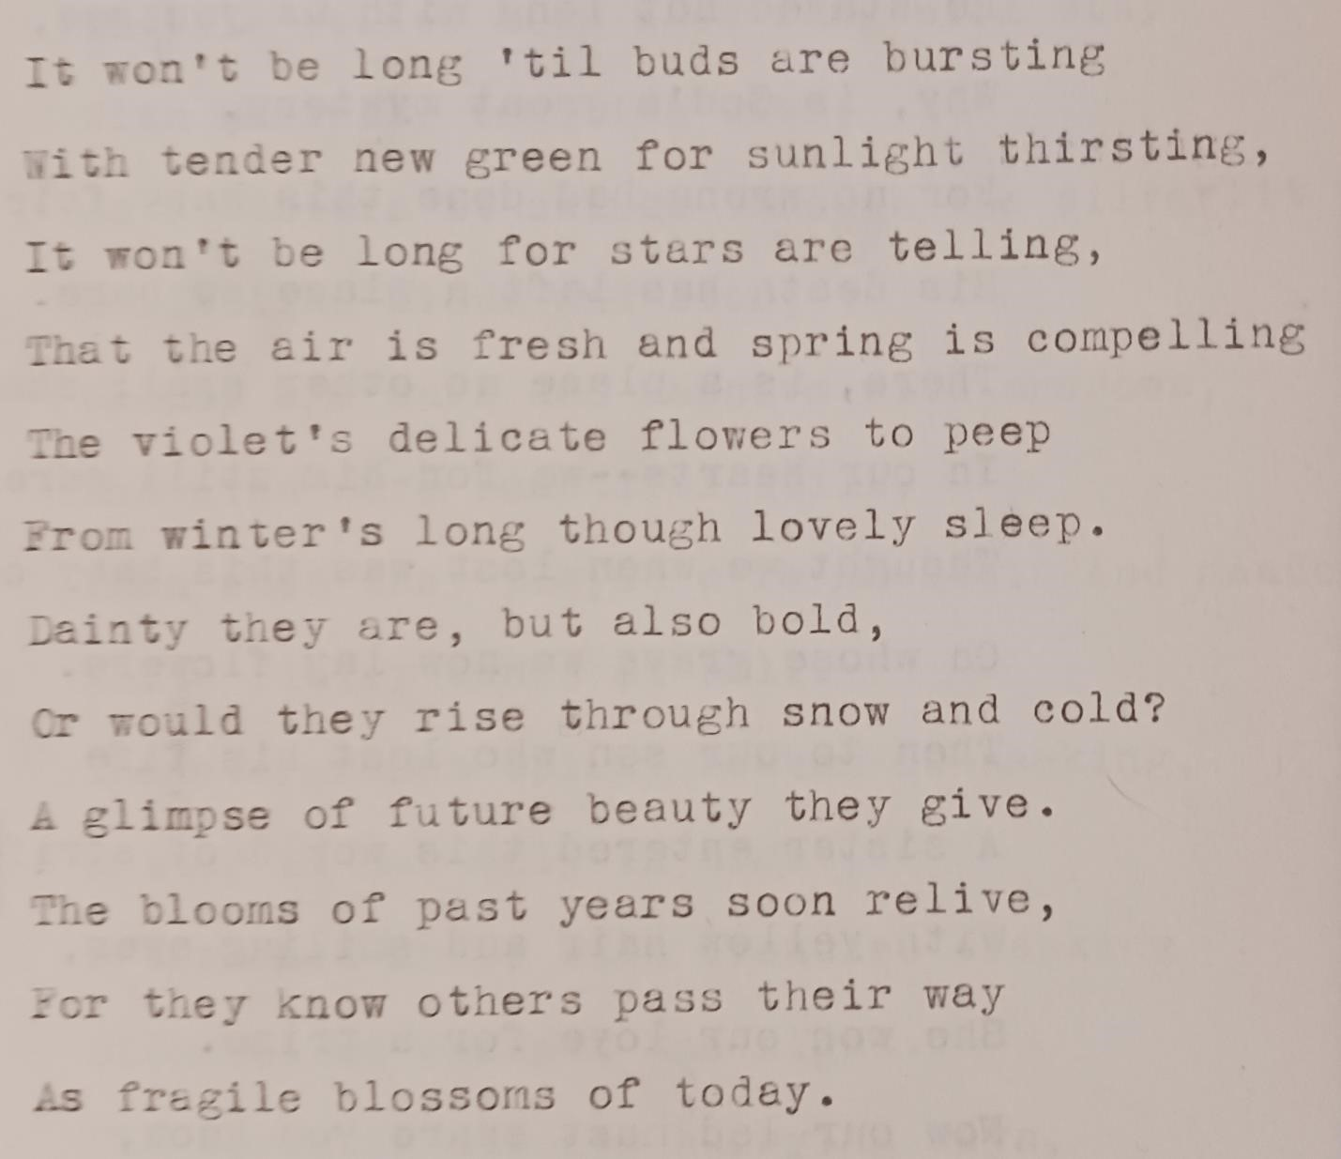
Contents

In Memory of a Baby
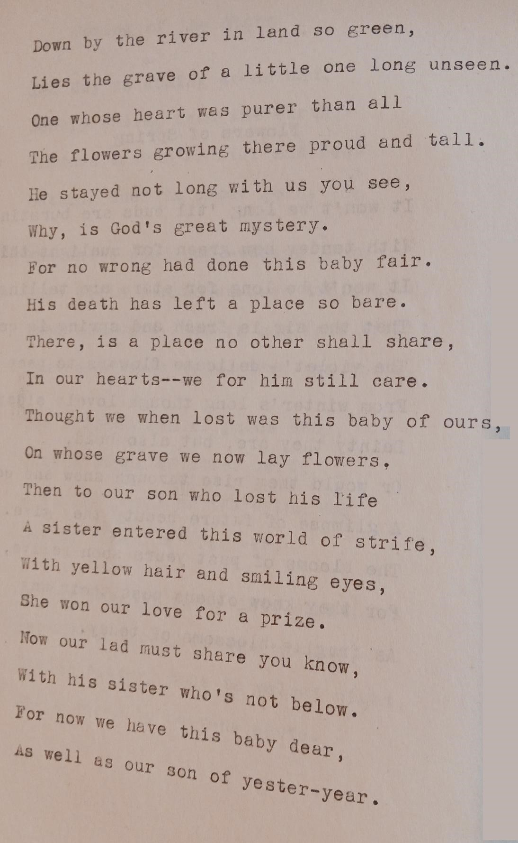
Contents

Night
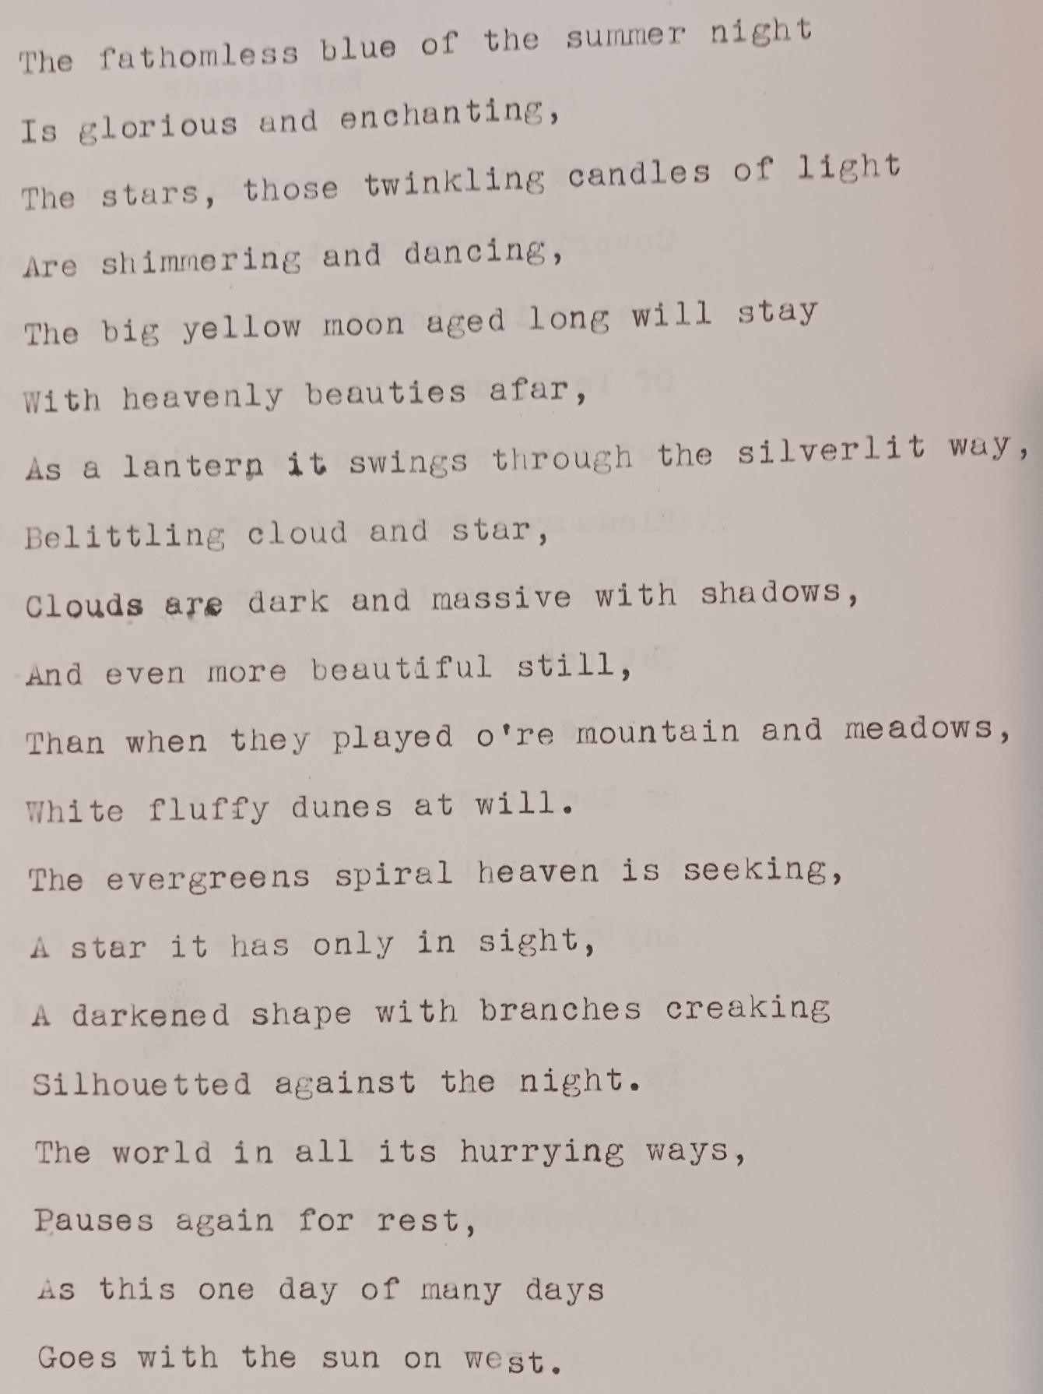
Contents

War Clouds
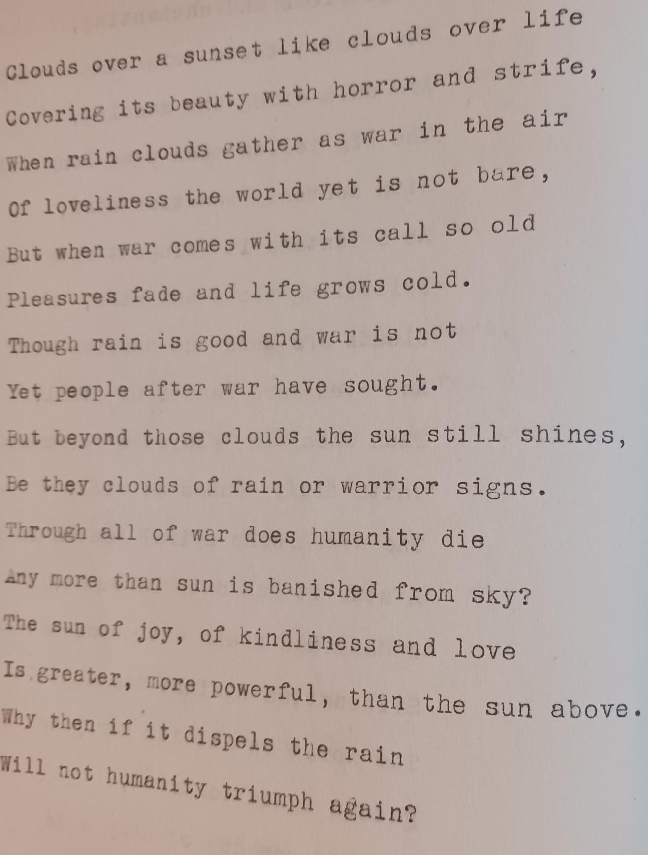
Contents

Where?
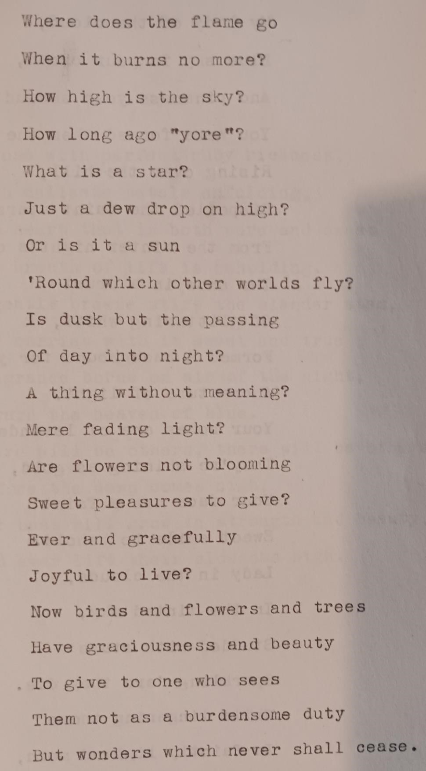
Contents

Lady in the Clouds
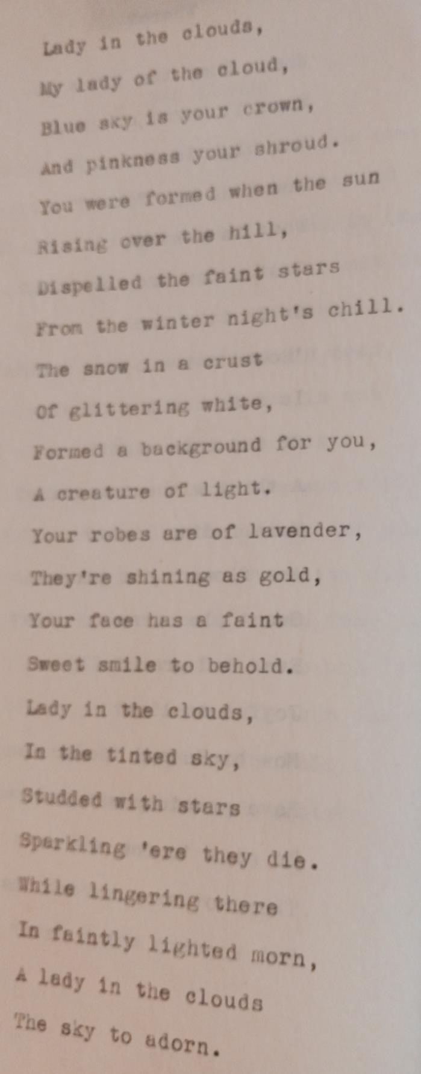
Contents

A Rose
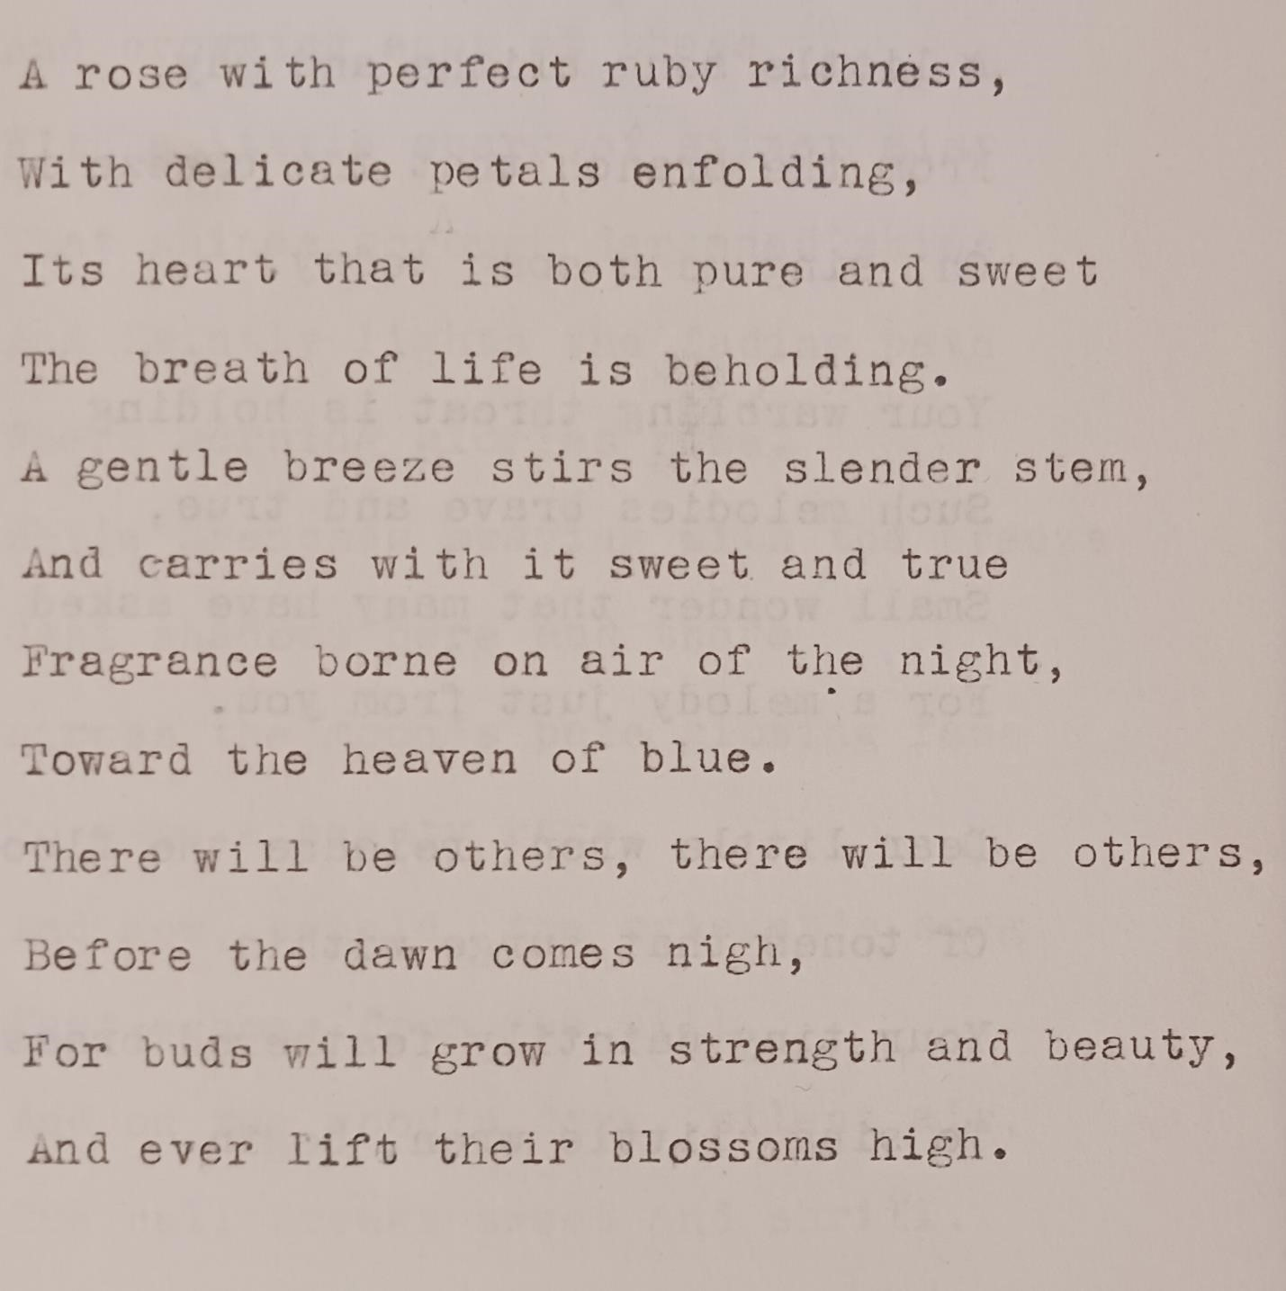
Contents

Sing

Sing me a song of the morning,
A little song blithe and gay,
From the branch that the breeze is swaying,
Oh, sing me a song today.

Your warbling throat is holding
Such melodies brave and true,
Small wonder that many have asked
For a melody just from you.
Dear little wren, release the flood
Of tones that surge within
Your tiny daintily feathered breast,
To sing, little wren, begin.
Contents

Woodland Midnight
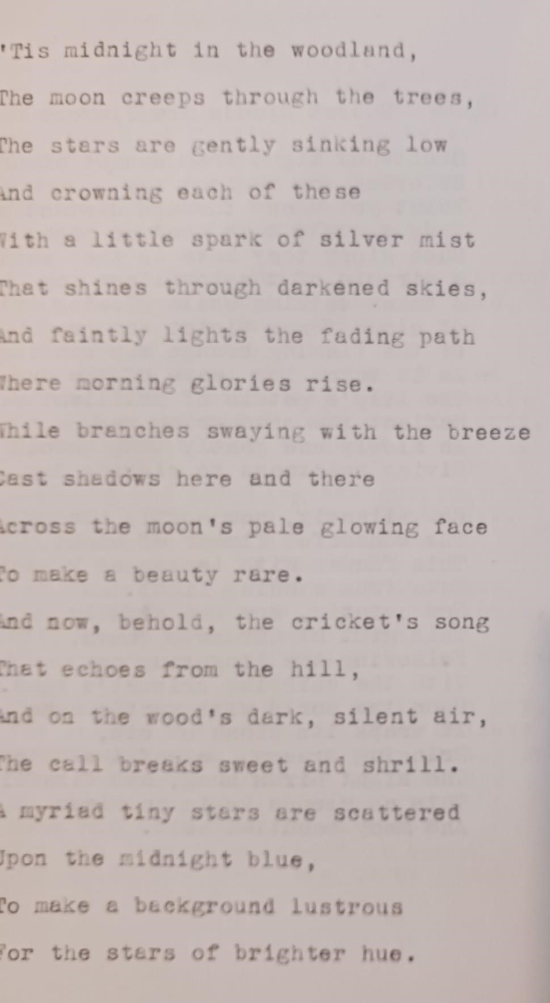
Contents

Sunset Clouds are Flowers
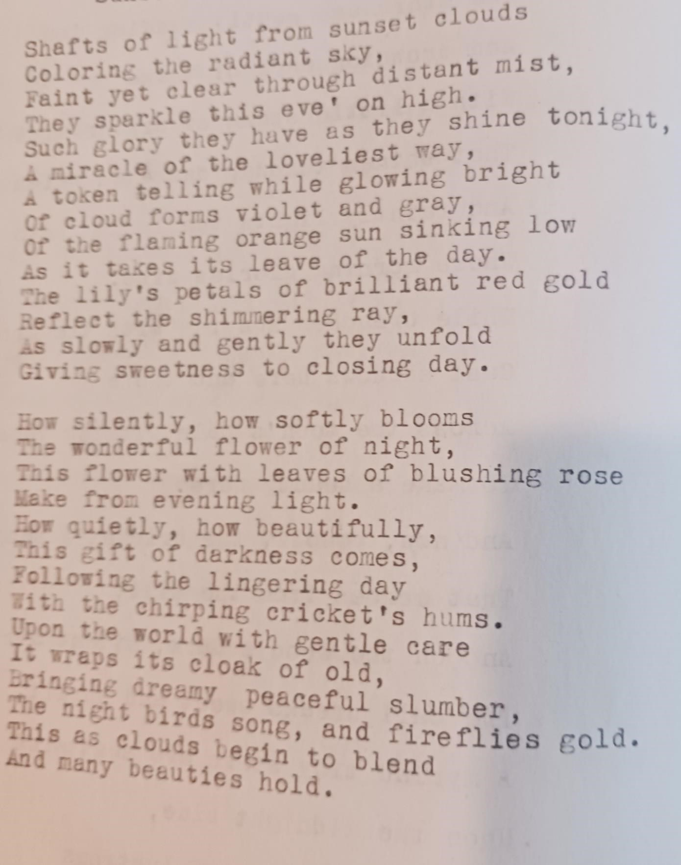Contents

Make Believe Land
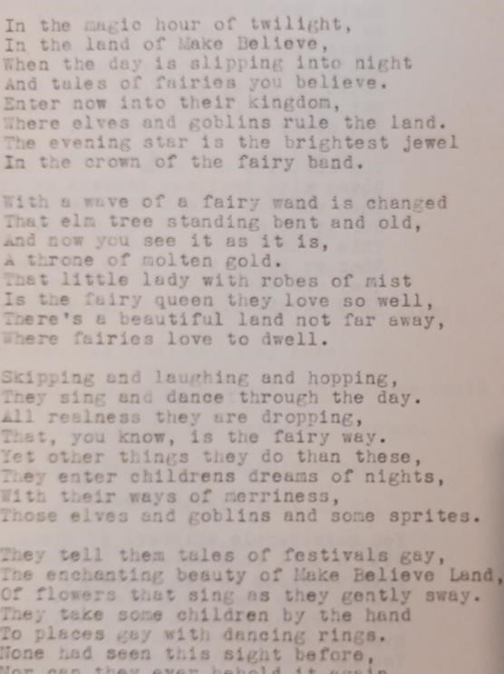
(continued)
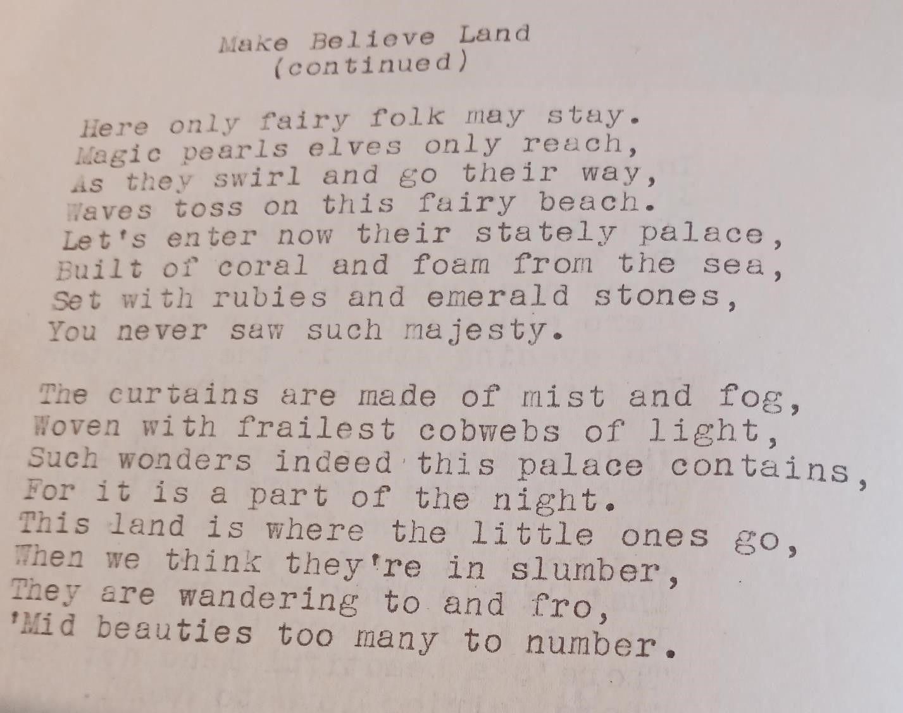Contents

To A Sunset
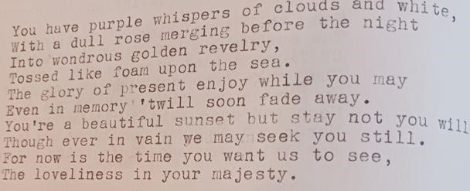Contents

The Christmas Baby
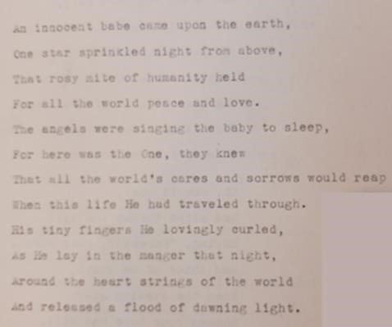
Contents

Farewell to Earth
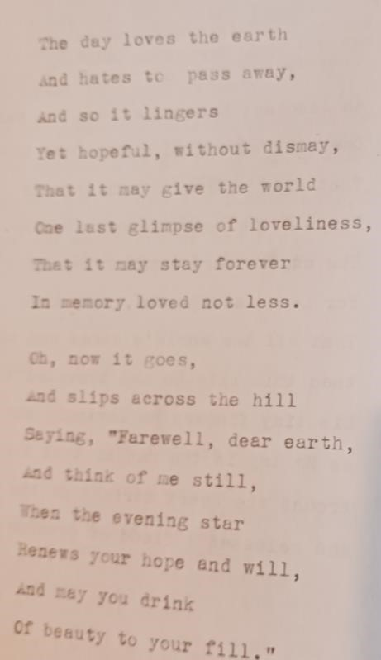
Contents

Starlight
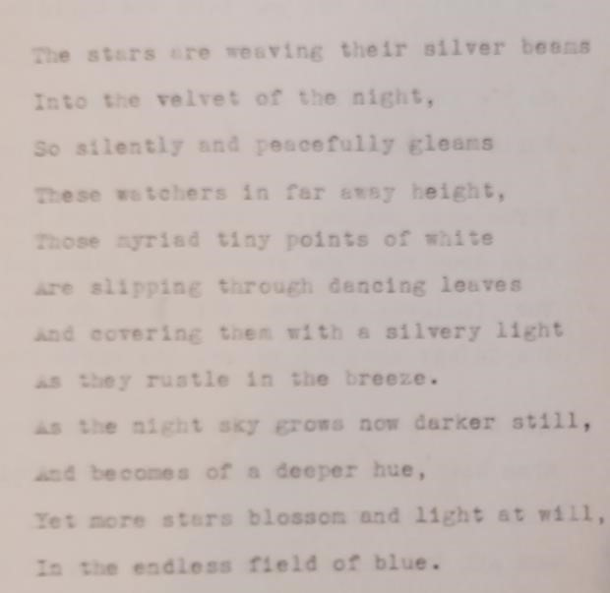
Contents

The Christmas Story

One night long ago was born the Christmas story,
How a baby King had for his throne of glory
Only a manger with straw for a bed,
While radiance shone as a crown from His head.

Three wise men were watching a light far away,
When down from the star cane a faint golden ray,
They followed the star this baby to see
The Infant that was to set the world free.

Shepherds were watching their flocks as they grazed,
When down came a host of angels and praised
This new born Son so tender and sweet,
And all the world’s pow’r they laid at His feet.
Contents

Published High School
Poems

Your Choice?

Which would you choose to be,
A granite statue having ageless beauty
perfect in form and line,
A flawless masterpiece preserved for time,
An image carved from faultless stone
With artistry of taste and tone,
Immortal? Never having known
A mortal body made of flesh and bone?
Or would you rather than a statue, be
One humble part of vast humanity,
Aglow and vibrant for one living hour,
To die ere wisdom had begun to flower?
Would you exchange a senseless perfectness
For one brief moment of imperfect bliss,
And promise vague but sweet that more will be
When all of life’s dear pleasures turn and flee?

Mary Webber –Lincoln H.S., Nebraska

Published in:
Young America Sings
1945 Anthology of Northwest States High School Poetry
National High School Poetry Association
p. 30
Contents

Spokesman
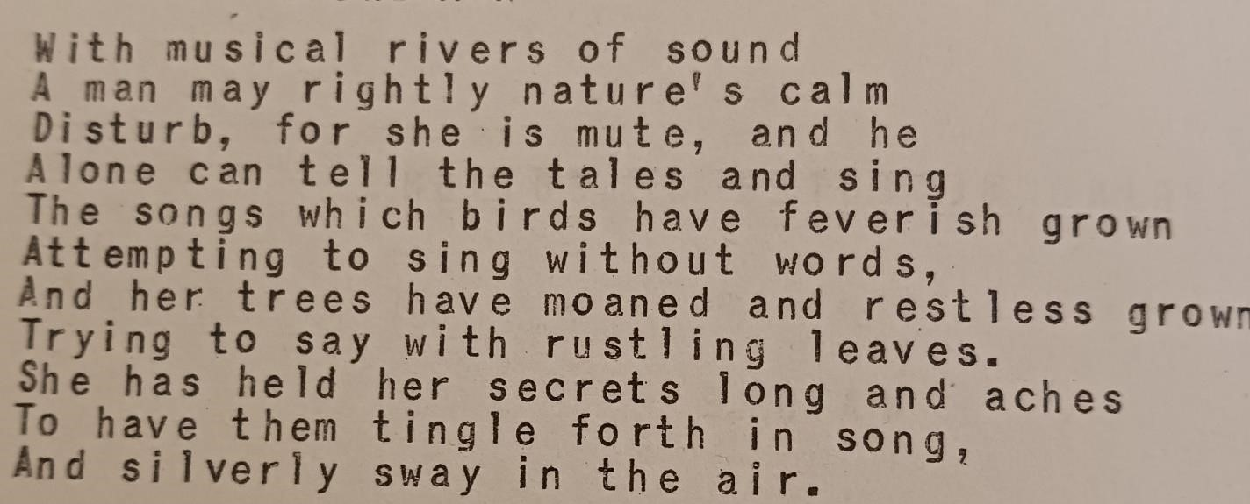
Mary Webber –Lincoln H.S., Nebraska

Published in:
Youth Sings
Poetry Society of America 1945 p. 100

Reprinted in:
Young America Sings
1945 Anthology of Northwest States High School Poetry National High School Poetry Association
p. 62
Contents

A Poet’s Prayer
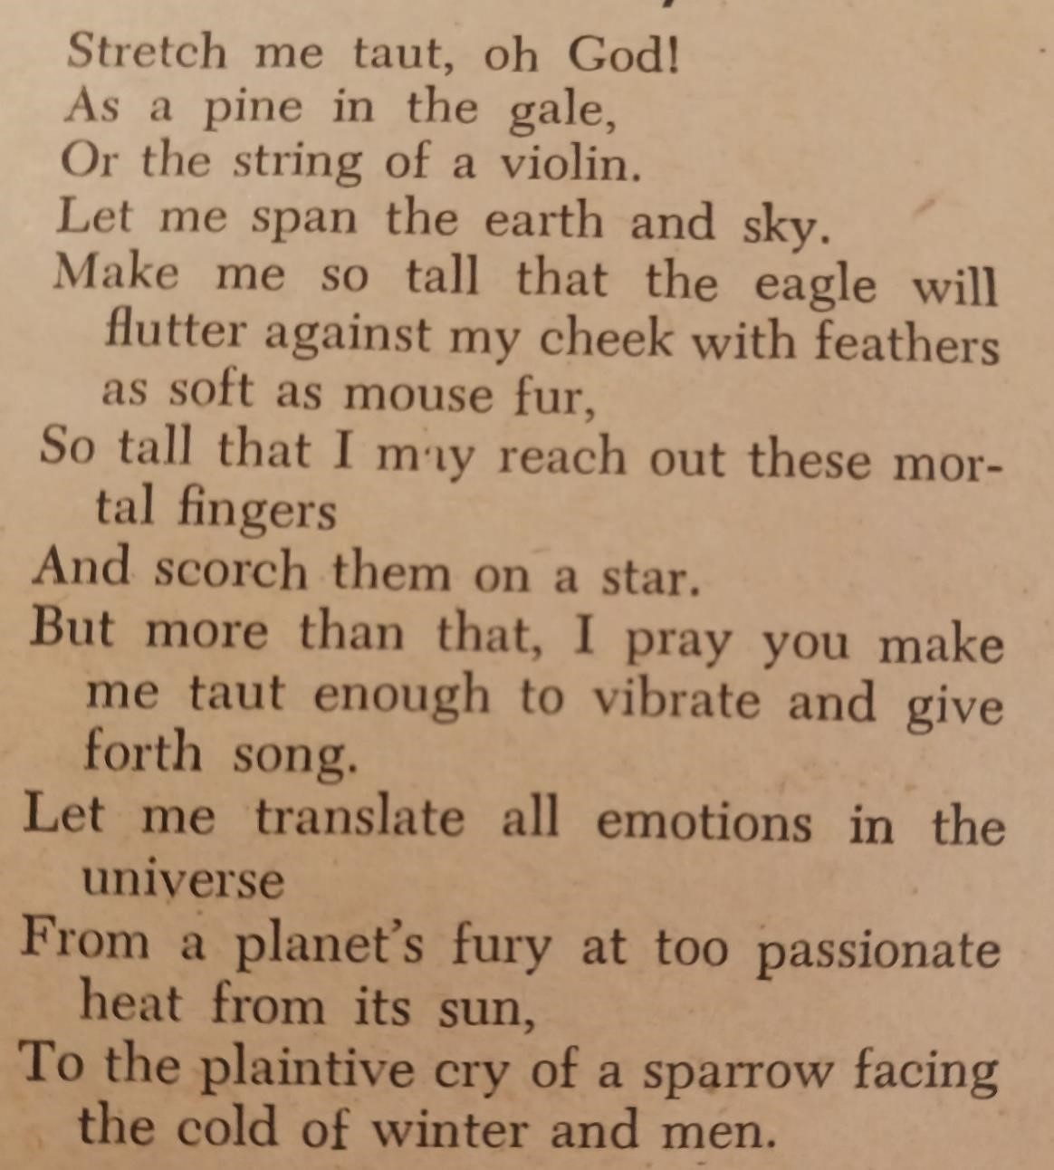
Mary Webber 16
Lincoln H.S., Nebraska
Teacher, Belle Farman

Published in:
Senior Scholastic
May 20, 1946 VOL. 48 No. 16 p.11
Contents

To Mother Eve
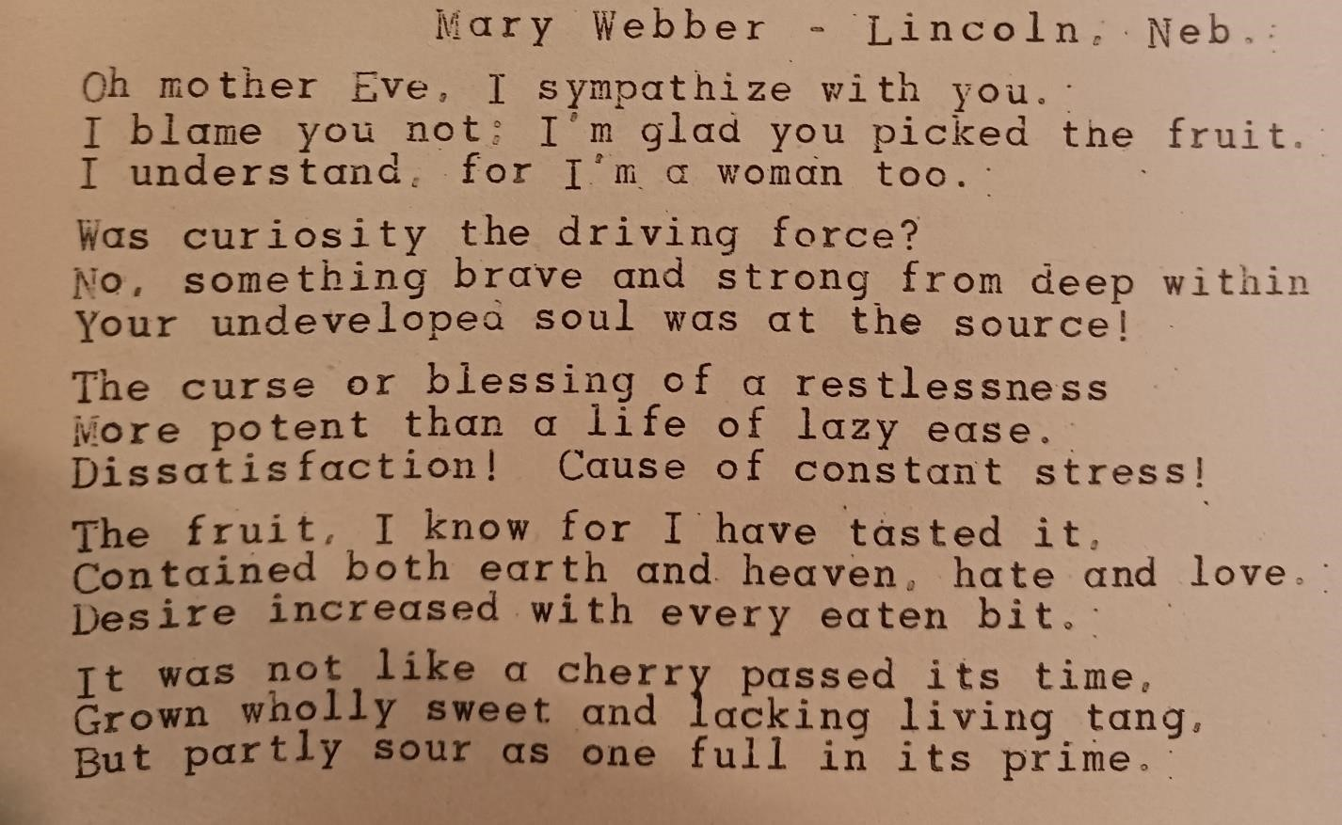
Published in:
Songs of Youth: A National Anthology Poetry Society of America 1946 p. 79
Contents

More from Mary Webber
(published)

Directions for House Building
By Mary Webber
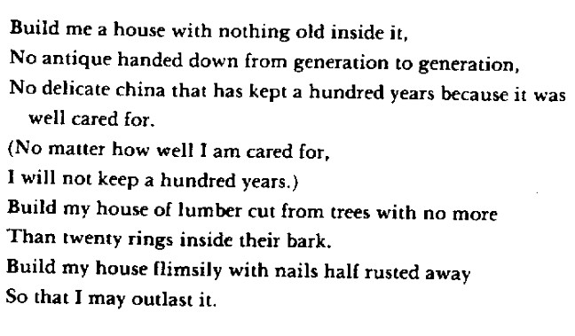
Published in Driftwind,
A Magazine of Verse
Summer 1949
p. 297
Reprinted in “A Will Windward”
Contents

Teacup
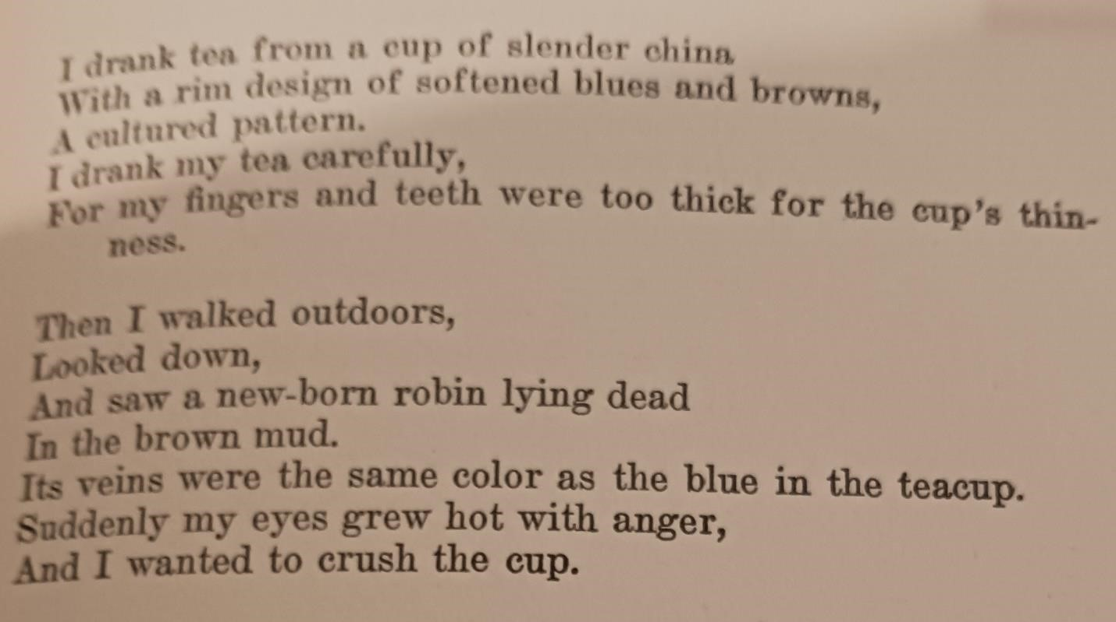
Mary Webber

Published in Poet Lore
World Literature and the Drama
Summer 1950
Volume LVI number 2
p. 181
Contents

Water Whimsies

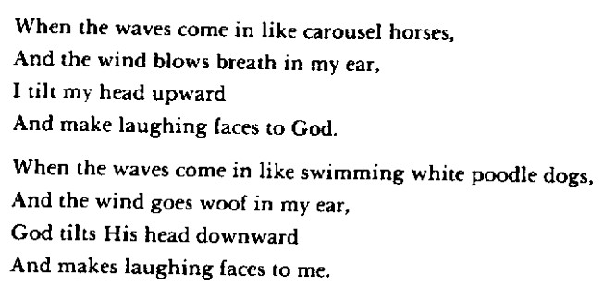
Mary Webber

Published in Poet Lore
World Literature and the Drama
Summer 1950
Volume LVI number 2
p. 181
Reprinted in “A Will Windward”
Contents

Spring Fever
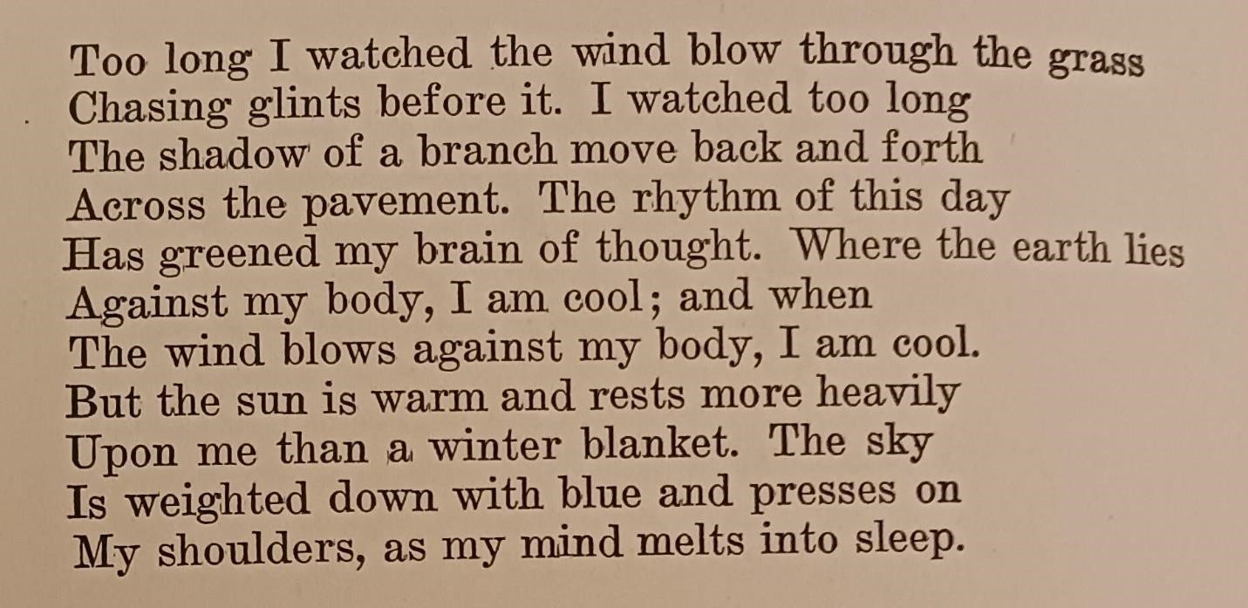
Mary Webber

Published in Poet Lore
World Literature and the Drama
Summer 1950
Volume LVI number 2
Contents

Sonnet to Someone Young

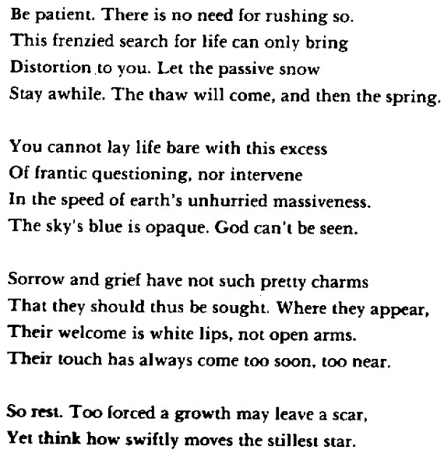
Mary Webber

Published in Poet Lore
World Literature and the Drama
Summer 1950
Volume LVI number 2
Reprinted in “A Will Windward”
Contents

Look Well at this Fair Hostess, Friends

Look well at this fair hostess, friends.
You step into a bandbox here.
Symmetric, how she’s used the space
Modest of course, but nice antiques ---
And if a thread were out of place
You’d hear of her distress for weeks ---
Look well at this fair hostess, friends.
I like Eudora, but … there’s that capacity
She has for tense intolerance, that shar[ sweetness
She has in speaking … animate vivacity
Trained in the condemnation of trite cases :
What someone said to someone,
Who’s having an affair,
What’s nice and not nice, neighborhood disgraces …
Some greasy foreigner moved next door.
Mess all around, it simply shows …
Revolting book, some Communist source,
Though I suppose
It’s true enough how Negroes live ---
Oh, keep them in their place, of course ---

(continued)

Eudora has a tenant
Too huge for this small building that’s her home.
A subterranean shape, a thrashing form
Cramped down to fit the maxims she calls Thought
(I always say … why, everybody knows!)
In straining conflict with the littleness,
The limitedness,
The trampling rut of all that she’s been taught ---
Her life’s not right;
Attack! Attack! The cleaning and the polishing,
Her outside work, habitual volunteer’s
Hospital hours ---
Eudora’s thin. She’s verged on serious breakdown
Many years.
’
Mary Webber

Published in Poet Lore
World Literature and the Drama
Summer 1950
Volume LVI number 2
Contents

Poetry from

Early Married Years
Mary Tookey

Early Thirties
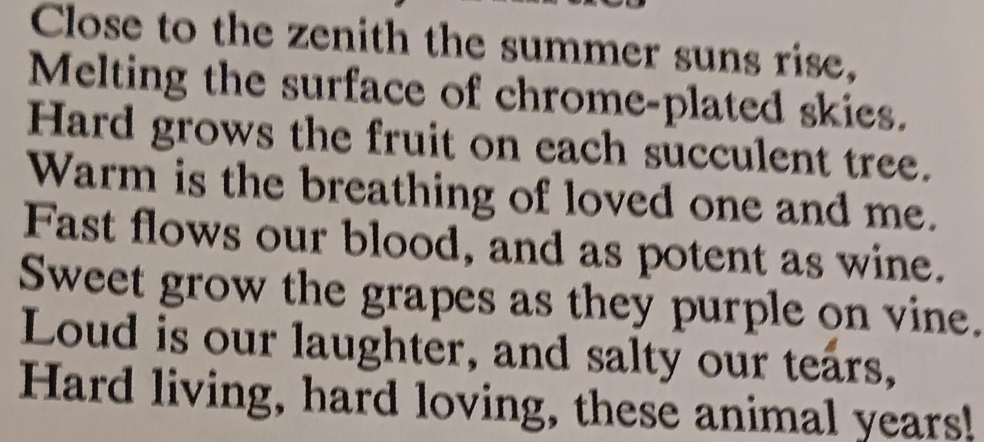
Mary Tookey

Published in:
The American Bard
Vol 13 no 11 July-Sept 1958
Contents

Sympathy
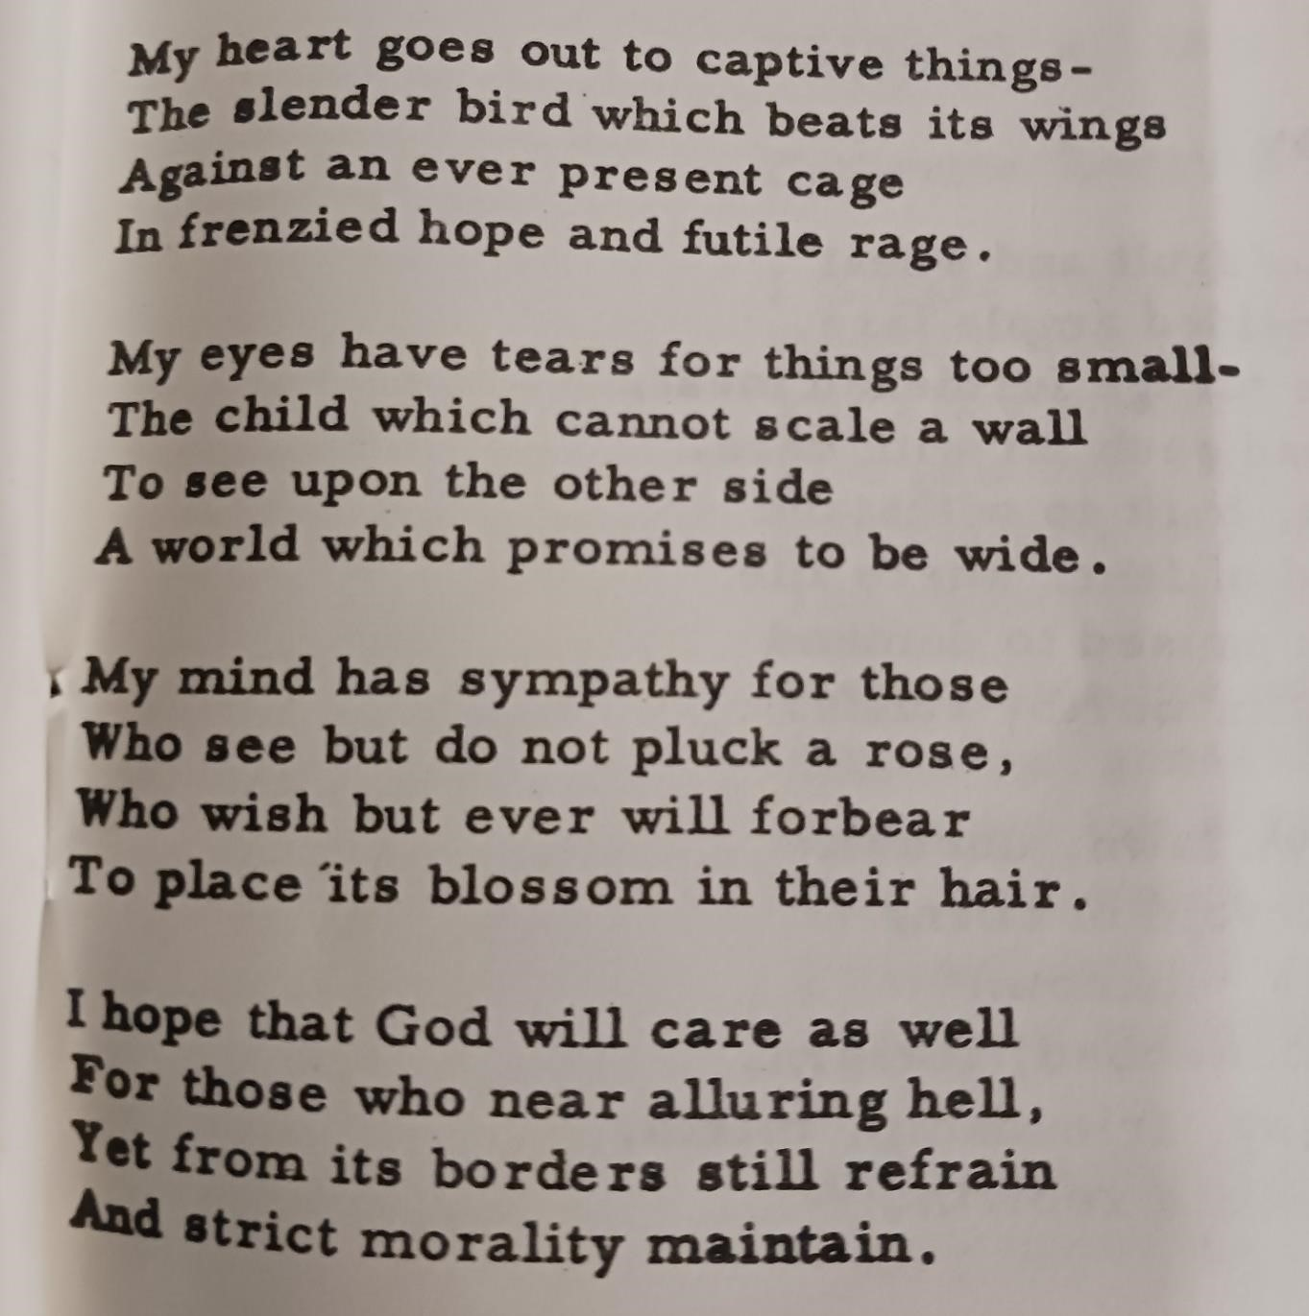
Mary Tookey

Published in:
Poetry Digest
Vol 5 no 4
Nov 1959
p. 37
Contents

Woven
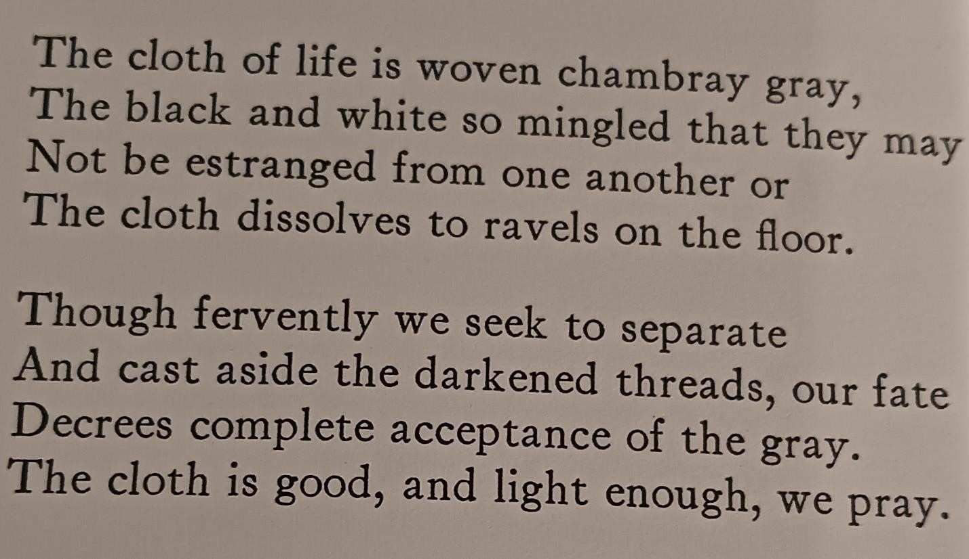
Mary Tookey

Published in:
The Lyric
Vol 39 no 4
Fall 1959
p. 87
Contents

Interlude
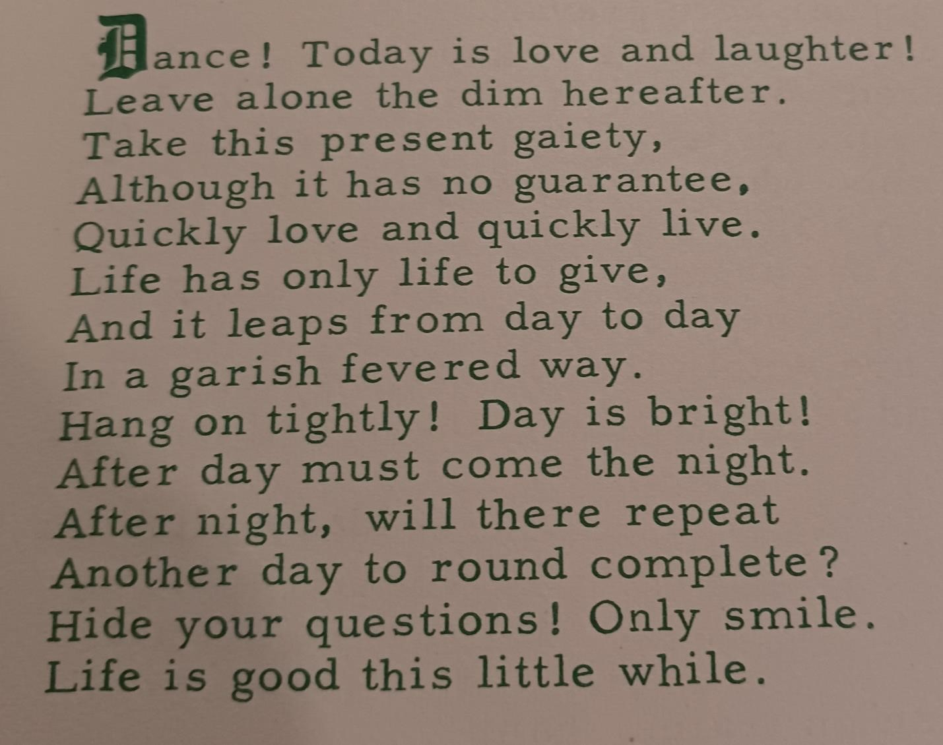
-Mary Tookey

Published in:
Hawkeye Poetry Magazine
Lamoni IA
Vol 5 no. 1 Jan/Feb 1960
Contents

Entire
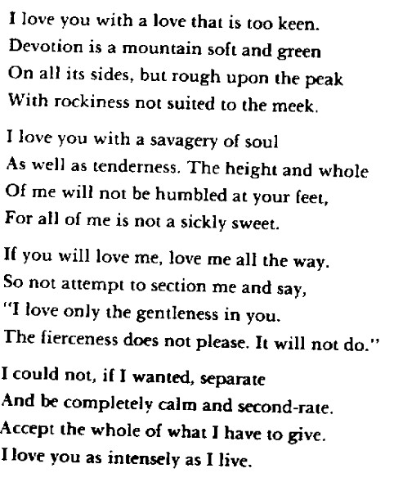
Mary Tookey

Published in:
The American Bard
Vol 14 no 6
Apr-June 1960
Reprinted in “A Will Windward”
Contents

The Sun Shines
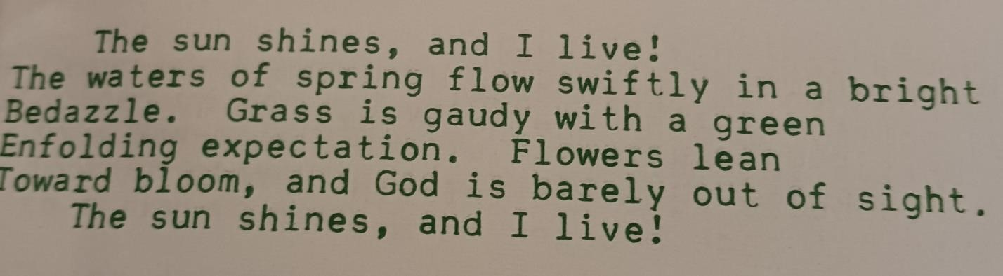
Mary Tookey

Published in:
Caravan
Hawkeye Poetry Magazine Lamoni IA
Vol 5 no 3 May-June 1960
Contents

Rapprochement

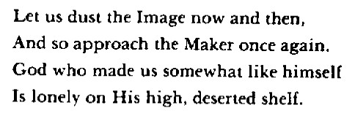
Published in:
The Lyric
Fall 1960
Vol 40 no 4
Fall 1960
Reprinted in “A Will Windward”
Contents

Unwelcome Autumn
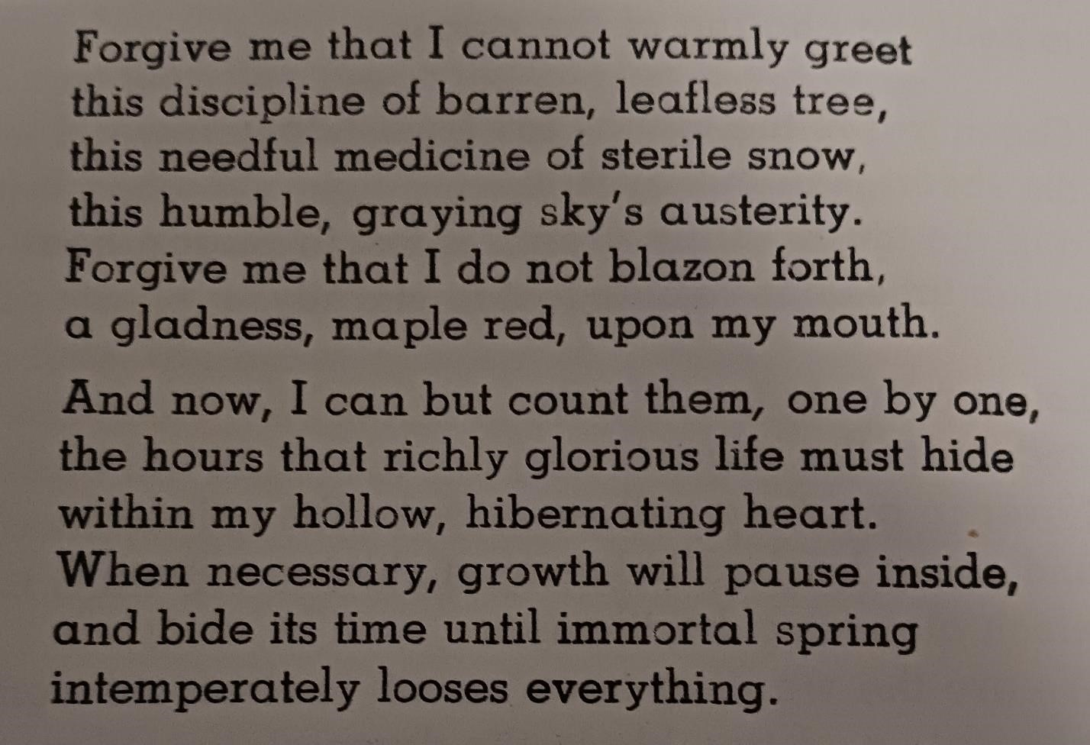
Mary Tookey

Published in:
American Weaver
A Poetry Quarterly
Vol XXV No 2 Autumn 1960
Contents

Oriental Deaths
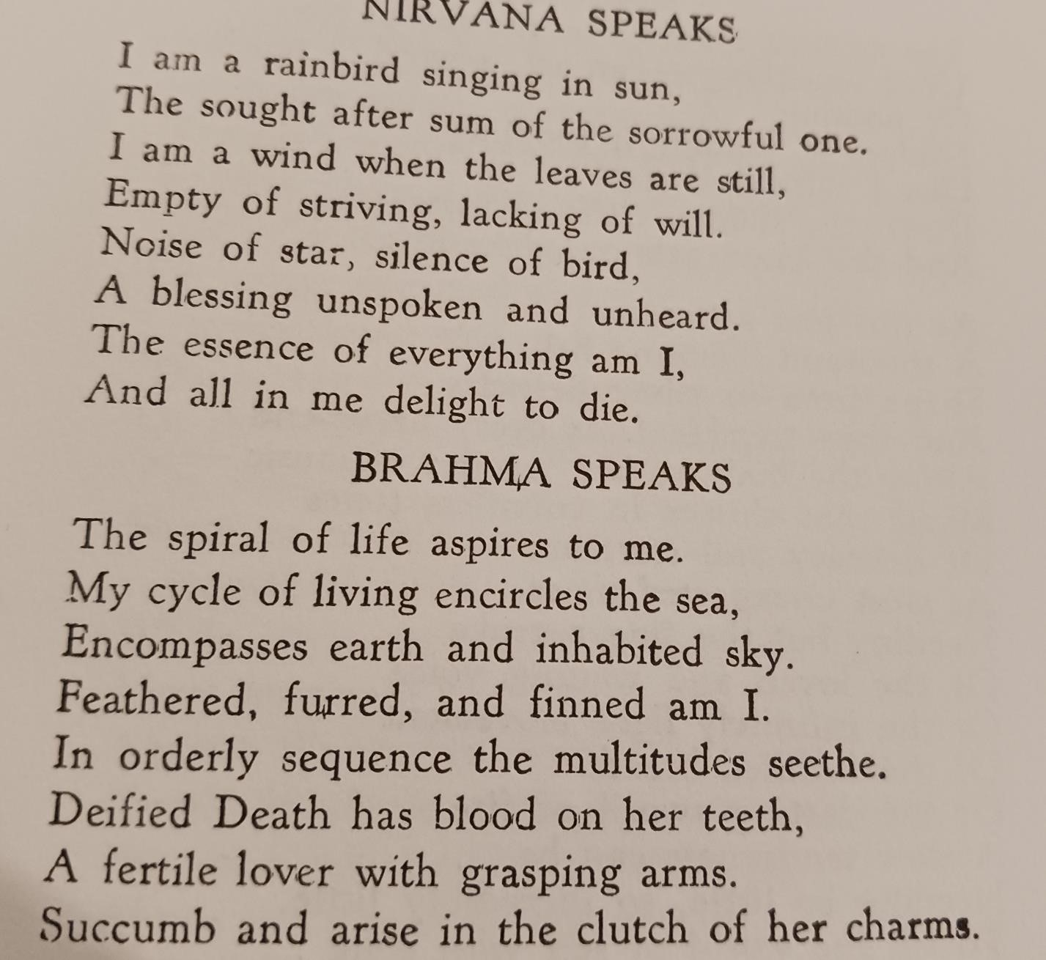
Mary Tookey

Published in:
The American Bard
Vol 14 no 9 Jan-Mar 1961
Contents

In Perfect Sunshine

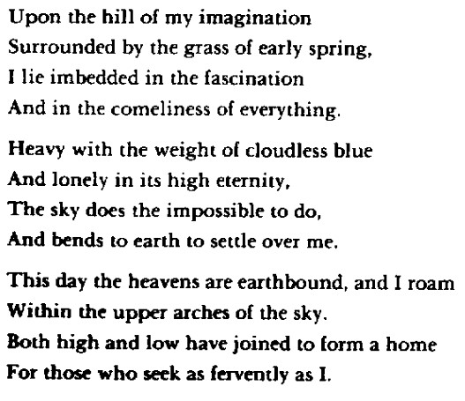
Mary Tookey

Published in:
Caravan
Hawkeye Poetry Magazine Lamoni IA
Vol 6 no 2 Mar-Apr 1960 Reprinted in “A Will Windward”
Contents

Individuality
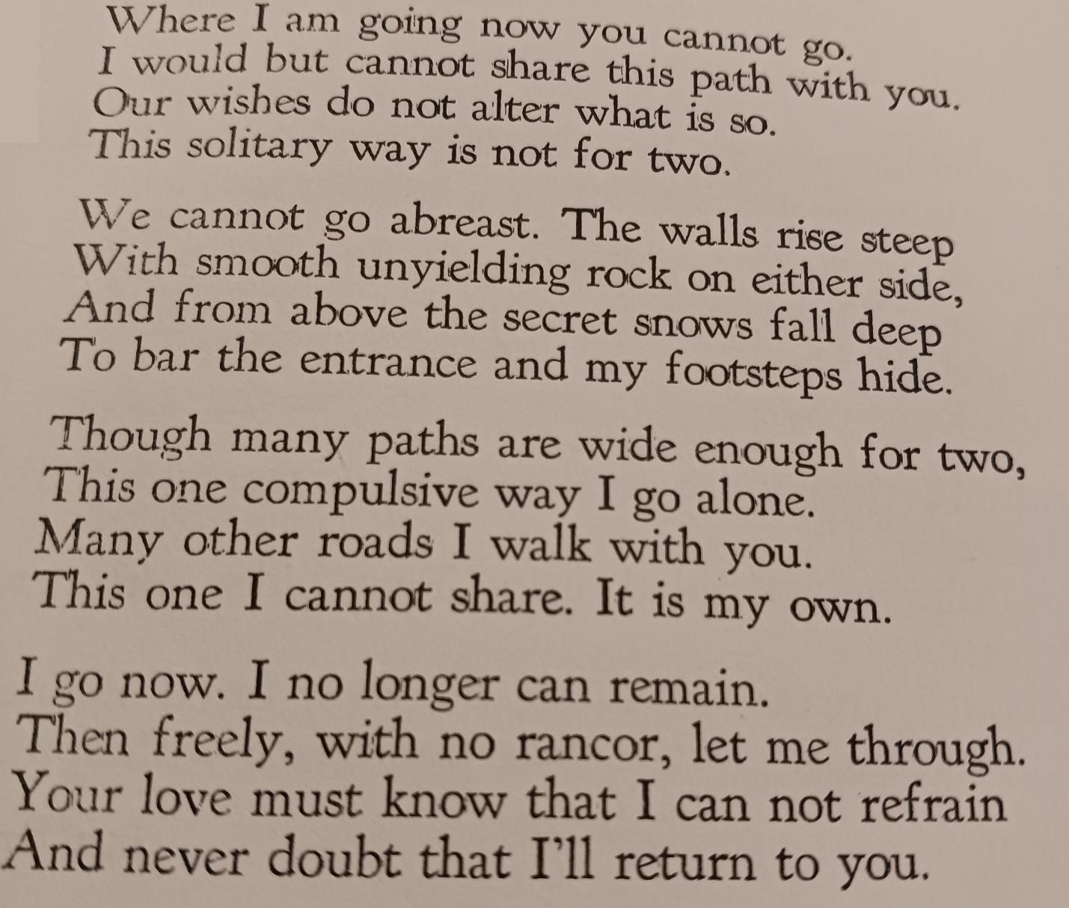
Mary Tookey

Published in:
The American Bard
Vol 14 no 12 Oct-Dec 1961
Contents

The Ultimate Fear
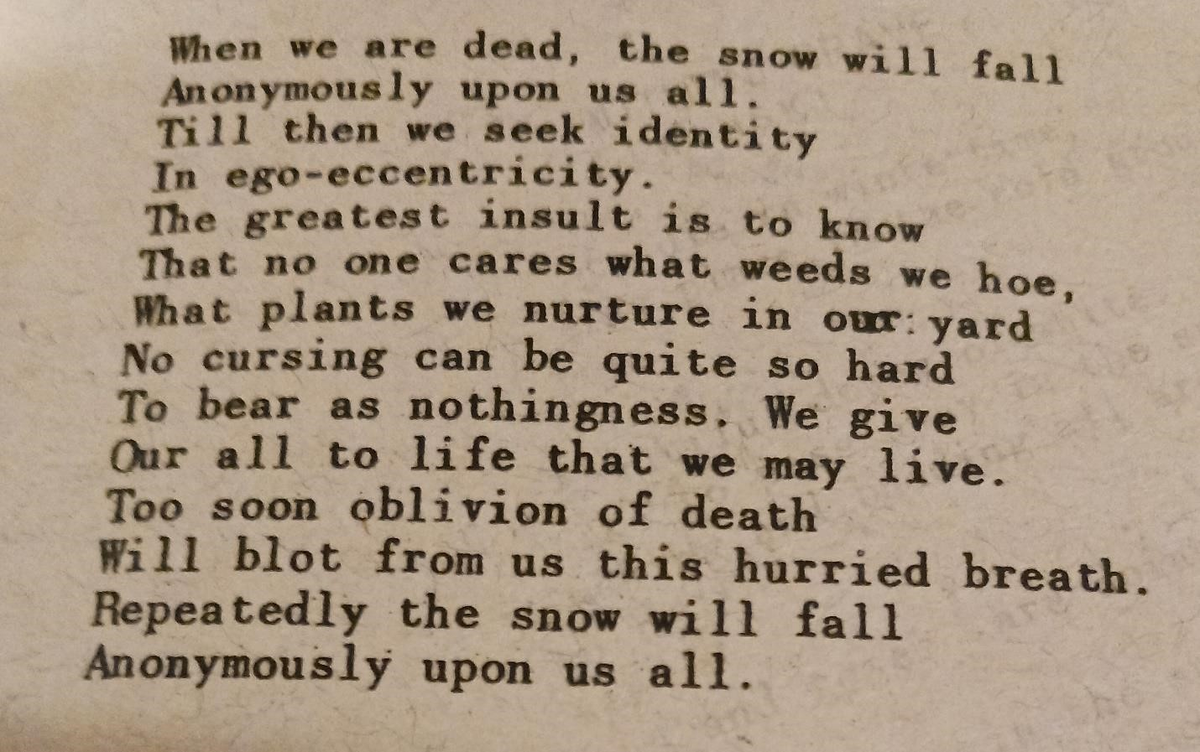
Mary Tookey

Published in:
Scimitar and Song
Vol XXIV No 8 Feb 1962
Contents

Who Are We?
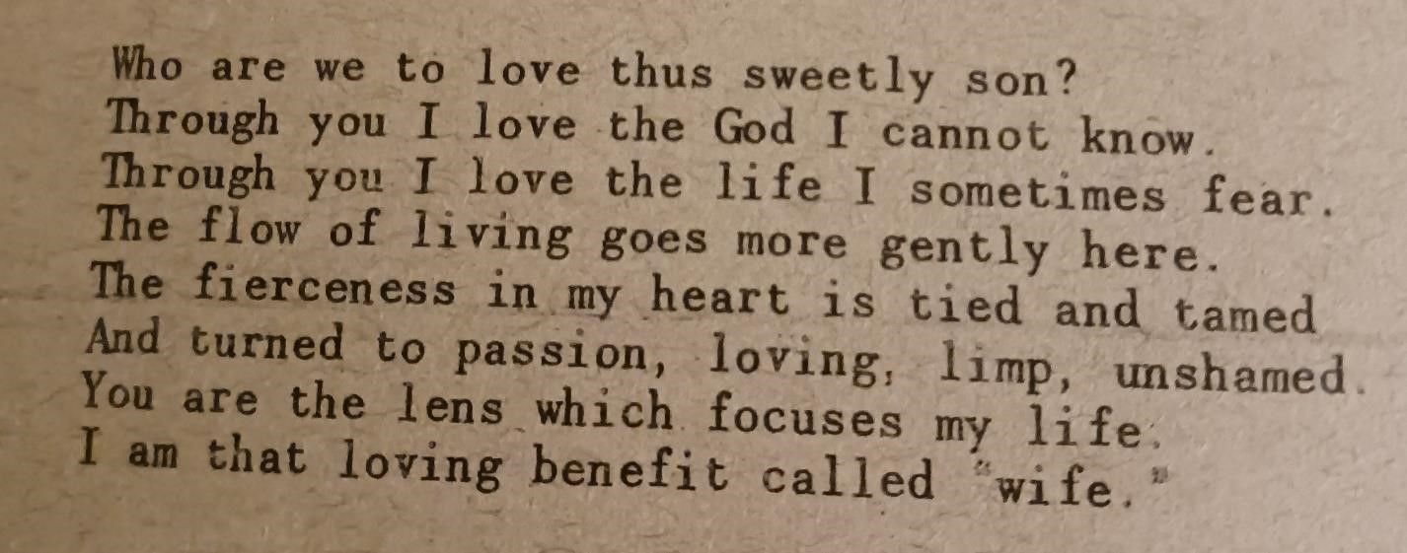
Mary Tookey

Published in:
Scimitar and Song
Vol XXIV No 8
Feb 1962
Contents

Huge Night
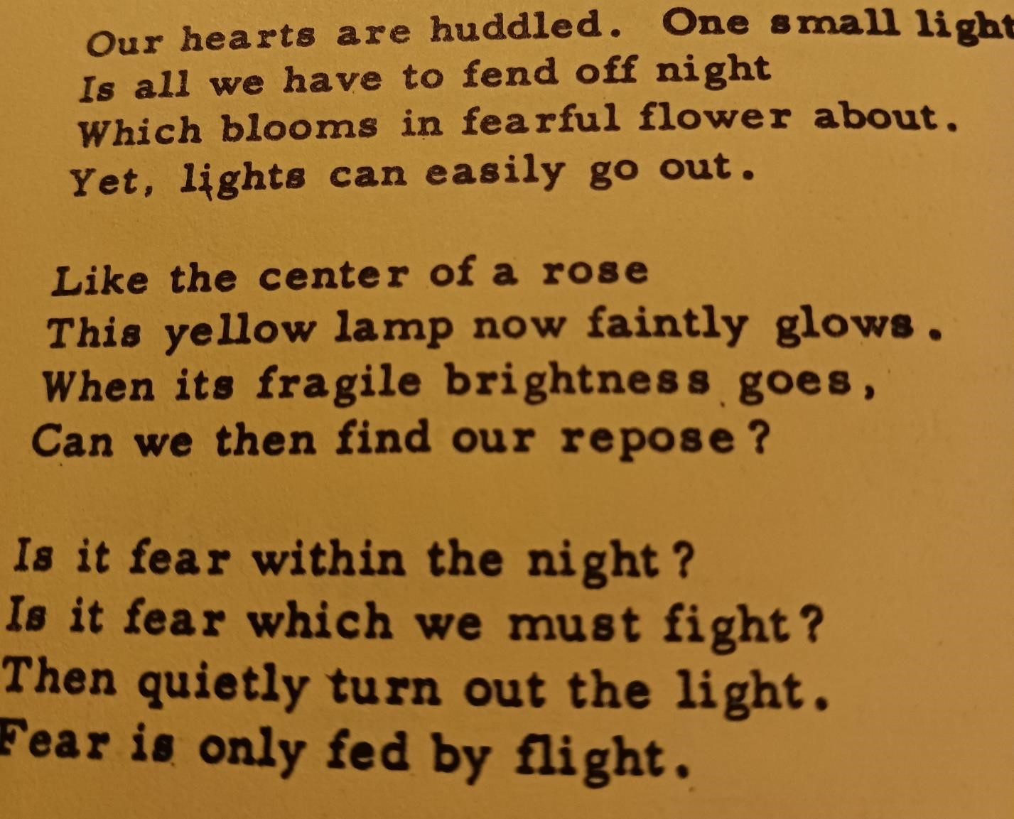
Mary Tookey

Published in:
National Weekly Poetry-Letter
Vol 1 no 2 April 23 1962
Contents

October
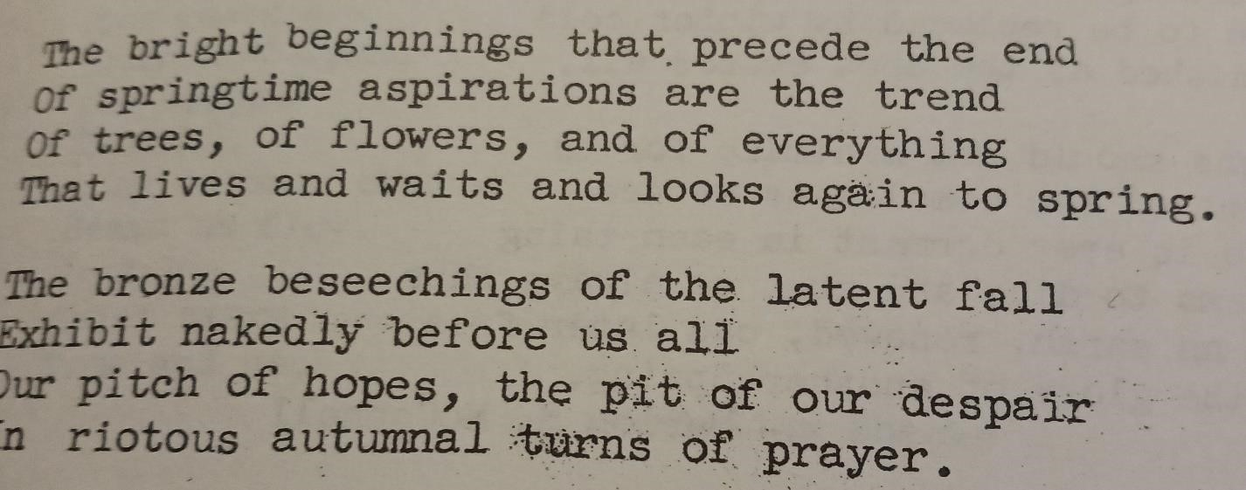
Mary Tookey

Published in:
Caravan
Hawkeye Poetry Magazine
Lamoni IA
Vol 7 no 5 Oct-Apr 1962
Contents

Doubtlessly
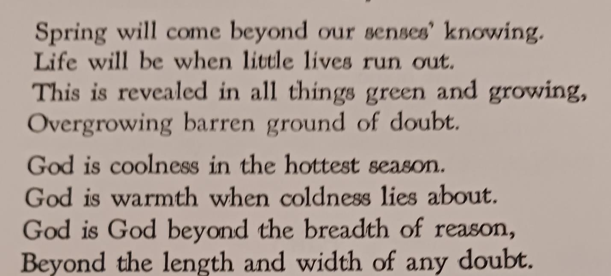
Mary Tookey

Published by:
The American Bard
Apr-June 1962 Vol 15 no 2
Contents

If
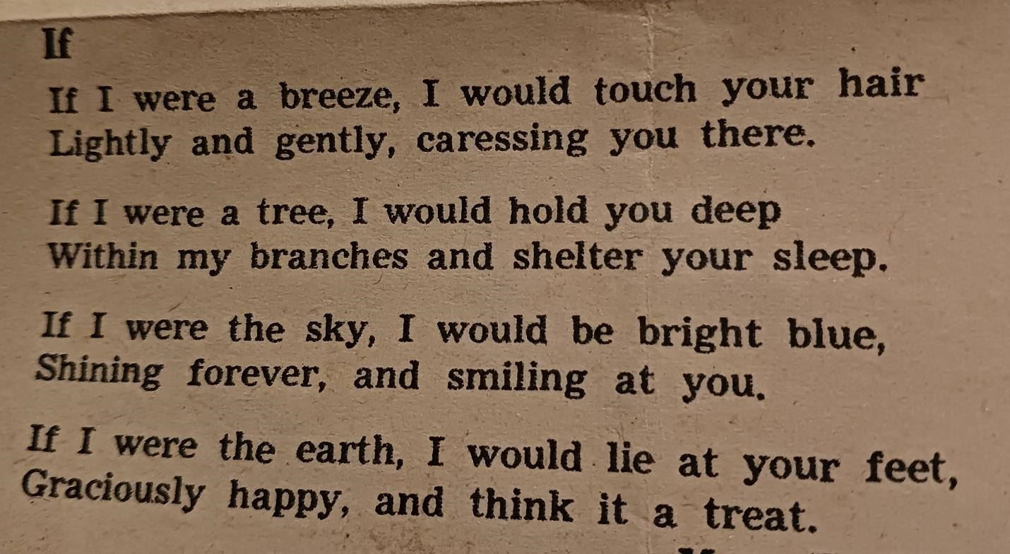
Mary Tookey

Published in
The Poetry Forum
The Denver Post Dec 16, 1962
Contents

Wiser
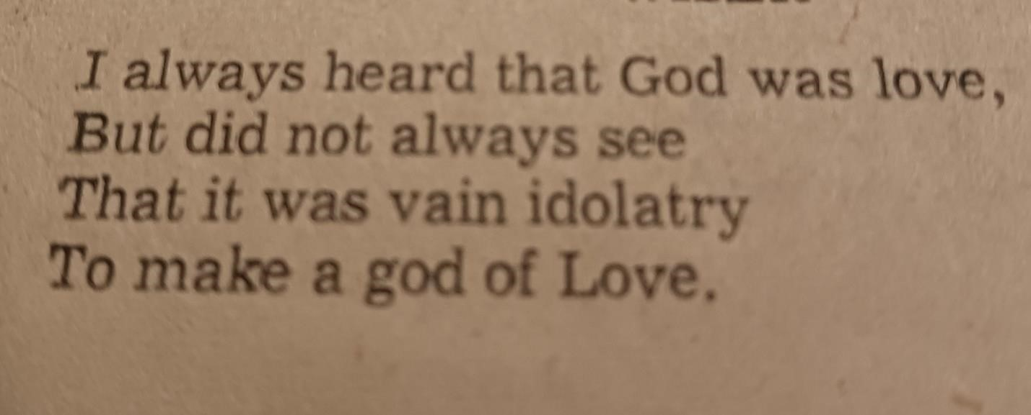
Mary Tookey
Published in
Oregonian Verse
The Sunday Oregonian
Date uncertain; probably 1962
Contents

Pleasant Weather
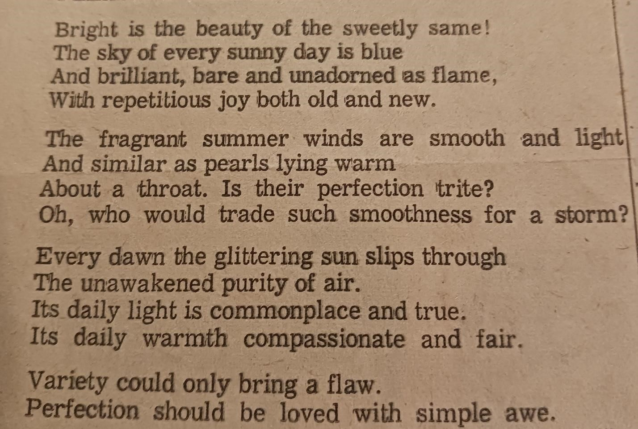
Mary Tookey

Published in
Oregonian Verse
The Sunday Oregonian
Date uncertain; probably 1962
Contents

On Immortality
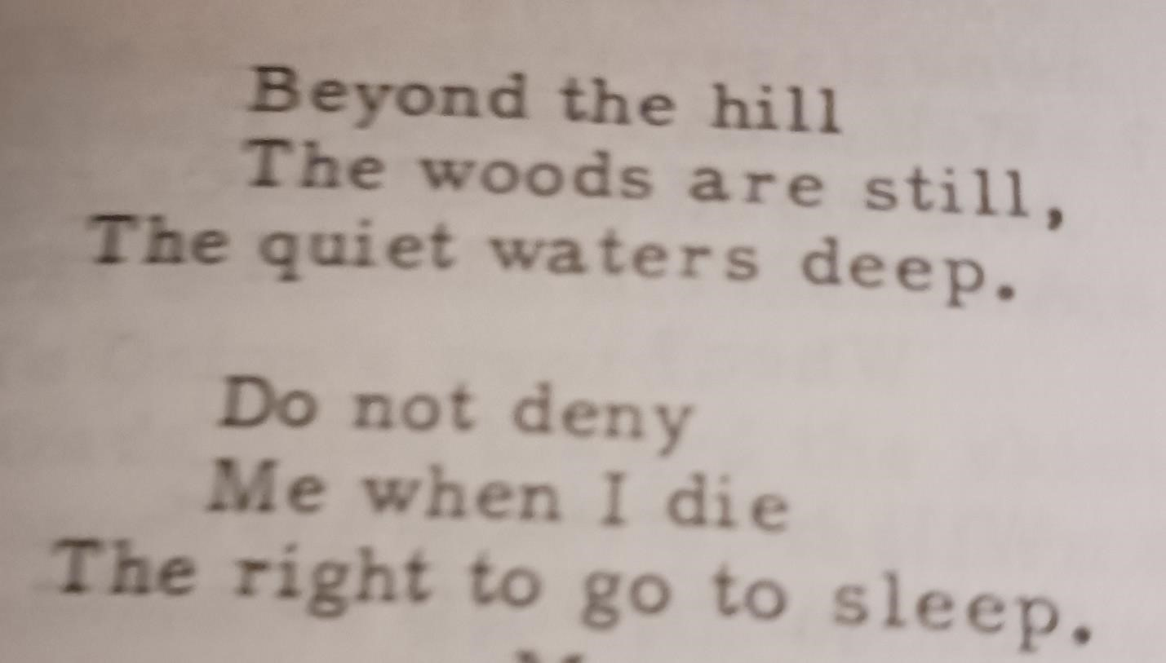
Mary Tookey

Published in:
Treasures of Parnassus
Best Poems of 1962
Lincoln B. Young, editor
Contents

Timorous
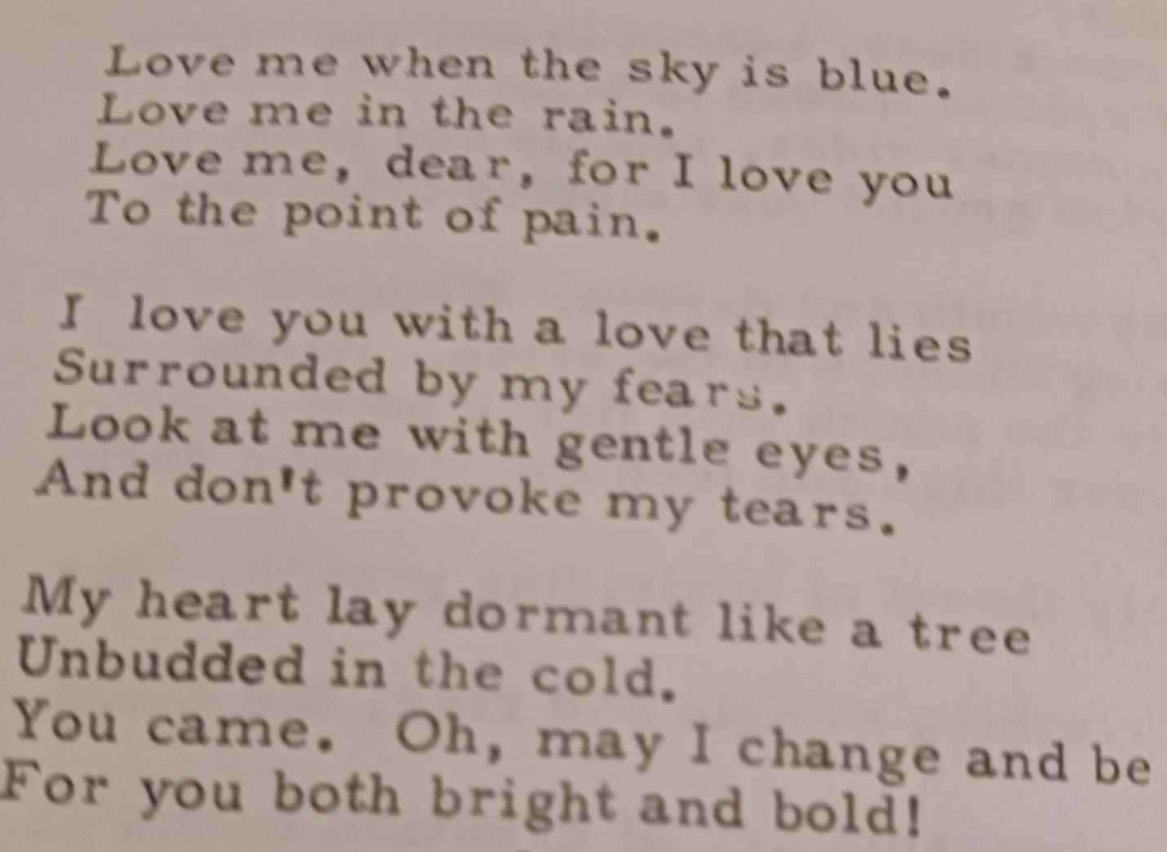
Mary Tookey

Published in:
Heart’s Secrets
Best New Love Poems
1962
Lincoln B. Young, editor
Contents

Sacrament of Love
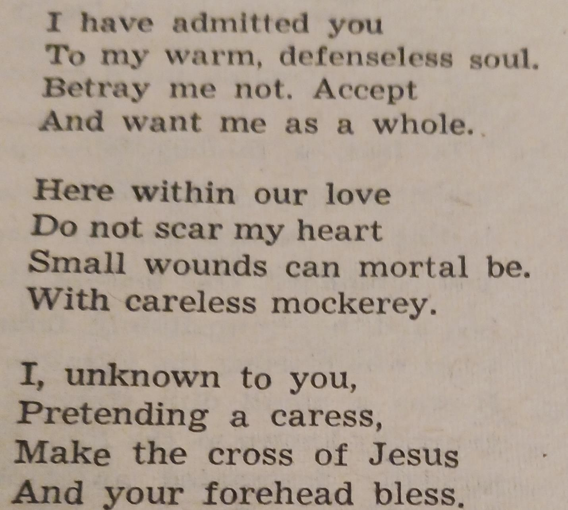
Mary Tookey

Published in:
The Post Poetry Forum
The Sunday Denver Post
Feb 17, 1963
Contents

Fleeing Creature
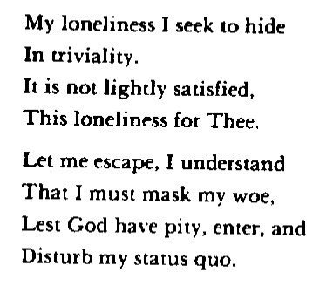
Mary Tookey

Published in World Call
Feb 1963
p. 82
Reprinted in “A Will Windward”
Contents

Brightening
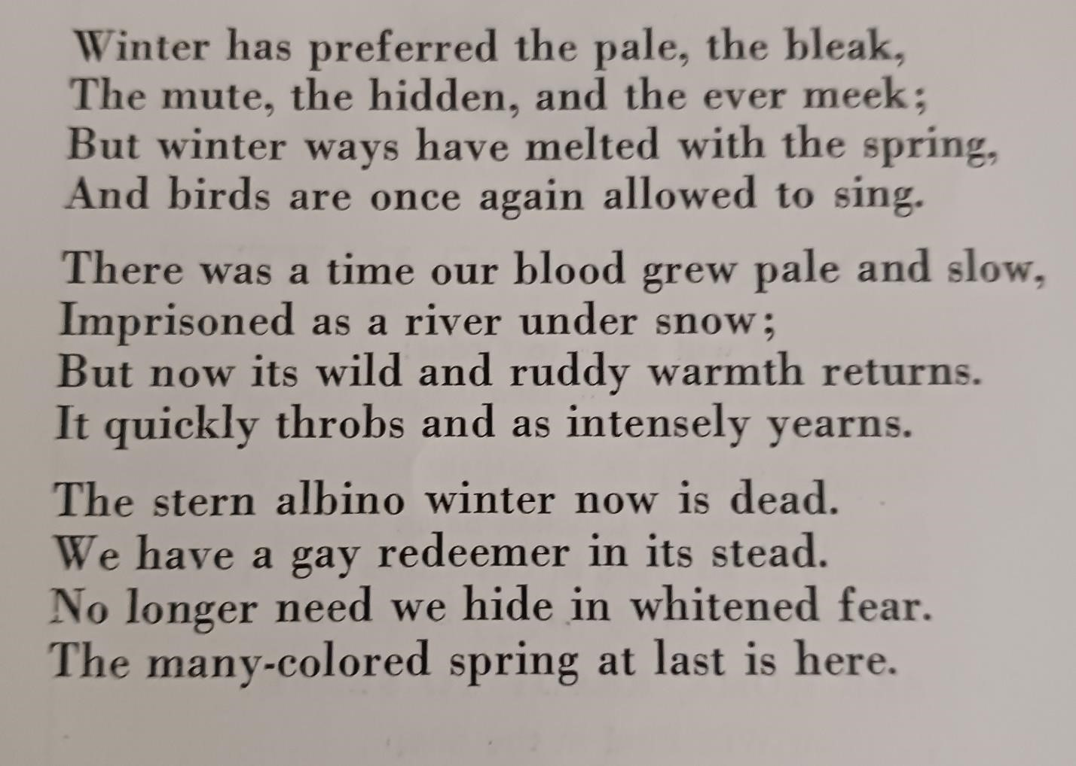
Mary Tookey

Published in:
The Villager
March, 1963
Vol XXXV no 5
p. 26
Contents

Musing

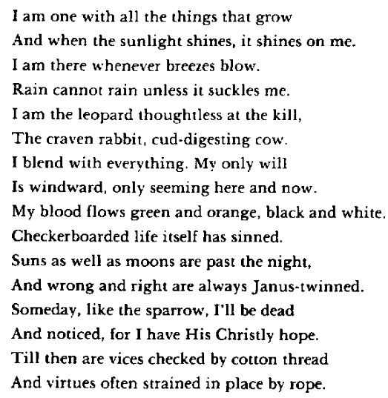
Mary Tookey

Published in:
The Muse
Vol 7 no 2
Winter 1963
p. 9
Reprinted in “A Will Windward”
Contents

Scientific View
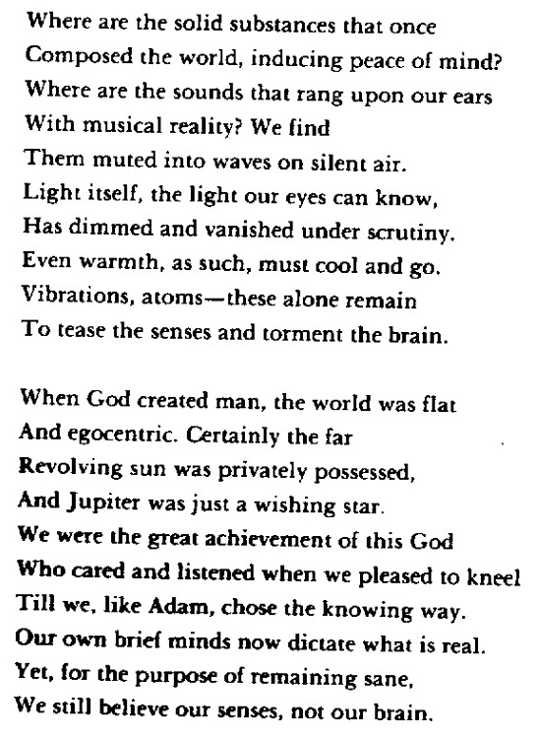
Mary Tookey Published in:
Poet Lore
World Literature and the Drama
Vol 58 no 1
Spring 1963
Reprinted in “A Will Windward”
Contents

The Turns of Time
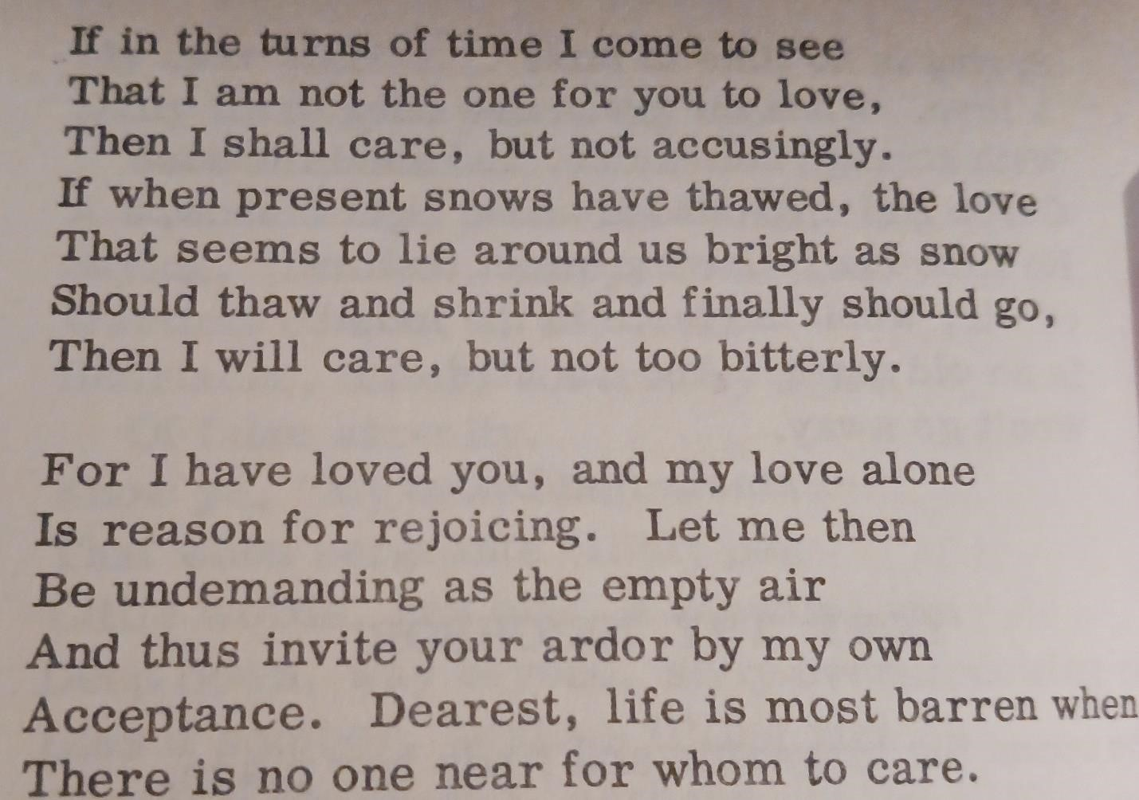
Mary Tookey

Published by:
Lyrics of Love
Best New Love Poems, 1963 Lincoln B. Young, editor
Contents

The Doubting Sheep
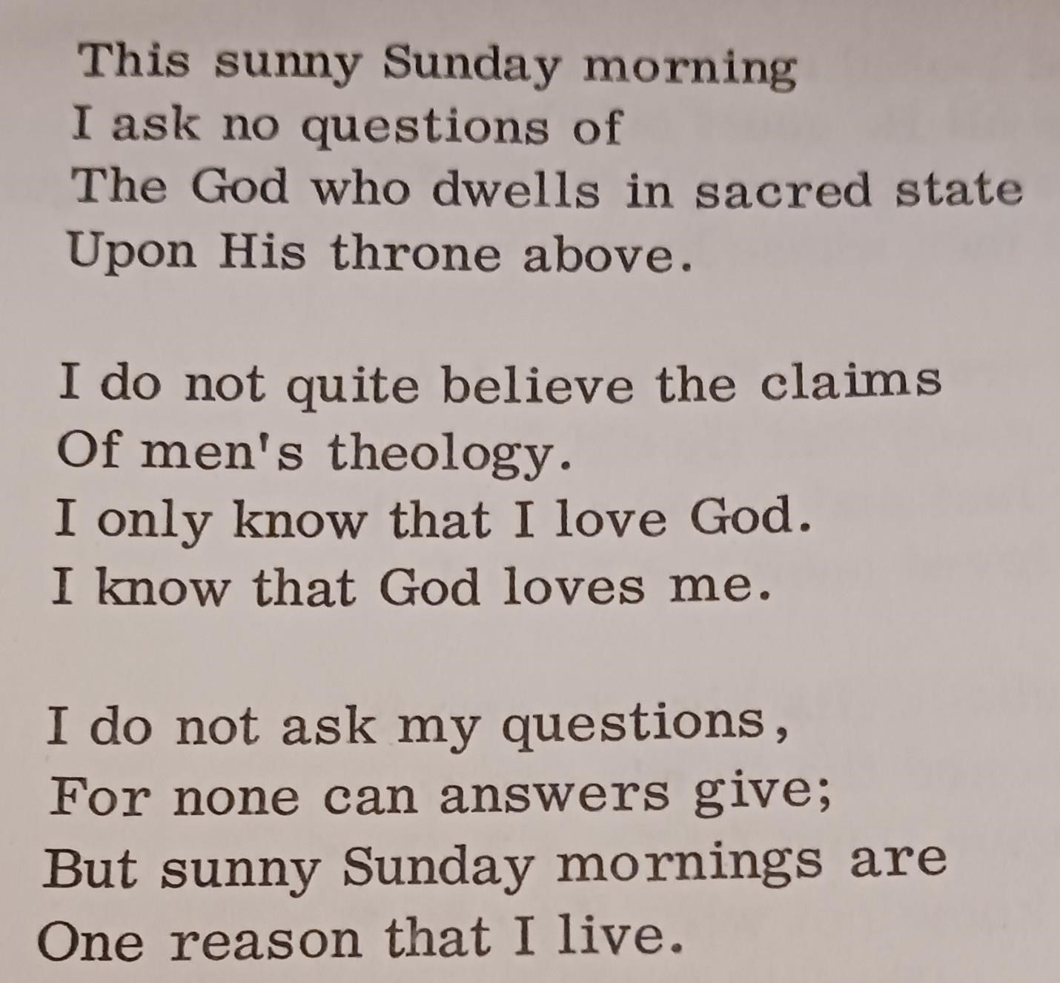
Mary Tookey

Published by:
Fragments of Faith
A Treasury of Religious Poetry
1963
Lincoln B. Young, editor
Contents

Obit for a Dead Tom
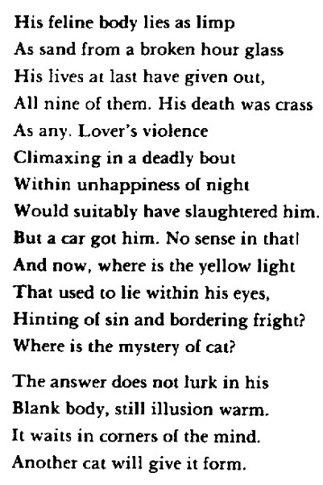
Mary Tookey
Published in:
New Athenaeum Winter 1964
Vol 20 no 2 p. 15
Reprinted in “A Will Windward”
Contents

Semicircle
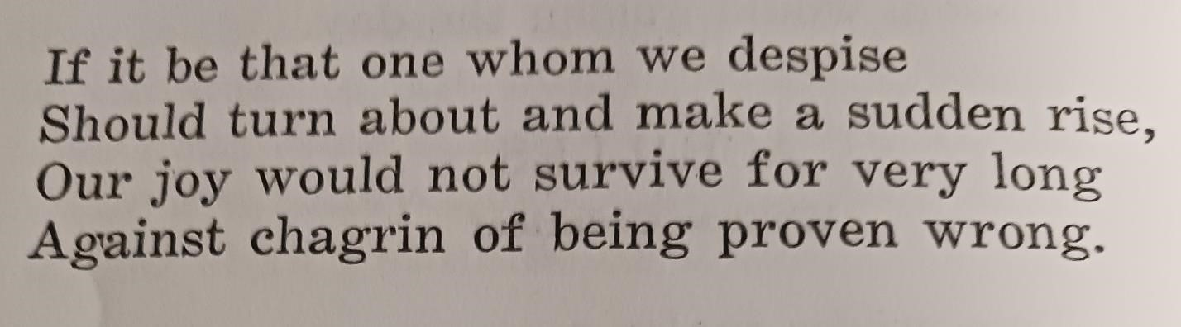
Mary Tookey

Published in:
The Muse
Vol 7 no 3
Spring 1964
p. 26
Contents

Avid Socialites
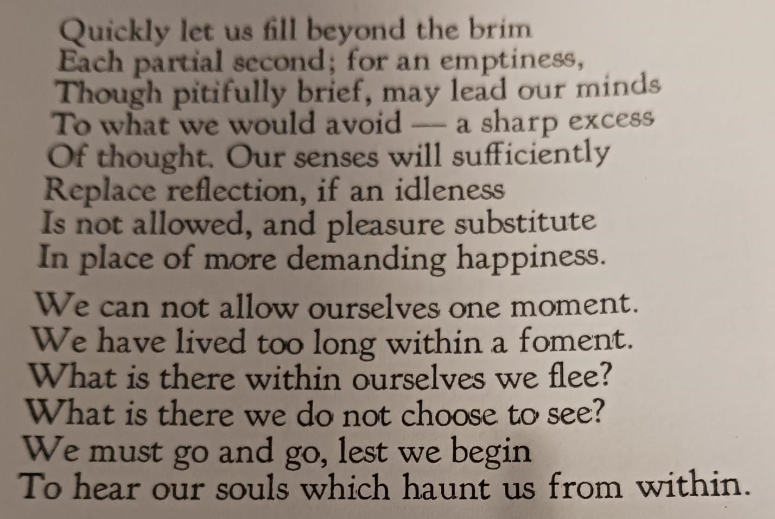
Mary Tookey

Published in:
The American Bard
Vol 15 no 10
Apr-June 1964
p. 12
Contents

Clock Watching
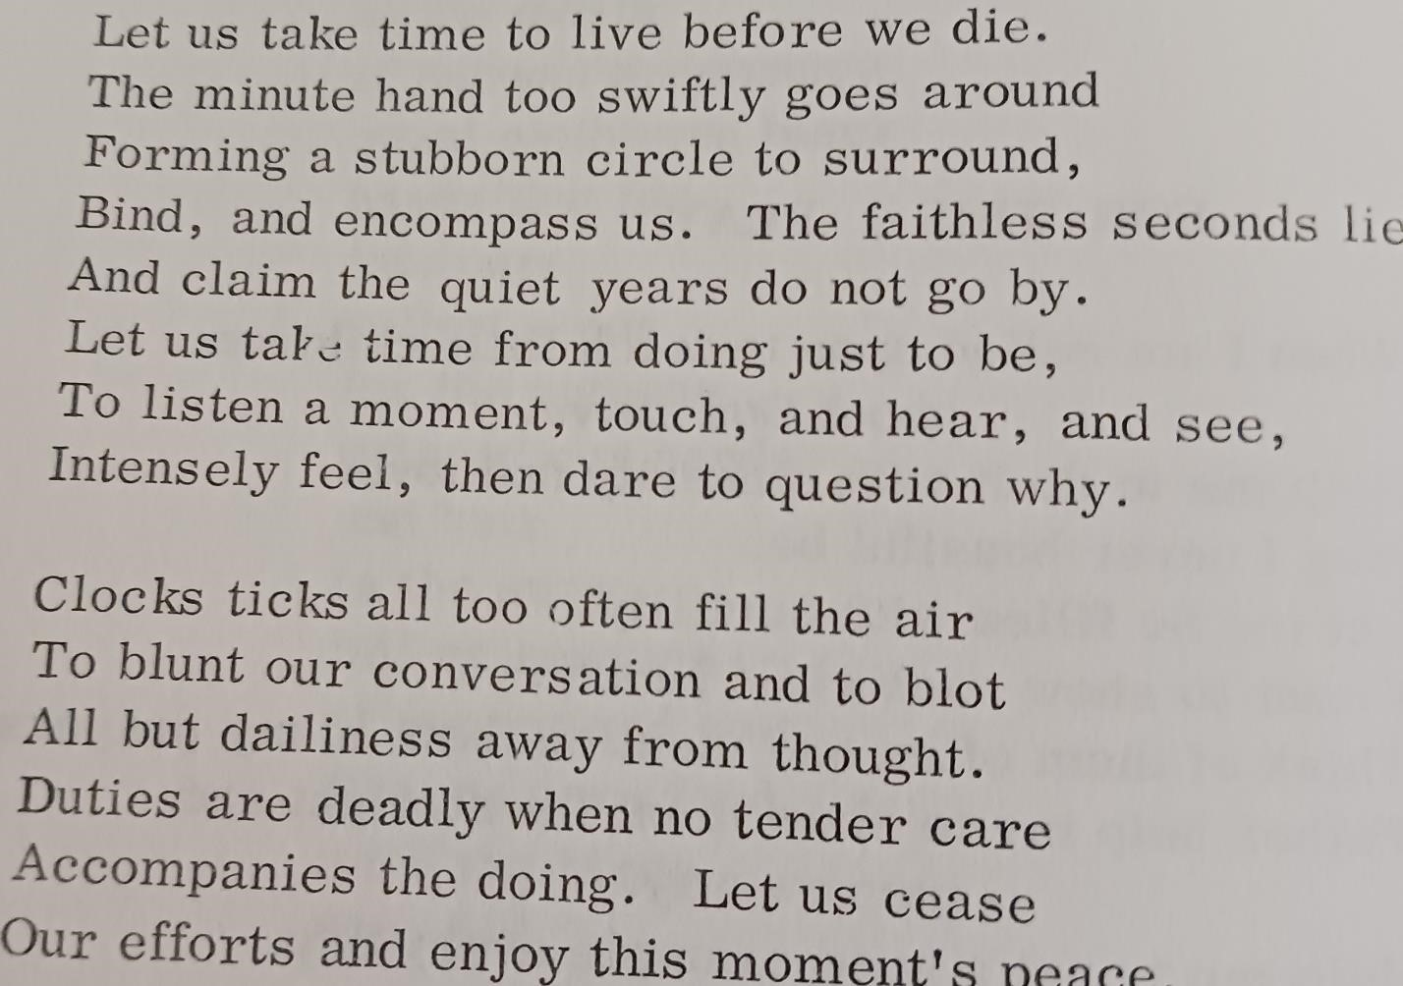
Mary Tookey

Published by:
Melody of the Muse
Best Contemporary Poetry
1964
Lincoln B. Young, editor
Contents

Early Years at Eureka

Offspring
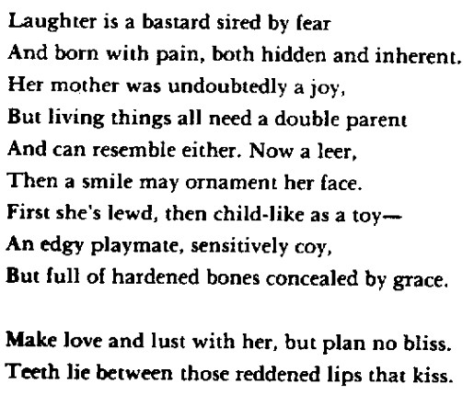
Mary Tookey

Published by:
Golden Harvest
Best Contemporary Poetry p. 342 Lincoln B. Young, Editor.
1967
Reprinted in “A Will Windward”
Contents

Sloven Song
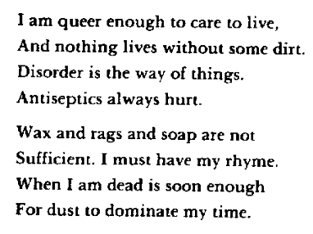
Mary Tookey

Published by:
Golden Harvest
Best Contemporary Poetry p. 358 Lincoln B. Young, Editor.
1967
Reprinted in “A Will Windward”
Contents

Spinster
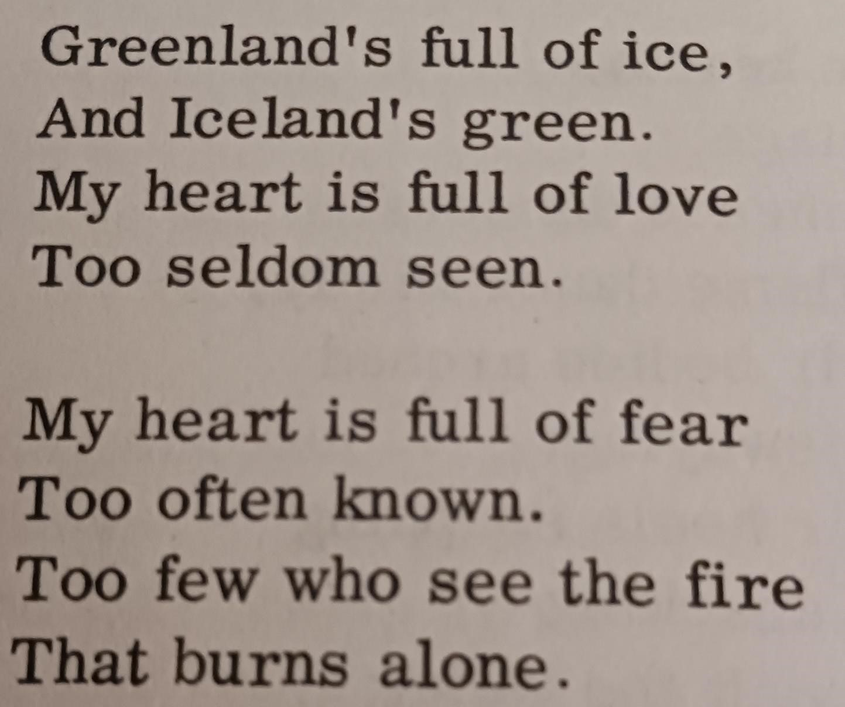
Mary Tookey

Published by:
Golden Harvest
Best Contemporary Poetry p. 357 Lincoln B. Young, Editor.
1967
Contents

Restraint
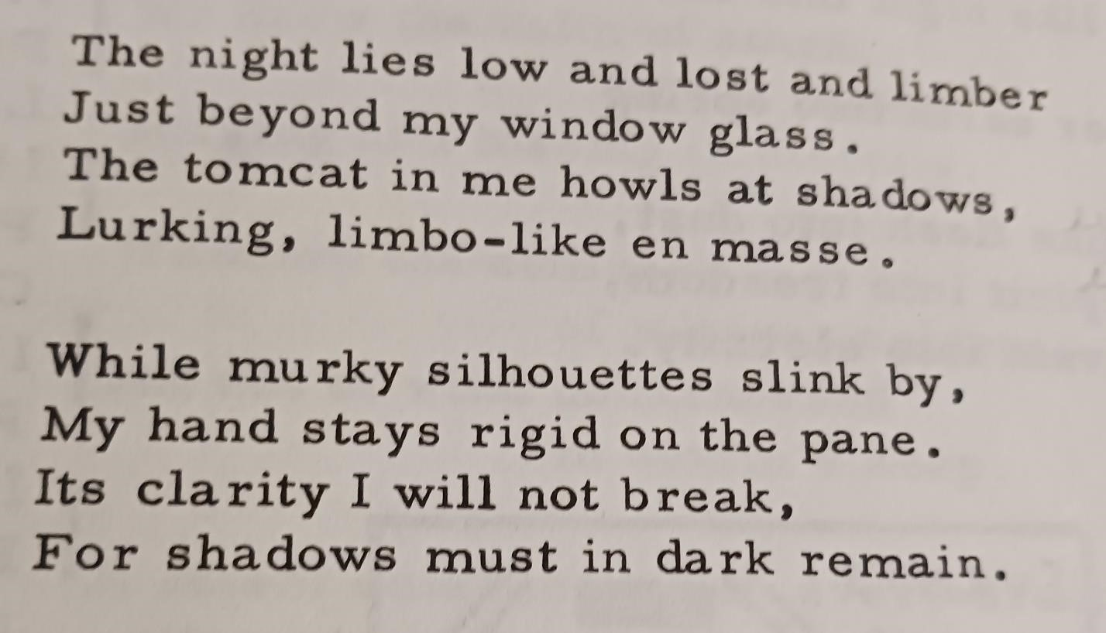
Mary Tookey

Published in:
Poetry Digest
Feb-Mar 1967
Vol 6 no 1
p. 41
Contents

Unaltered Love
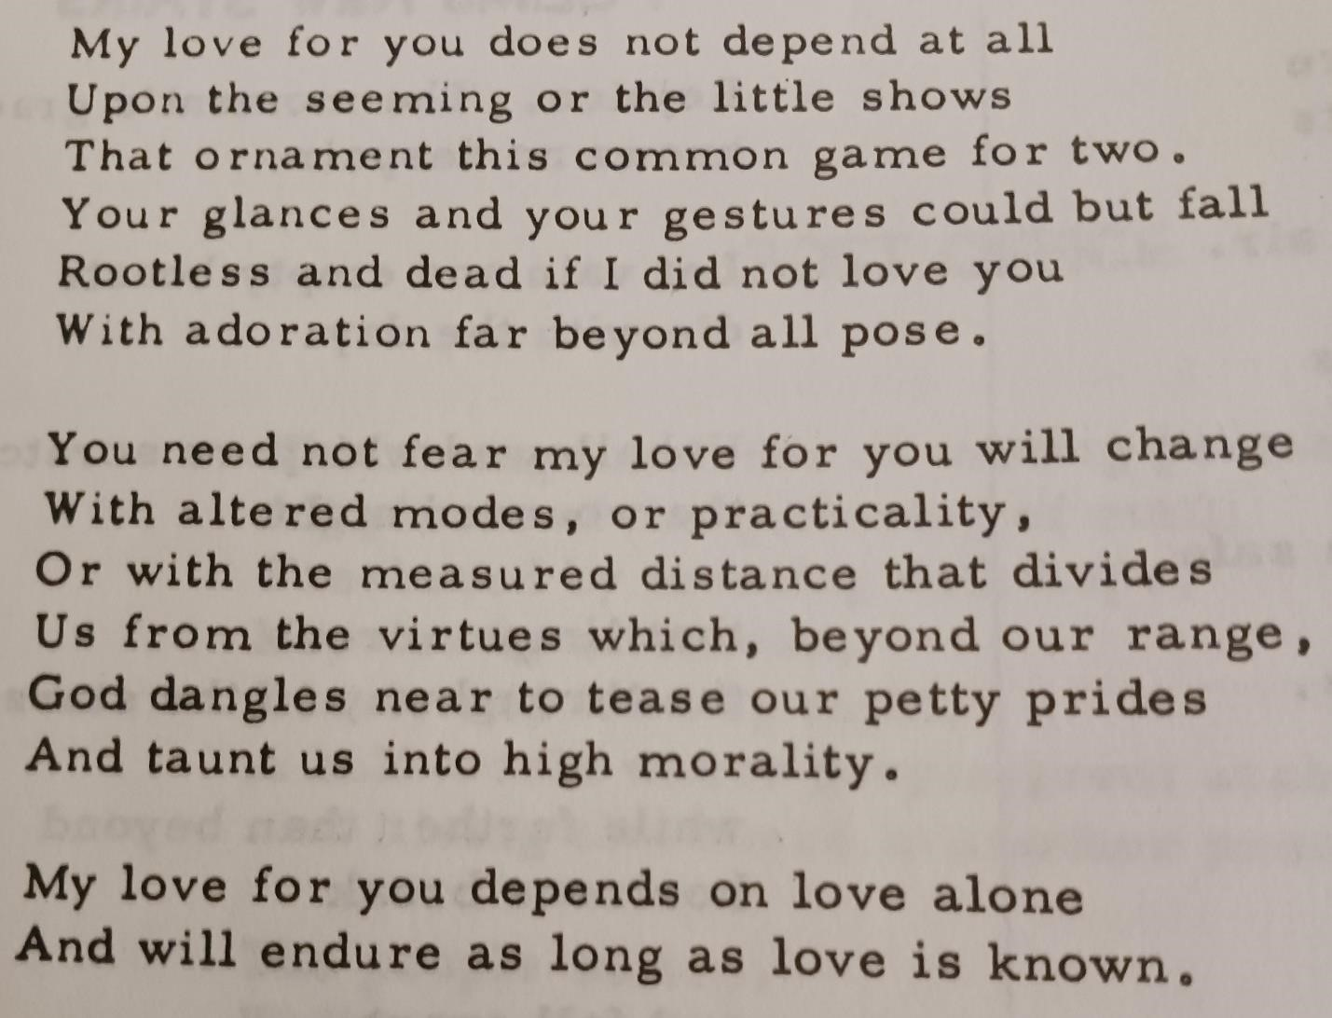
Mary Tookey

Published in:
Poetry-Prose Digest
Vol 6 no 5
Oct-Nov 1967
p. 8
Contents

Restraint
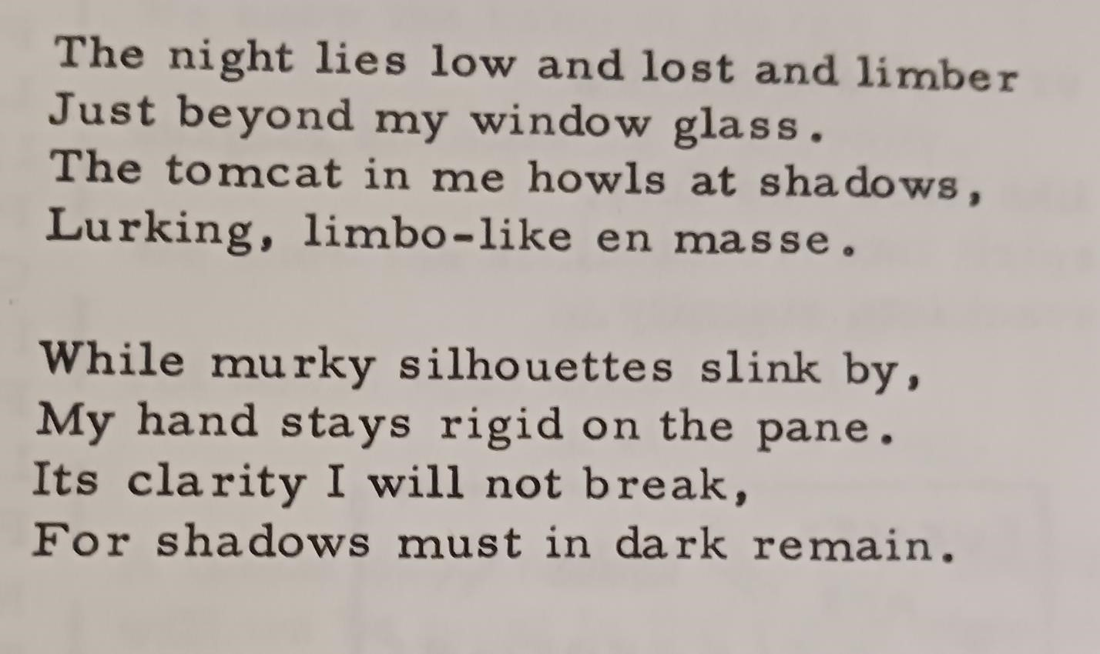
Mary Tookey

Published in:
Poetry Digest Vol 6 no 1
Feb-Mar 1967
p. 41
Contents

Apology
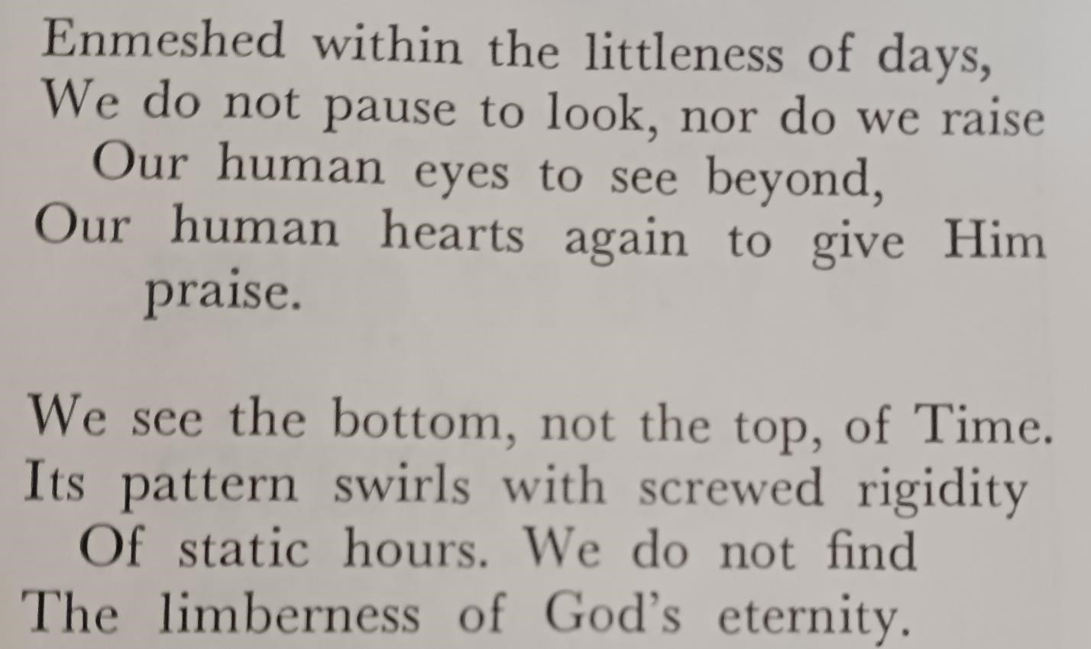
Mary Tookey

Published in:
World Call: Magazine of the Disciples of Christ
Nov 1967
p. 41
Contents

Minor Monarch
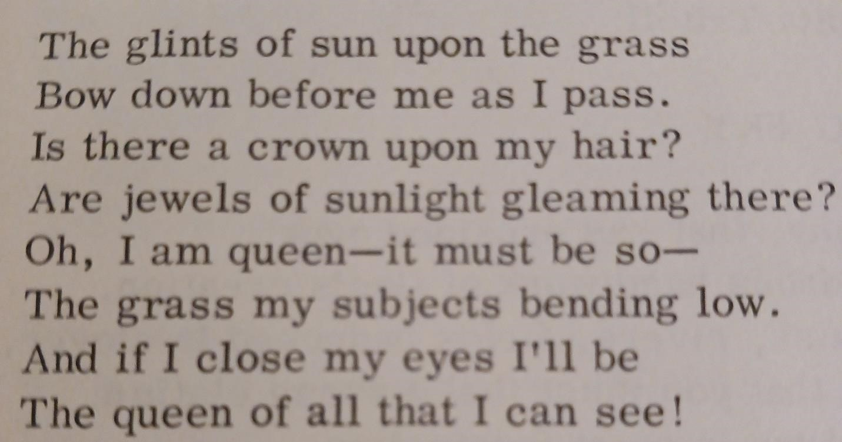
Mary Tookey

Published by:
Yearbook of Modern Poetry p. 568
Compiled and edited by Jeanne Hollyfield
Yong Publications, Appalachia Virginia
Copyright 1971 by Lincoln B. Young
L of C 38-37553
Standard Book Number 91166-06-0
Contents

Mental Architecture
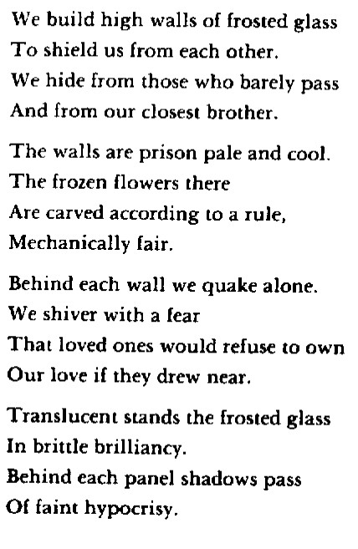
Mary Tookey

Published by:
Yearbook of Modern Poetry p. 568
Compiled and edited by Jeanne Hollyfield
Yong Publications, Appalachia Virginia
Copyright 1971 by Lincoln B. Young L of C 38-37553
Standard Book Number 91166-06-0

Reprinted in “A Will Windward”
Contents

Later Years at Eureka

To a Newborn Child
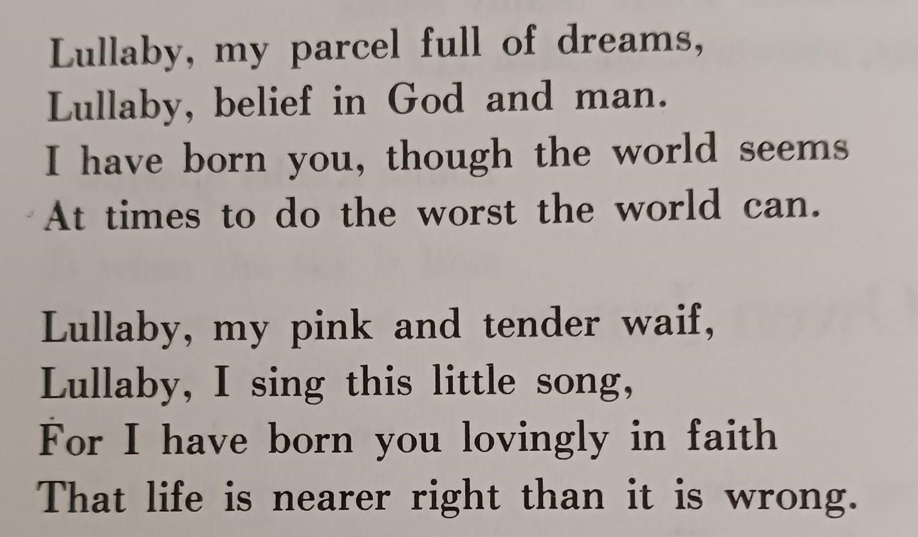
Mary Tookey

Published in:
Major Poets No. 18
Mary Marks, editor
Fall 1972
Pierson Mettler Associates Box 52 Tremont IL
Contents

May Love
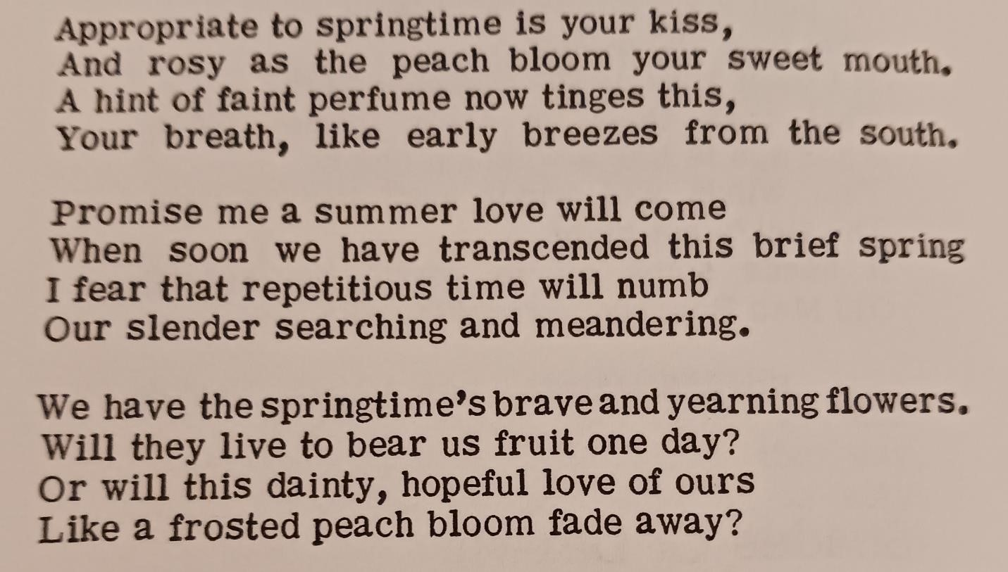
Mary Tookey

Published in:
Outstanding Contemporary Poetry Dale and Arthur Moore, ed.
Pied Piper Press
Sandwich IL
1972
Contents

Infusion
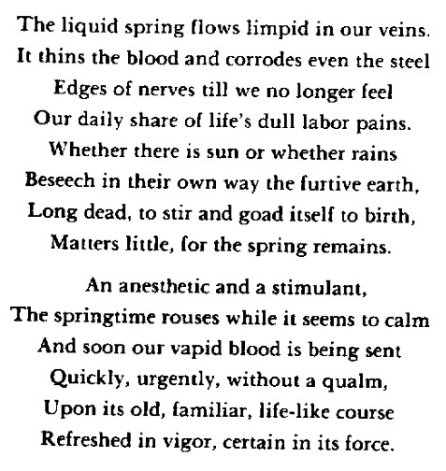
Mary Tookey

Published in:
Major Poets No. 20
Mary Marks, editor
Spring 1973
Pierson Mettler Associates
Box 52 Tremont IL
Reprinted in “A Will Windward”
Contents

Frame
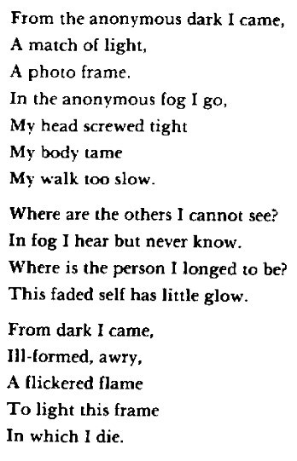
Mary Tookey

Published in:
I.S.P.S. Newsletter
Illinois State Poetry Society
Charleston IL
Spring, 1973
p. 1
Reprinted in “A Will Windward”
Contents

Carrot-Weed
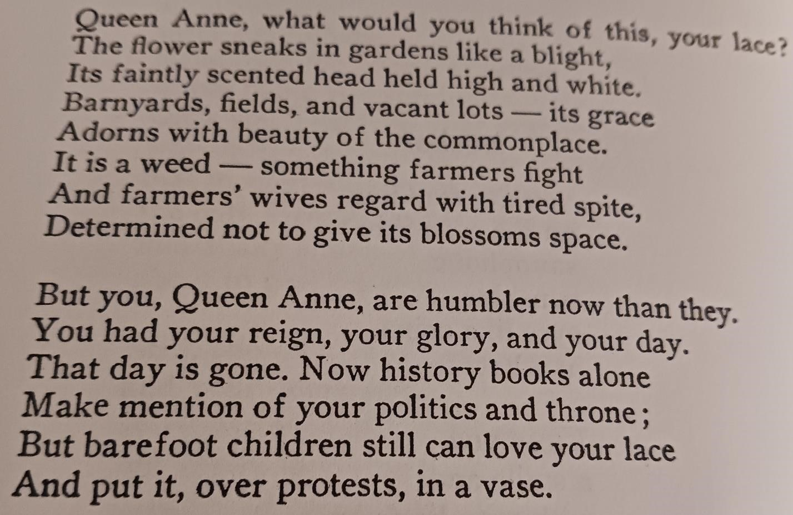
Mary Tookey

Published in:
“The English Teacher’s Own Writing”
Illinois English Bulletin
IATE: Illinois Association of Teachers of English
Spring 1987
Vol 74 No 3 Urbana IL
Contents

To Our Daughter at Commencement
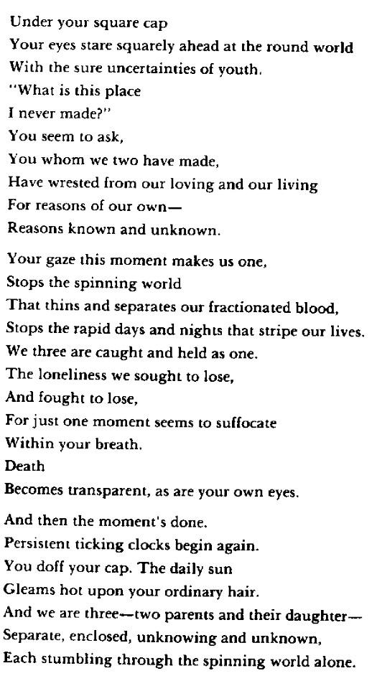
Mary Tookey

Published in:
Western Ohio Journal
Spring 1989
Vo X no 1
WOTELA
p. 31
Reprinted in “A Will Windward”
Contents

Ice Flow
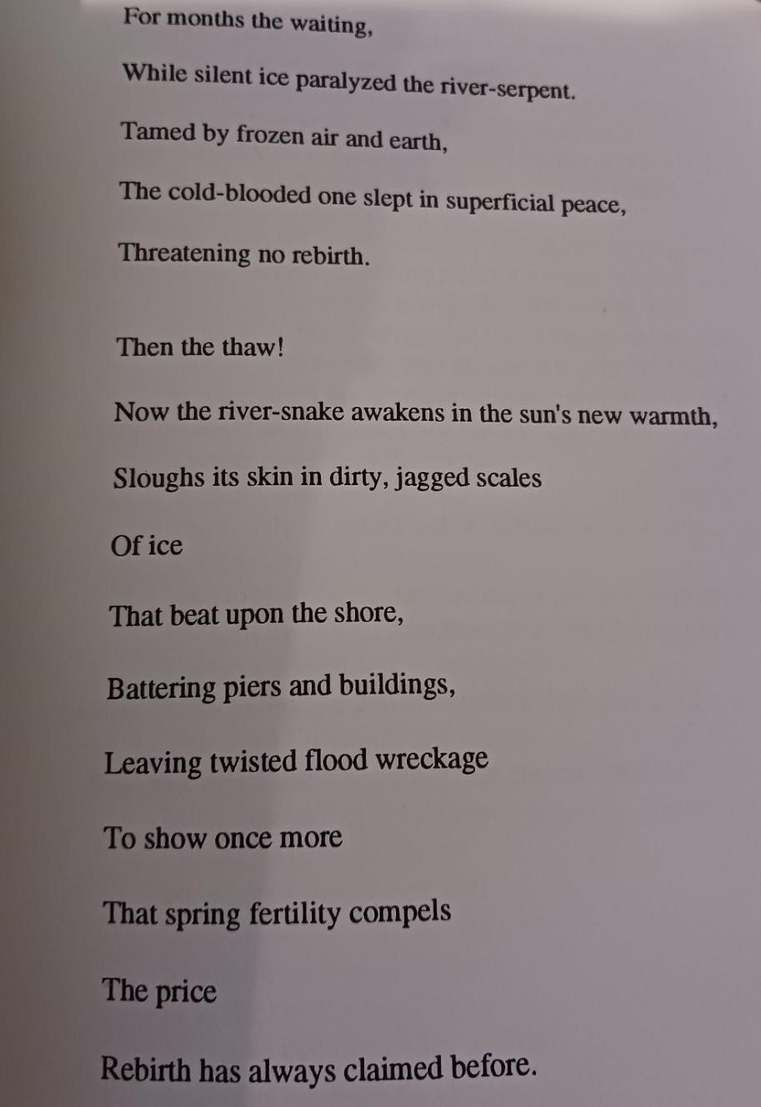
Mary Tookey

Published in:
Eureka Literary Magazine
Vol 1 no 2 p. 55
Spring 1993
Loren Logsdon, editor
Contents

Friend of the Deceased
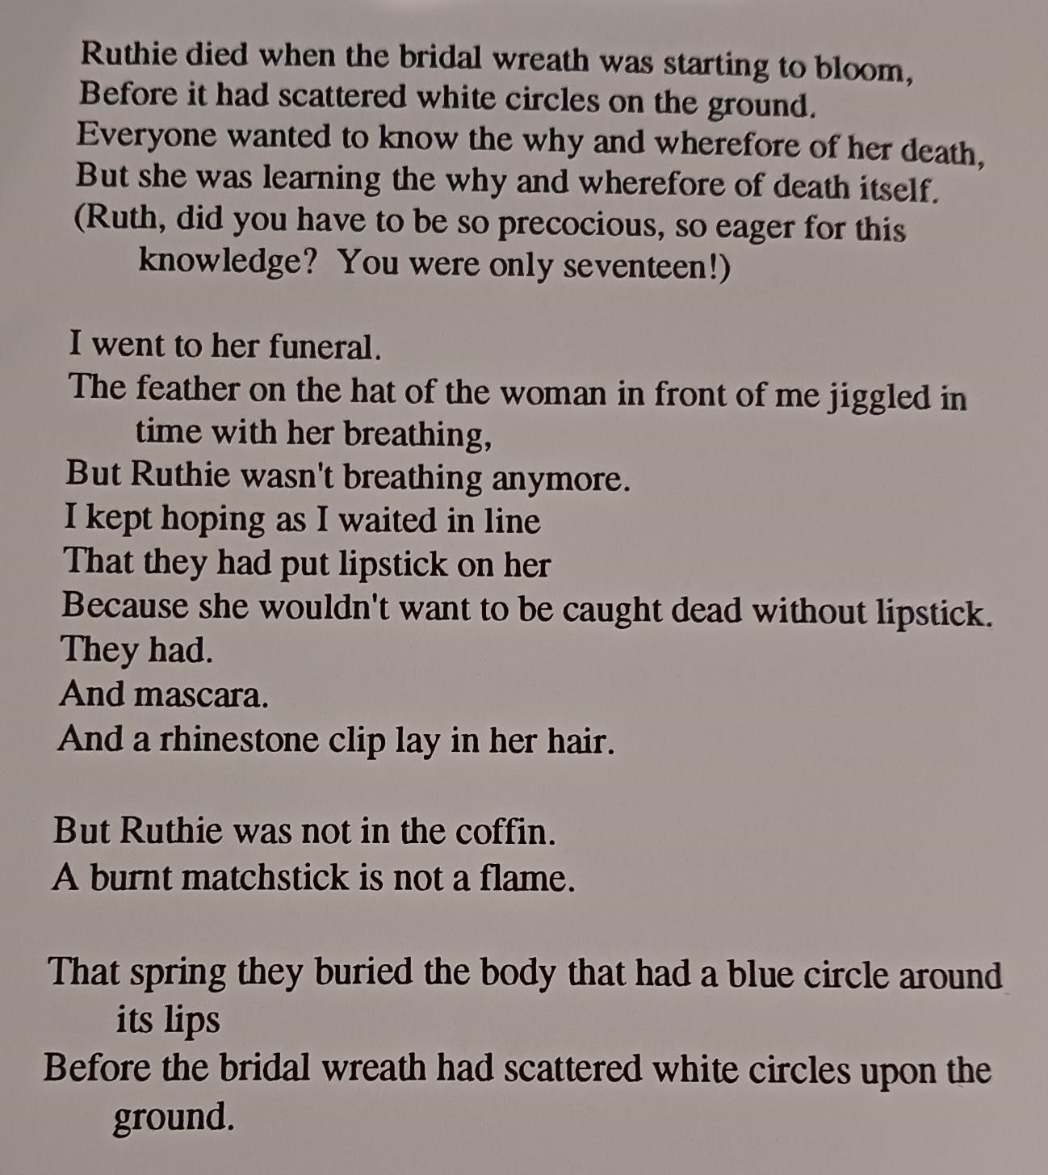
Mary Tookey

Published in:
Eureka Literary Magazine
Vol 1 no 2
Spring 1993 p. 56
Loren Logsdon, editor
Contents

Interim Protest
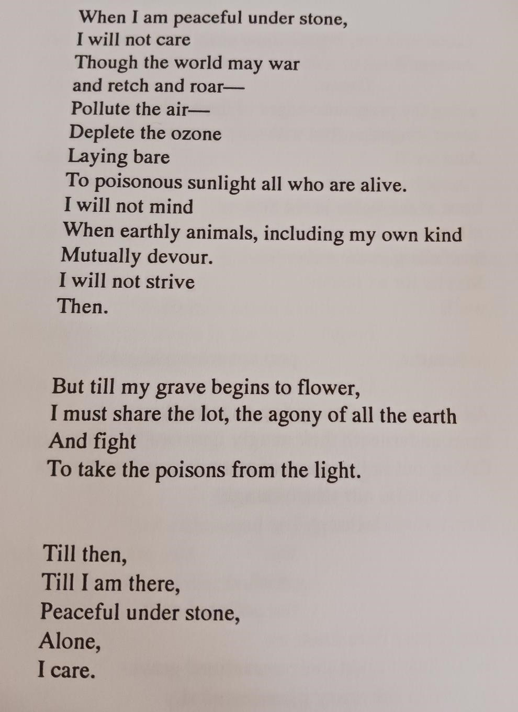
Mary Tookey

Published in:
Eureka Literary Magazine
Vol 2 no 2 p. 74
Spring 1994
Loren Logsdon, editor
Contents

June Beetles
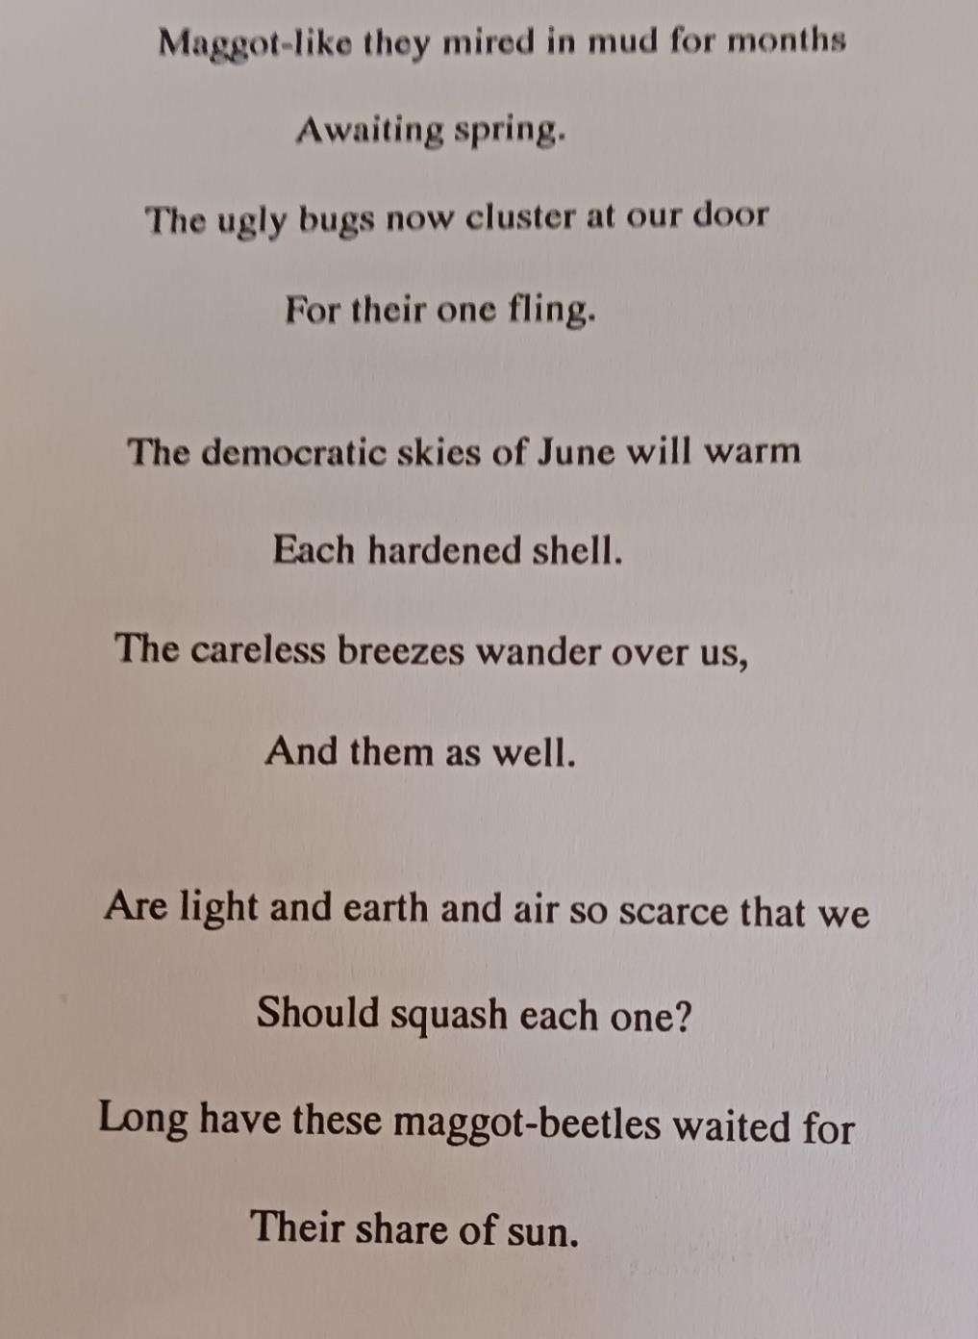
Mary Tookey

Published in:
Eureka Literary Magazine
Vol 2 no 2 p. 75
Spring 1994
Loren Logsdon, editor
Contents

Brightening
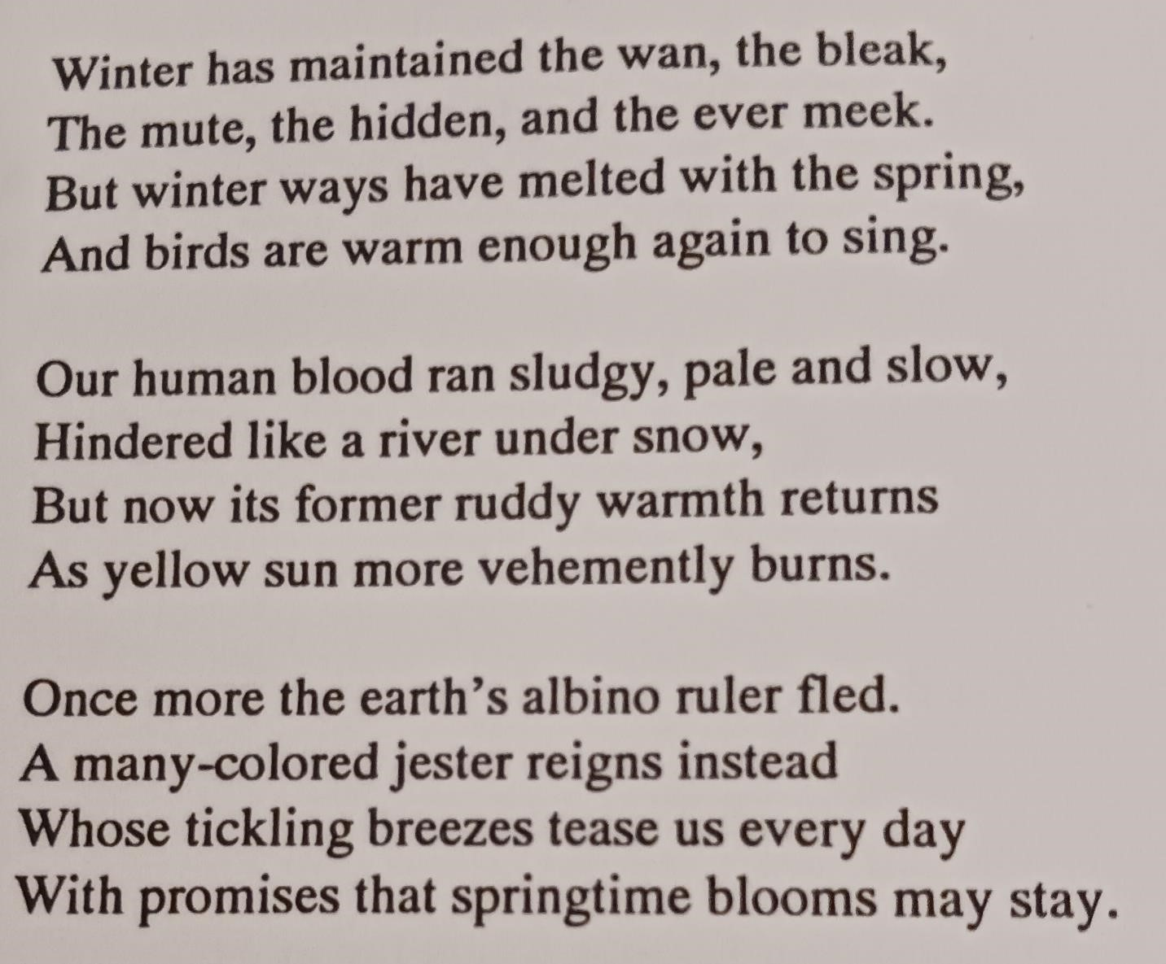
Mary Tookey

Published in:
Eureka Literary Magazine
Vol 2 no 2 p. 76
Spring 1994
Loren Logsdon, editor
A different version appeared in “A Will Windward”
Contents

City Shine
Their brightnesses fought,
The city’s and the comet’s.
The city was ready with a bubble of reddish haze
That glowed possessively,
Strongest where nearest,
Finally fading into a high, thick blackness
That only the strongest stars penetrate—sometimes.
The comet could not slit the bubble
And slide its light through.
The city killed the last comet.
Will it kill the next?

(continued)

The city waits—still ready.
With car lights,
Street lights,
Home lights,
And those gaudy neon advertisements
That invite,
Taunt,
Dare.
In white, gold, amber, and red the city silently shouts about
Excitement,
Enticement,
But not those only—also about
Safety,
Comfort,
Home.
Something for everyone, the city lights say.
Let us protect you
From the dark and all that it holds,
From the outsiders,
Most of all, from the huge, empty nothingness
That surrounds and swallows.
You know we are jewels, the lights insist.
When you have looked down upon us, you have known.

When you have been close to the chaos
Inside one of your fragile metal birds,
You have looked down and seen that we are diamonds and rubies
Decorating velvet.
You have always known that we are your welcome home.

(continued)

The city killed the last comet
With its luminous defiant shine
Will it kill the next?
Can it kill all those
Unknowns,
Terrors,
Emptinesses
That come from the outer dark?

Mary Tookey

Published in:
Eureka Literary Magazine
Vol 6 no 2 p. 109
Spring 1998
Loren Logsdon, editor
Contents

Insult and Revenge
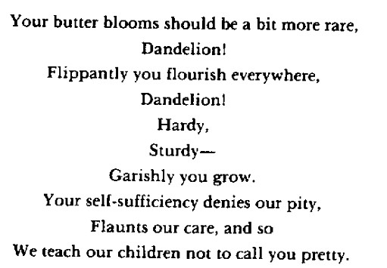
Mary Tookey

Published in:
“A Will Windward”
Reprinted in:
American Poetry Roundup
Western Poetry Association
1992
Contents

About “A Will Windward”

Mary Tookey went to a publisher of poetry, and presented her (proposed) book of poems, to be published. As part of her pitch, she presented enrollment trends in a poetry class at Eureka College, where students were required to buy books of poems. [Mary Tookey, personal communication]
While the book may have been presented as poetry for poetry students, it is reasonable to assume that it included what she considered to be her best poems.

The following poems were first published in
“A Will Windward”
By
Mary Tookey

Lewiston Poetry Series Volume 10
The Edwin Mellon Press 1989

Twentieth Century Lullaby
Bits with Bite
Current Topic
Moral Mist
Response to the Minister
Reinterpretation
Wedding
Shadow
One Winter Night
Fertility Song
With Thanks to Mr. Blake
A Comfort
Realistic Lullaby
Later Love
Anticipation
Driving Through the Plains
Road
Alone

Paranoia
100 degrees F
Civilized
Haiku Moment
Delight
Morning Joy
Disillusionment
Storm
Summer Attainment
Foreshadowings of Autumn
November
The Cold
Brightening
Eternally
Resurrection
Artificial Satellite on Christmas Eve

Contents

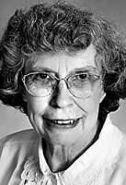

Mary Tookey Obituary
PEORIA - Mary D. Tookey, 83, passed away on Wednesday, Feb. 6, 2013, at Lutheran Hillside Village. Mary was born July 15, 1929, in Lincoln, Neb., the daughter of Richard C. and Mary B. (Grice) Webber.
She graduated from the University of Nebraska, Lincoln campus. It was there she met her husband, Harvey, and they were a devoted couple until his passing on Dec. 14, 2012. They were wed on Christmas day in 1950.
Unlike many mothers of her generation, when her children went to school, she went back herself. After obtaining her master's degree in English from Bradley University in 1965, she worked as a professor of English at Eureka College in Eureka, Ill., until retiring in 1991 with Professor Emerita status.
She passed on her love for literature to both her students and her children.
She has been published professionally, and was especially proud of her book of poetry called "A Will Windward."
Over the years, she was active in church choir, contributing in later years her skill as a lyricist for some of the church hymns composed by her husband. She was active at West Bluff Christian Church volunteering in myriad ways, and she also tutored underprivileged children at Common Place.
Mary had a passion for wildflowers with numerous flower beds around the yard.
She is survived by her two sons, Ralph of Montclair, N.J., and Keith (Gerry) of
Washington, Ill.; two daughters, Ellen (Gerald) Wallen of Madison, Wis., and Linda
(Chris Hall) Tookey of Centennial, Colo.; six grandchildren, Adrienne Tookey, Christopher Tookey, Benjamin Hall, Matthew Hall, Jonathan Tookey, and Daniel Tookey.
Her husband of 61 years, Harvey L. Tookey, preceded her by 57 days.
She will be remembered as a loving mother, devoted wife, and doting grandmother.
In lieu of flowers, memorial gifts may be sent to Eureka College.
Please visit Mary's story at www.woolsey-wilton.com.
https://www.legacy.com/us/obituaries/pjstar/name/mary-tookeyobituary?id=24811031
Contents

