Mary Tookey’s

A Will Windward
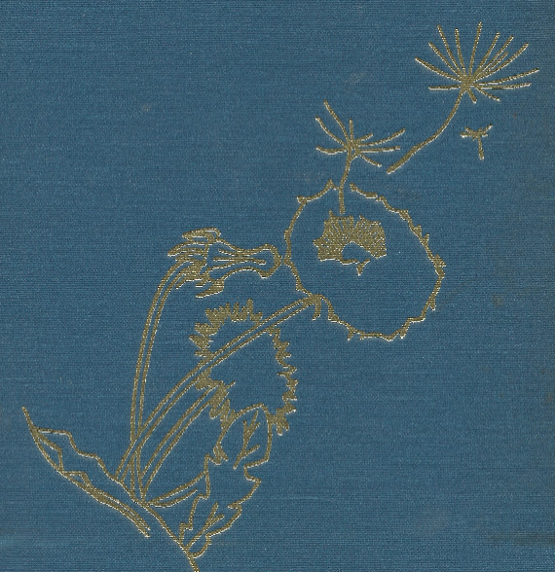
Ebook Edition

K.R. Tookey, editor

Mary Tookey’s “A Will WindWard”
Ebook Edition
K.R. Tookey, Editor

Originally published as
“A Will Windward”
Lewiston Poetry Series
Volume 10

The Edwin Mellon Press
Copyright 1989
ISBN 0-88946-899-0
Box 450
Lewiston NY 14092

Illustrated by Wallace Armstrong
Edwin Mellon edition edited by Patricia Schultz

Reprinted with permission of Mary Tookey’s estate.

ACKNOWLEDGEMENTS
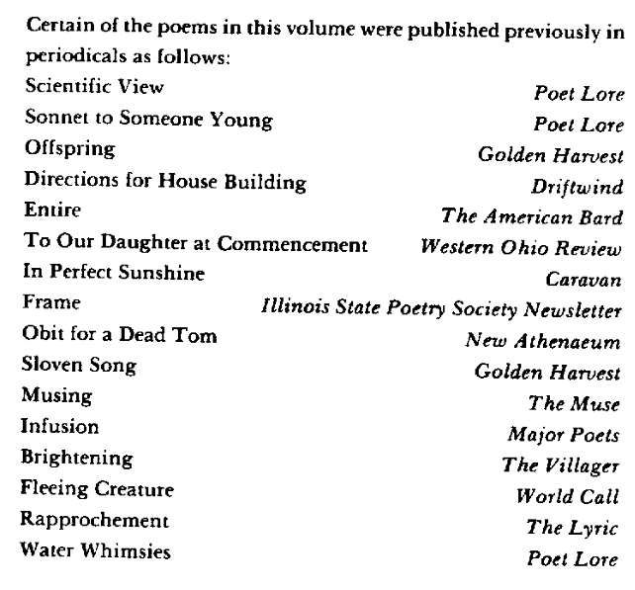

Contents
A Will Windward
ACKNOWLEDGEMENTS
Contents
HUMANKIND: wise and not so wise
Scientific View
Twentieth Century Lullaby
Sonnet To Someone Young
Interim Protest
Offspring
Bits With Bite
Current Topic
Woven
Moral Mist
Mental Architecture
Response to the Minister
Directions for House Building
Reinterpretation
FOR RICHER OR POORER … in many ways
Virgin
Wedding
Shadow
Who Are We?
One Winter Night
Fertility Song
Entire
With Thanks to Mr. Blake
A Comfort
Realistic Lullaby
To My Son
To Our Daughter At Commencement
Later Love
Anticipation
MOODS: the brights and the blues
In Perfect Sunshine
Driving Through the Plains
Road
Alone
Paranoia
Frame
Huge Night
Restraint
100 Degrees F
Civilized
Obit For A Dead Tom
Haiku Moment
Insult and Revenge
Sloven Song
Delight
Morning Joy
Musing
Disillusionment
Storm
EARTH and its fullness
Infusion
Summer Attainment
Foreshadowings of Autumn
November
The Cold
Brightening
WHEREVER THOU ART
Rapprochement
Fleeing Creature
Apology
Water Whimseys
Eternally
Resurrection

HUMANKIND: wise and not so wise
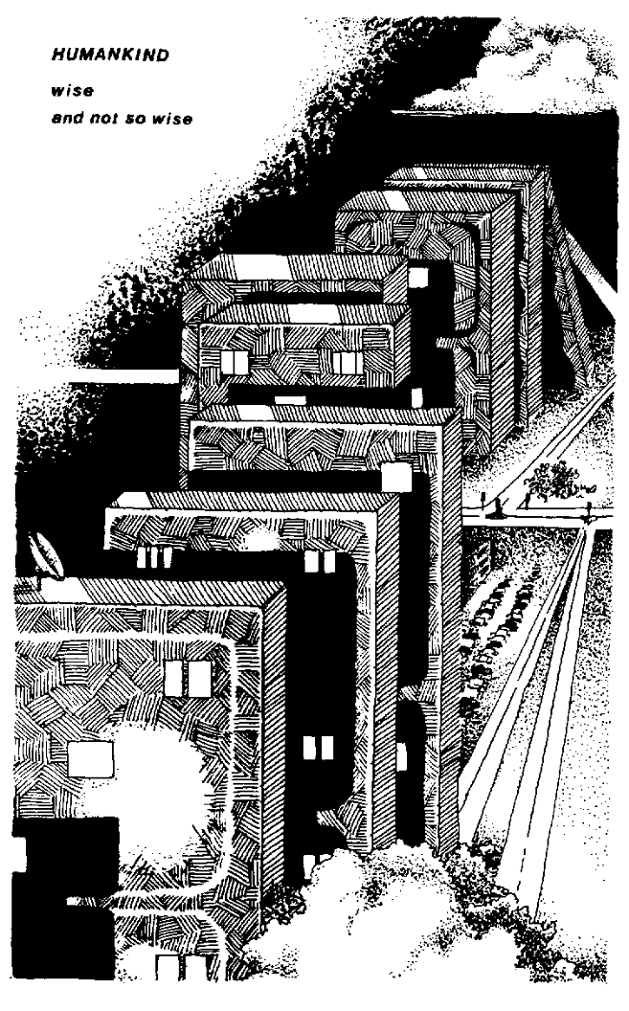
Contents

Scientific View

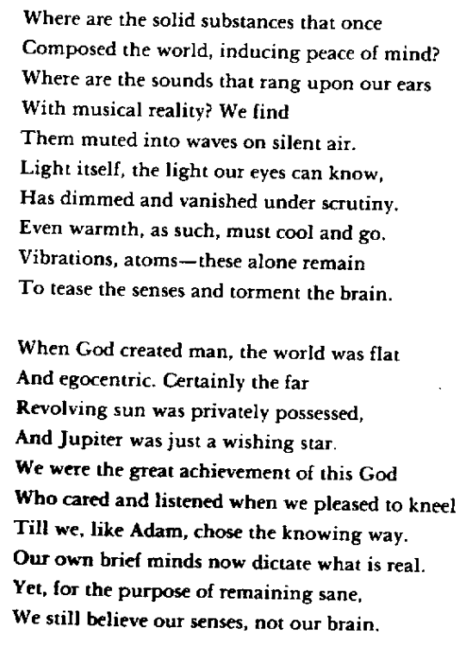
Contents

Twentieth Century Lullaby

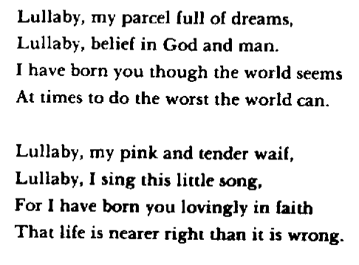
Contents

Sonnet To Someone Young

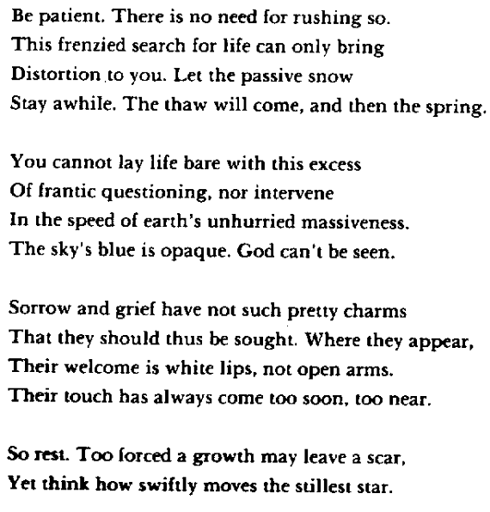
Contents

Interim Protest

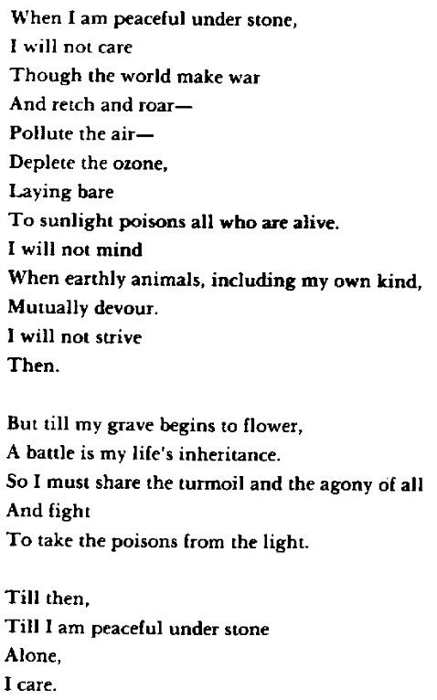
Contents

Offspring

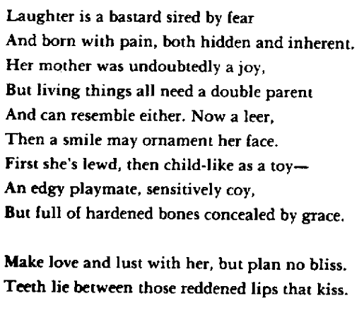
Contents

Bits With Bite

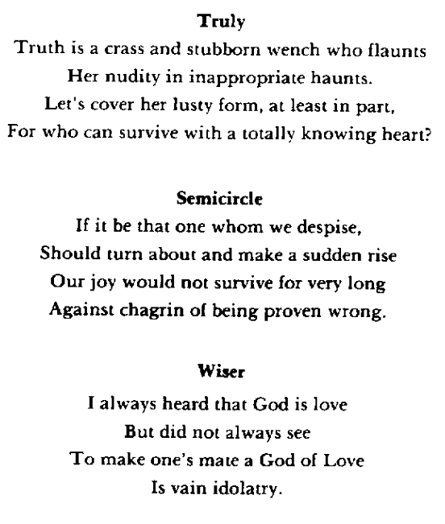
Contents

Current Topic

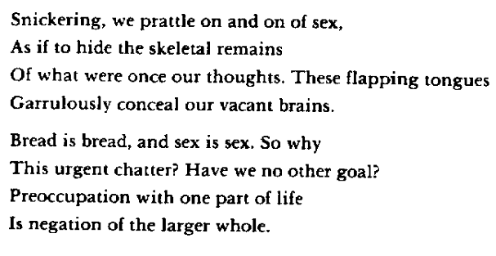
Contents

Woven

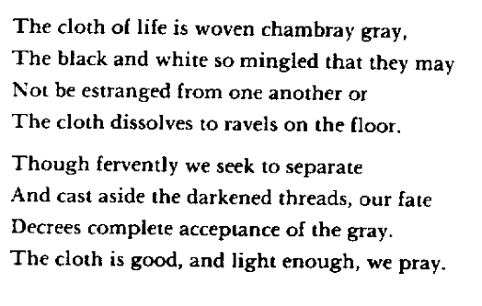
Contents

Moral Mist

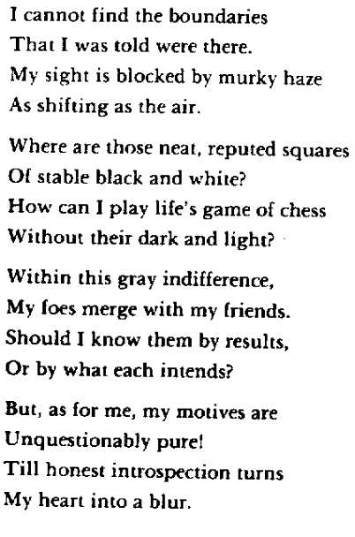
Contents

Mental Architecture

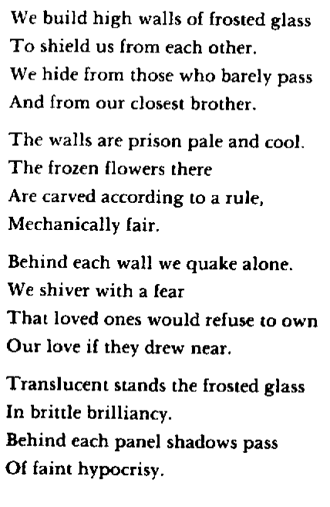
Contents

Response to the Minister

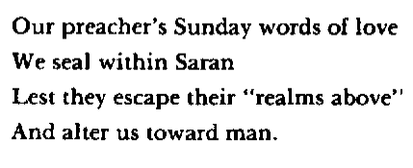
Contents

Directions for House Building

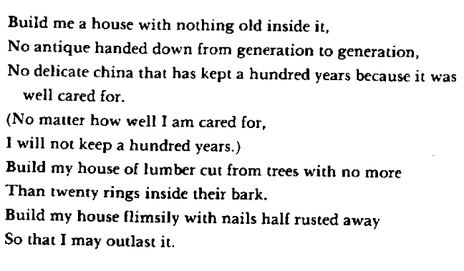
Contents

Reinterpretation
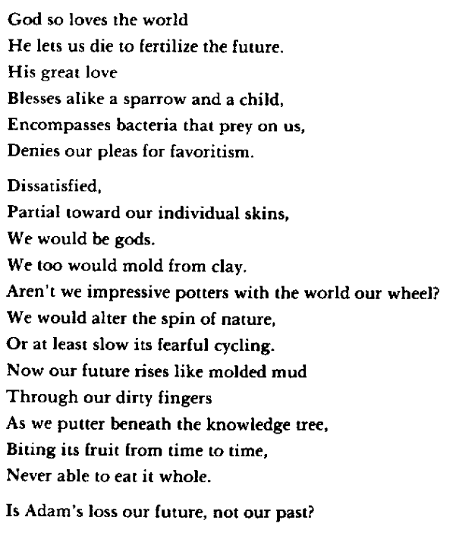
Contents

FOR RICHER OR POORER … in many ways
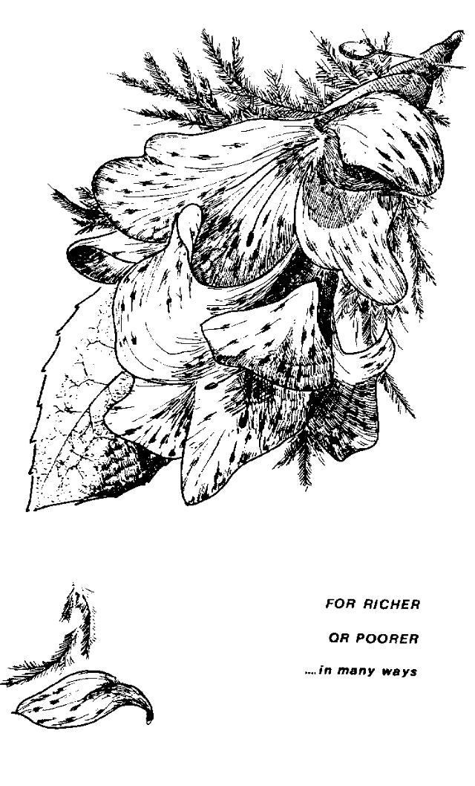
Contents

Virgin

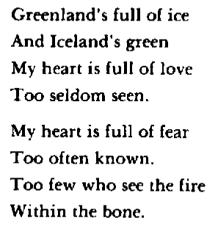
Contents

Wedding

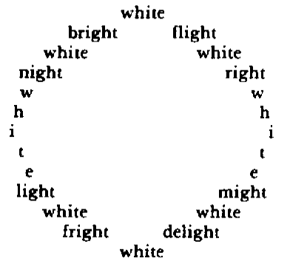
Contents

Shadow

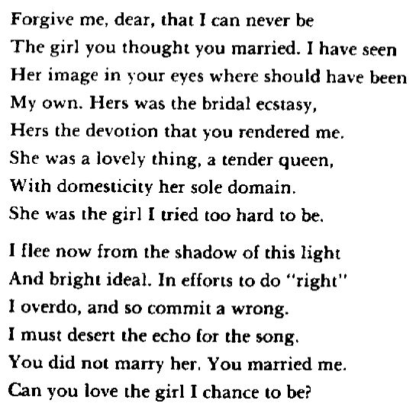
Contents

Who Are We?

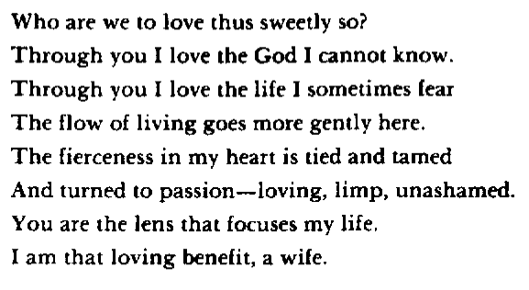
Contents

One Winter Night

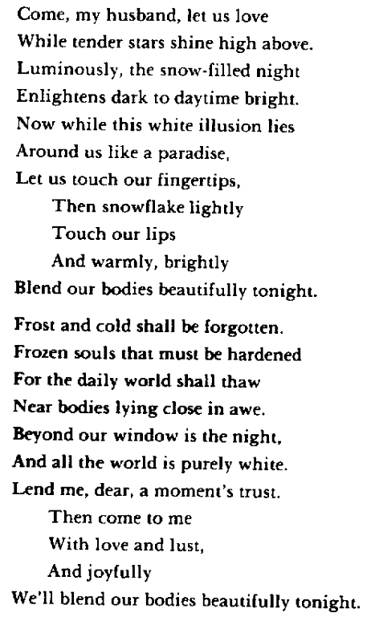
Contents

Fertility Song

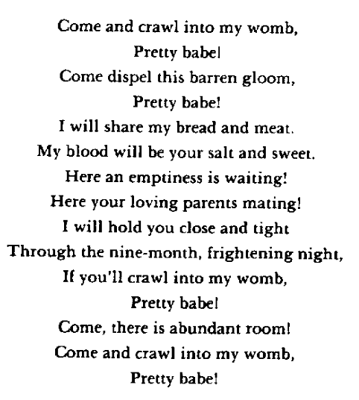
Contents

Entire

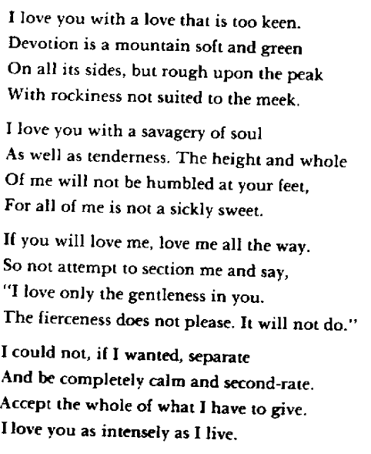
Contents

With Thanks to Mr. Blake

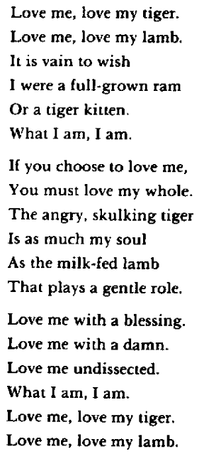
Contents

A Comfort

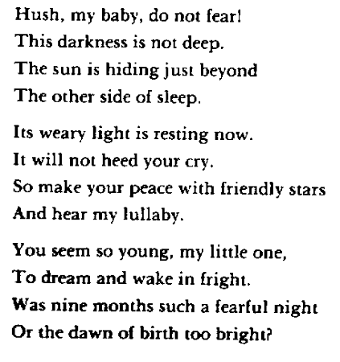
Contents

Realistic Lullaby

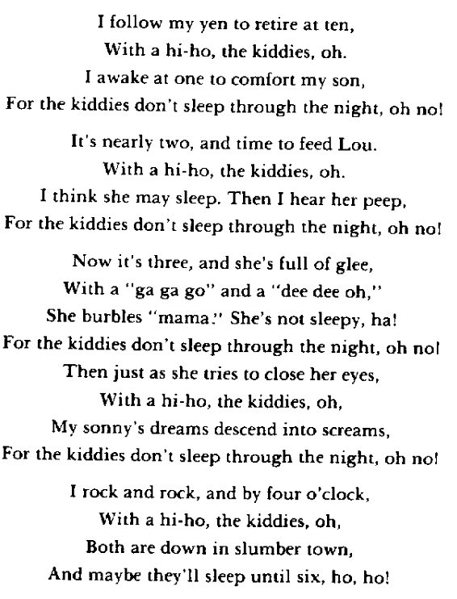
Contents

To My Son

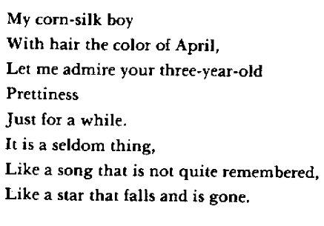
Contents

To Our Daughter At Commencement

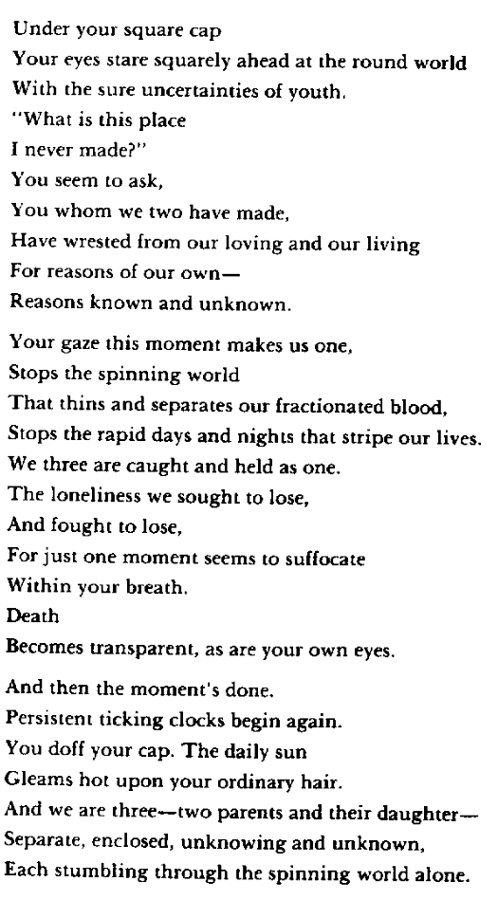
Contents

Later Love

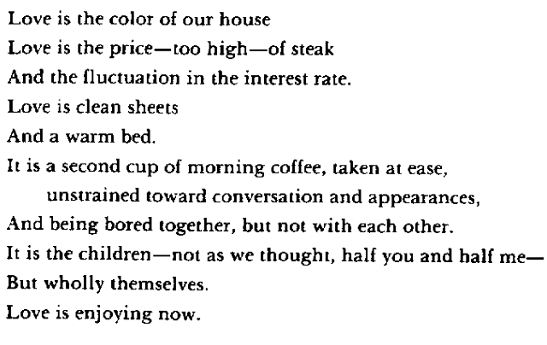
Contents

Anticipation

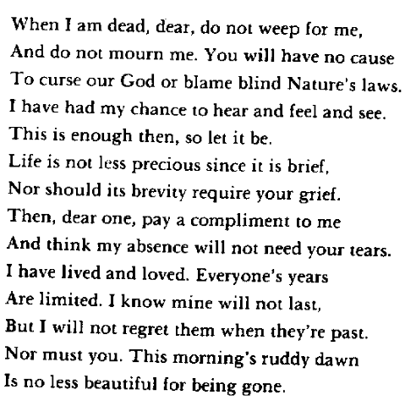
Contents

MOODS: the brights and the blues
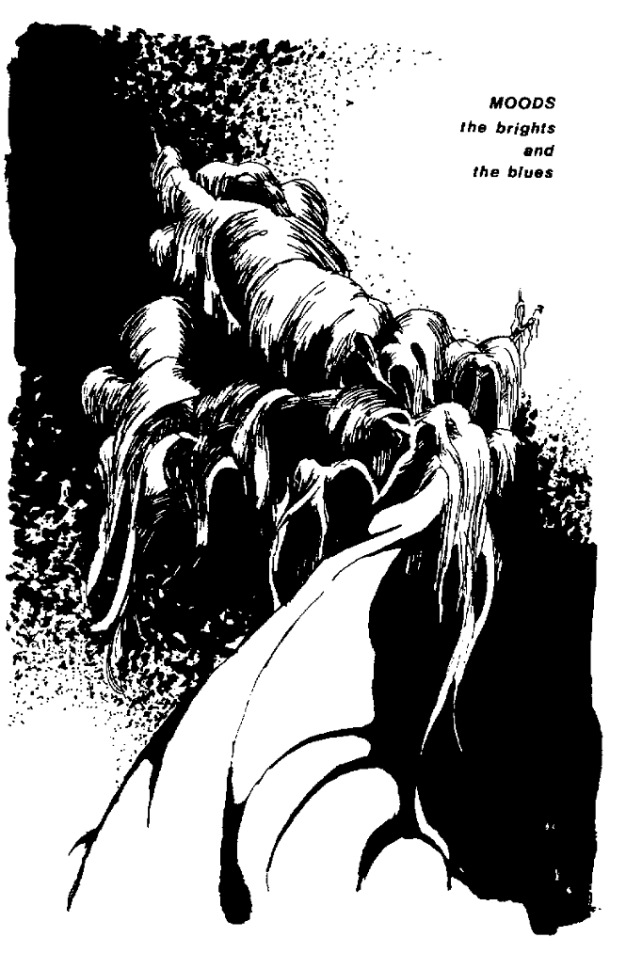
Contents

In Perfect Sunshine

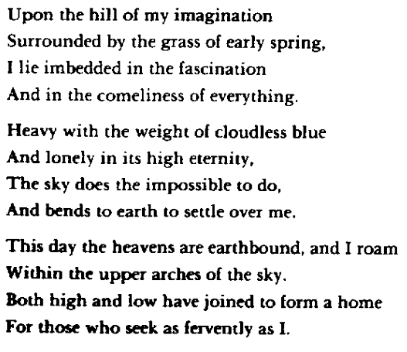
Contents

Driving Through the Plains

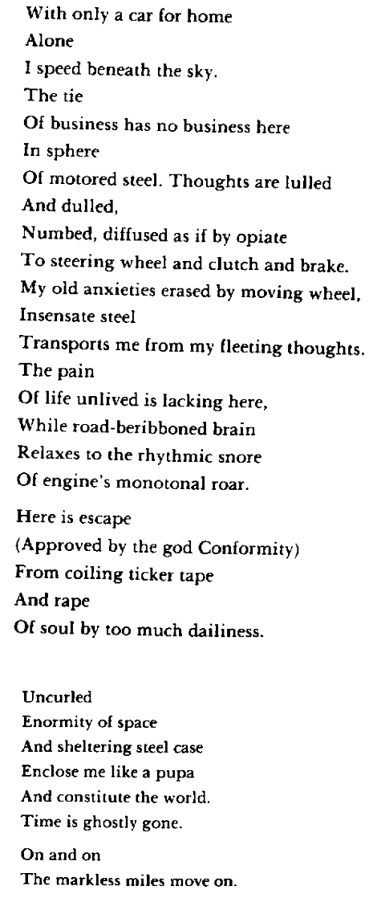
Contents

Road

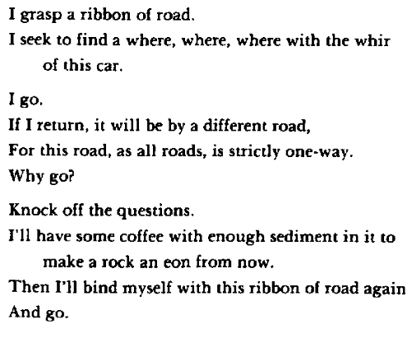
Contents

Alone

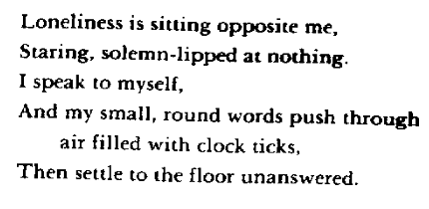
Contents

Paranoia

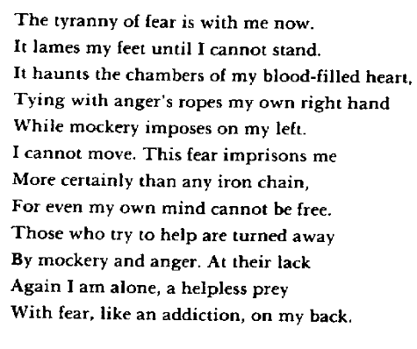
Contents

Frame

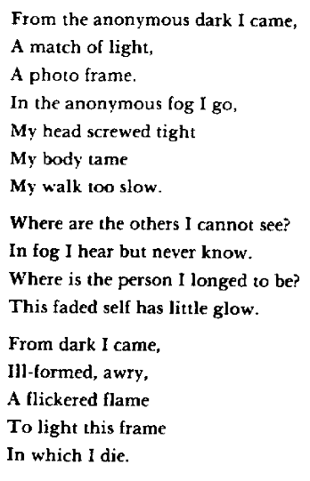
Contents

Huge Night

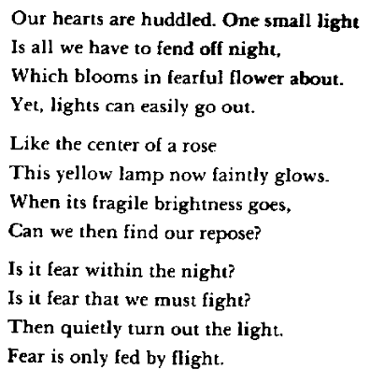
Contents

Restraint

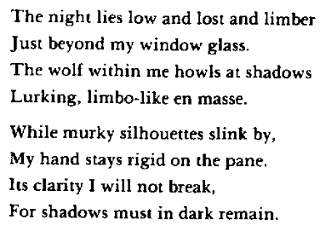
Contents

100 Degrees F

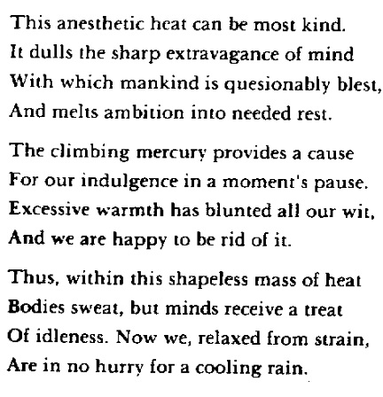
Contents

Civilized

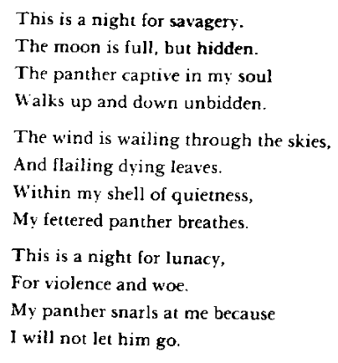
Contents

Obit For A Dead Tom

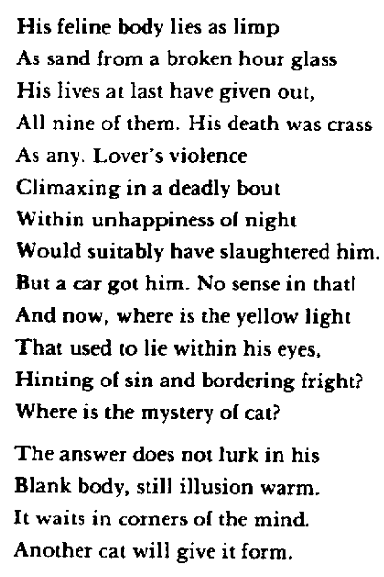
Contents

Haiku Moment

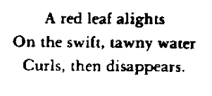
Contents

Insult and Revenge

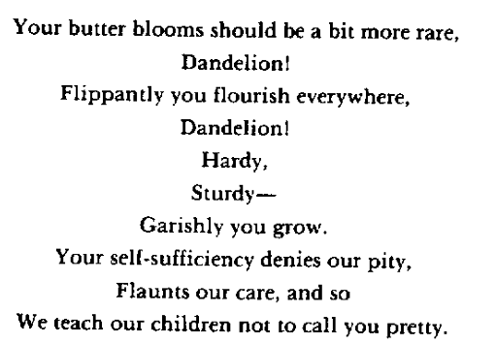
Contents

Sloven Song

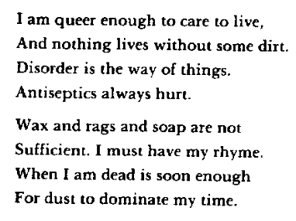
Contents

Delight

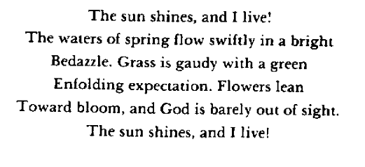
Contents

Morning Joy

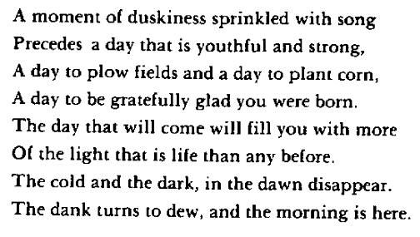
Contents

Musing

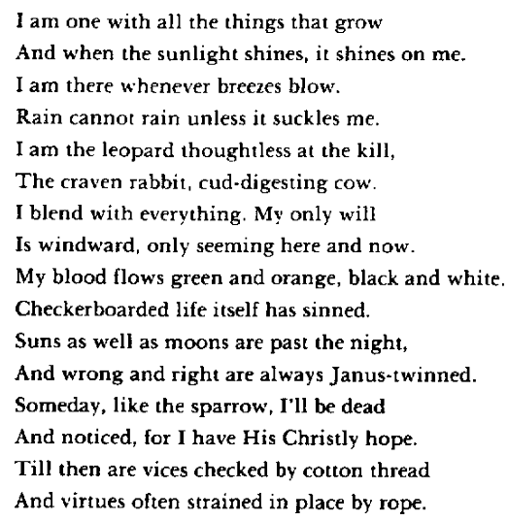
Contents

Disillusionment

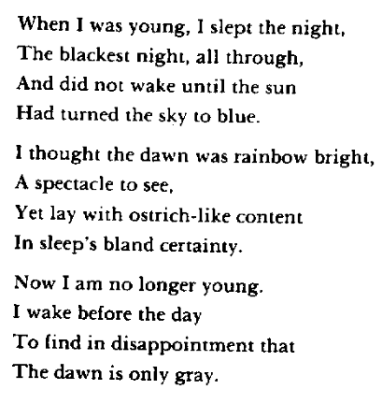
Contents

Storm

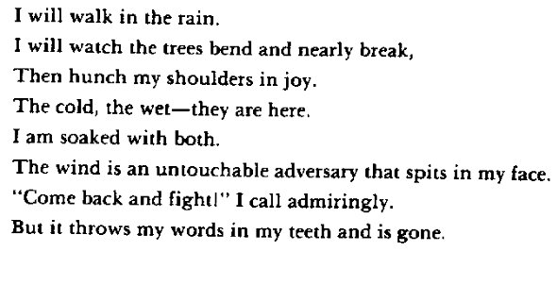
Contents

EARTH and its fullness
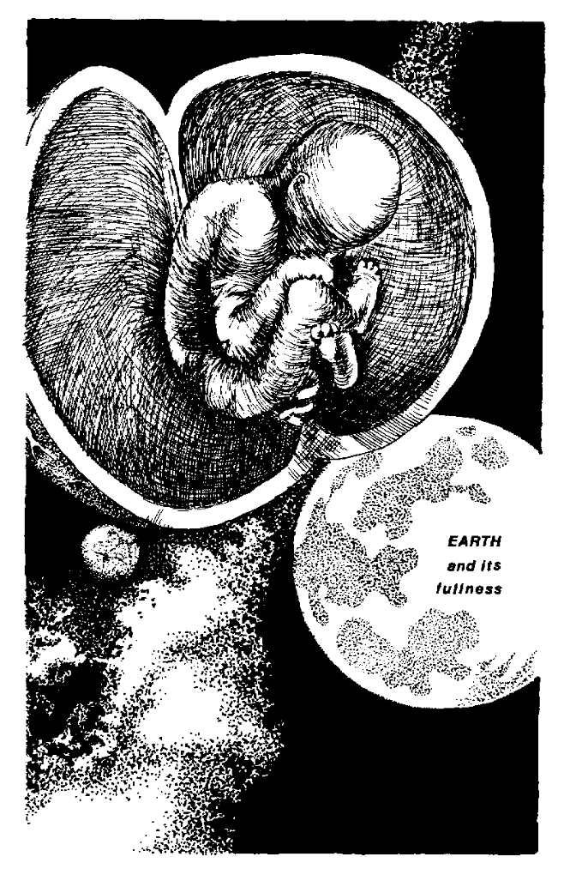
Contents

Season Songs
I

Infusion

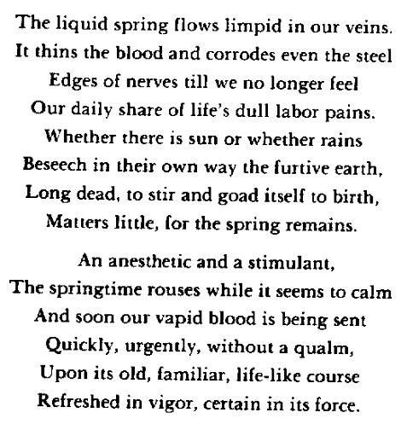
Contents

II

Summer Attainment

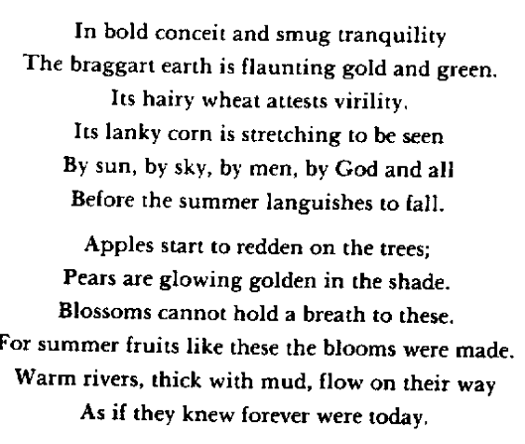
Contents

III

Foreshadowings of Autumn

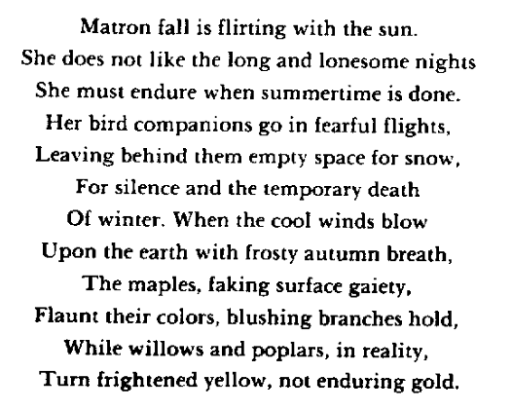
Contents

IV

November

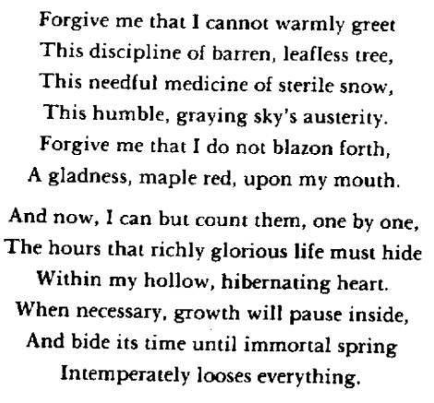
Contents

V

The Cold

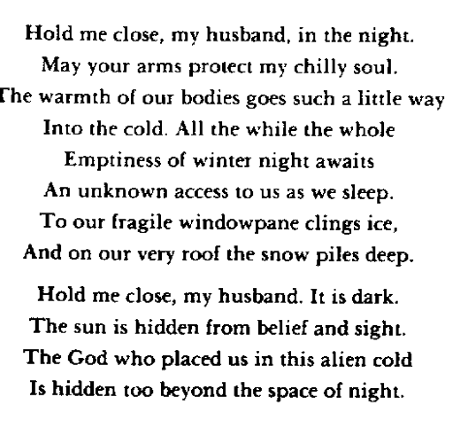
Contents

VI

Brightening

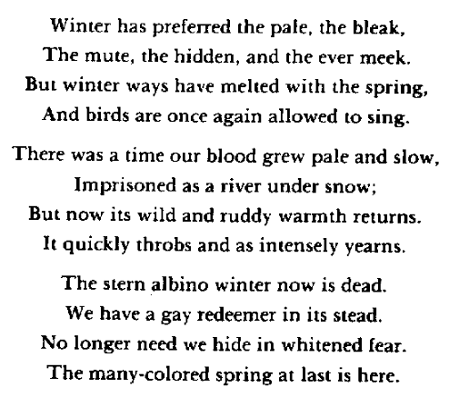
Contents

WHEREVER THOU ART
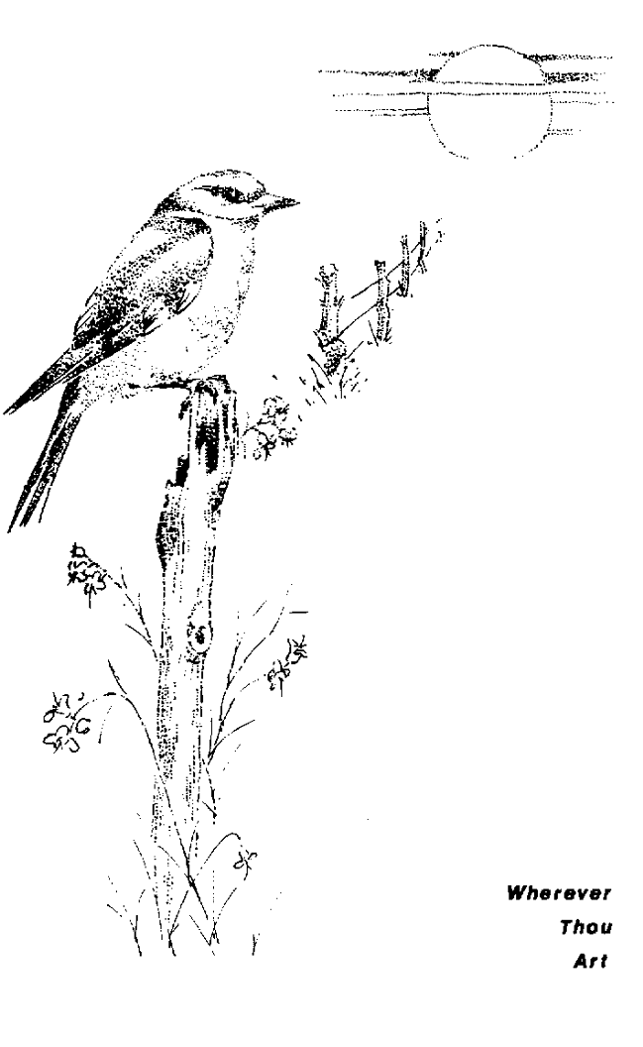
Contents

Rapprochement

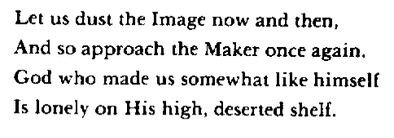
Contents

Fleeing Creature

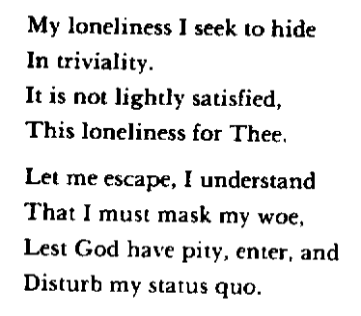
Contents

Apology

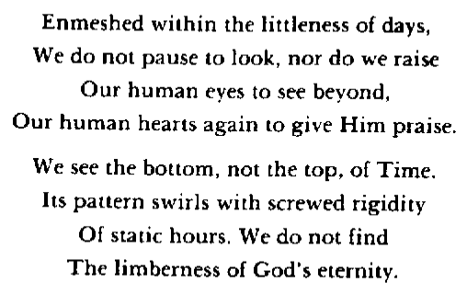
Contents

Water Whimseys

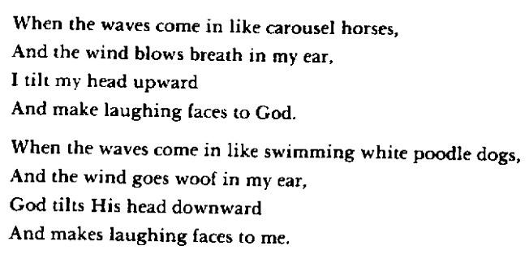
Contents

Eternally

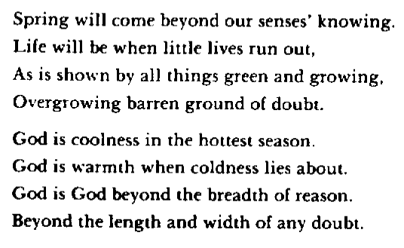
Contents

Resurrection

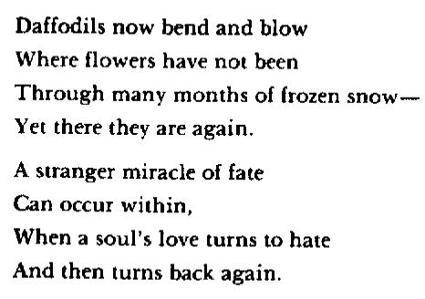
Contents

